TraCit
Transport Carbon IntenCities

ADVICE GUIDE



ISBN: 9781861376244

Edited by Catherine Teeling & Lee Woods (University of Portsmouth)

Contributors:
Graham Wall University of Portsmouth, UK.
Mari Jüssi Stockholm Environment Institute, Tallinn, Estonia.
Katarzyna Nosal Krakow University of Technology, Poland.
Merle Laager Viimsi Municipality, Estonia.

Contents

1. Executive Summary 1
2. Introduction 2
2.1. TraCit and POWER 2
2.2. TraCit Partners and Contact Details 3
2.3. Context 5
3. Description of Pilot Studies 7
3.1. Big Green Commuter Challenge (BGCC) 8
3.2. Land Use Transport Interaction (LUTI) modelling 9
3.3. Design Charrette 10
3.4. Promotional tram event 12
3.5. Promotional ’bike happening’ event 13
3.6. Transport policy measures 14
3.7. Simulation Modelling 14
3.8. Various alternatives of public transport 15
3.9. Coastline development, incorporating leisure facilities 16
3.10. Viimsi Bike event 17
3.11. Interactive Internet Cartoon 17
3.12. Estonian transport carbon audit and policy pathways 18
4. Interregional evaluation 20
4.1. Publicity events (Pilot Studies 1, 4, 5, 10 and 11) 20
4.2. Simulation modelling (Pilot Studies 2, 6, 7 and 8) 24
4.3. Integrated sustainable developments (Pilot Studies 3, 8 and 9) 27
5. Conclusions & Recommendations 30
5.1. Advice for best practice 30
5.1.1. Implementing a publicity event to raise awareness about reducing CO₂ emissions 30
5.1.2. Conducting a questionnaire survey to gain a better understanding of people’s awareness, and acceptance and willingness to change mode. 31
5.1.3. Calculating the impact of the specific measures on reducing CO₂ emissions 32
5.1.4. The use of transport policy measures to reduce CO₂ emissions from transport 32
5.1.5. The use of LUTI and other simulation modelling to predict reductions in CO₂ emissions 33
5.1.6. Encouraging companies to produce a travel plan 33
5.1.7. Internet publicity: cartoon 34
5.1.8. Integrated sustainable developments 34
5.2. Policies influenced 35
5.3. Transfer of best practice 36
6. Detailed Results from Pilot Studies 37
6.1. CURe University of Portsmouth Pilot Studies 37
6.1.1. Big Green Commuter Challenge (BGCC) 37
6.1.2. Land use transport interaction (LUTI) modelling 45
6.1.3. Design Charrette 50
6.2. CUT Pilot Studies 54
6.2.1. Promotional Tram event 54
6.2.2. Promotional 'Bike happening' event 60
6.2.3. Transport Policy measures 71
6.2.4. Simulation modelling 84
6.3. Viimsi Pilot Studies 96
6.3.1. Various alternatives of public transport 96
6.3.2. Coastline development incorporating leisure facilities 111
6.3.3. Viimsi Bike event 116
6.4. SEI Pilot Studies 121
6.4.1. Interactive internet cartoon 121
6.4.2. Estonian transport carbon audit and policy pathways. 125

Appendices

Appendix 1 BGCC: Portsmouth transport baseline data.
Appendix 2 Questionnaire used during the tram event, Krakow.
Appendix 3 Questionnaire used during ‘Bike Happening’, Krakow.
Appendix 4 Questionnaire used among transport and land use experts in Krakow.
Appendix 5 Questionnaire used to develop Viimsi public transport model.

Executive Summary

The TraCit project’s aims of breaking the links between growth in the economy and growth in carbon emissions from transport fits with the European White Paper: Roadmap to a Single European Transport Area – Towards a competitive and resource efficient transport system. Indeed, if the target of a 60% reduction in CO₂ emissions from transport by 2050 while current standards of living are maintained and improved, this link between the economy and transport emissions must be broken. Current levels of transport carbon intensity vary greatly across Europe with 2.11 tonnes of CO₂ per person per year in the UK from transport compared to 1.78 tonnes in Estonia and 1.12 tonnes in Poland. However, when measured in terms of emissions per Euro of GDP, the UK has a lower level of Transport Carbon Intensity than Poland or Estonia.
The TraCit project undertook 12 pilot studies across the UK, Poland and Estonia that had the potential to reduce carbon emissions from transport and to support economic growth. Interventions in each project region were evaluated in terms of the emissions saved to identify good practices in each region. These practices were transferred to develop similar interventions in partner regions which were in turn evaluated to determine their impact on transport carbon intensity levels.
The pilot studies were diverse, including educational and promotional campaigns, land use planning, public transport improvements and the effects of improved public transport. The educational and promotional campaigns generally showed the smallest emissions savings per person compared to the improved land use planning and public transport improvements. However, the expenditure required for the educational programmes were far less.
This report describes in detail the pilot studies, their contribution to breaking the links between carbon emissions from transport and economic activity, good practises identified and transferred and finally provides recommendations to policy makers across partner regions and elsewhere, some of which are already being implemented.

Introduction

TraCit and POWER

TraCit (Transport Carbon IntenCities) is a subproject of the POWER interregional programme aimed at driving forward low carbon economies. The POWER programme has funded projects in seven European regions:

Andalucia (Spain)
Emilia-Romagna (Italy)
Malopolska (Poland)
Province Noord-Brabant (The Netherlands)
South East England (England)
Stockholm (Sweden)
Tallinn (Estonia)

Nine projects are currently funded through the POWER programme in five themes of joint cooperation:

Energy Efficiency
Renewable Energies
Eco-innovation and Environmental Technologies
Sustainable Transport
Behaviour Change

TraCit is one of three projects to be funded under the sustainable transport theme.

More information on the POWER programme can be accessed through the following website:
http://www.powerprogramme.eu/index.php

TraCit Partners and Contact Details

CURe University of Portsmouth (Lead Partner)
Contact person: Catherine Teeling
Tel: +44 02392 84 2098 & +44 02392 84 2083,
Email: Catherine.teeling@port.ac.uk,
Website: www.port.ac.uk/departments/academic/architecture/cure/2010/tracit/

Viimsi Municipality Estonia
Contact person: Merle Laager
Tel: +3725162086, Email: merle.laager@mail.ee, Website: www.viimsi.ee

CUT Krakow University of Technology
Contact person: Prof. Andrzej Rudnicki
Tel: +48 12 628 30 84, Email: ar@transys.wil.pk.edu.pl, Website: www.pk.edu.pl

SEIT Stockholm Environment Institute- Tallinn Centre, Estonian Institute for Sustainable Development
Contact person: Mari Jüssi
Tel: +3726276100, Email: mari@seit.ee, Website: www.seit.ee

TraCit webpage: www.tracit.org.uk

Reducing carbon emissions and the associated consequences of global warming is the most pressing problem the world faces in the 21st century and much of the carbon emitted in Europe is as a result of transport. Carbon emissions in Europe have followed a long term upward trend and in the few periods over the last fifty years when emissions have fallen, most have coincided with economic downturns. This is far from a coincidence, as the symbiotic relationship between growth in transport and growth in the economy are well documented.(ref) Increasing economic activity is related to increased numbers of people travelling to work, increased freight movements, and increased retail and leisure travel.

Much of the increase in travel, and indeed carbon emissions from the transport sector, has arisen by the use of the car. While examples exist of situations in Europe where economic growth has been achieved without large increases in the use of the car, these examples remain the exception. Most European regions continue to experience increased private car use associated with any economic growth, creating further carbon emissions, localised air pollution, congestion and social inequality.

The TraCit project has investigated a variety of different interventions in each partner region that have the potential to break this long established link between growth in the economy and growth in emissions from transport. These range from educational and promotional events to enhanced transport modelling projects and integrated urban design and transport solutions. The interventions were either planned specifically as part of the TraCit project or were established following investigations into good practice in each TraCit project partner region. The effectiveness of the interventions have been assessed and comparisons made across the pilot studies as to the overall efficacy of these various schemes. As a result of these pilot studies being undertaken, suggestions have been made and adopted as to how these schemes can be improved in the future. In addition policy recommendations have been proposed along with good practice identified which has been shared across the project partners and their regions.

Therefore the findings from the TraCit project presented here have the potential to help inform decision makers across Europe as to the effectiveness of different interventions in different national and regional contexts to ensure that resources are directed to those schemes that have the greatest potential in breaking the links between growth in the economy and growth in emissions from transport, in particular CO₂.

This report describes the European, national and regional contexts of the pilot studies, along with a detailed description of the studies; the report presents results, interregional evaluations, policy recommendations and good practices transferred.

Context

It is important to consider the different national and regional contexts that the pilot studies have been undertaken in as well as the common regulatory framework of the European Union. Greenhouse gas emission rates vary across the EU as do the sizes of national economies and populations. In setting a benchmark of transport carbon intensity, it is important to consider the best ways in which it can be measured. The most common metrics used are green house gas emissions (CO₂ equivalent) per capita and per unit of gross domestic product (GDP). In terms of emissions per person, the UK performs poorly when compared with Poland and Estonia. Greenhouse gas emissions from domestic transport in the UK amount to the equivalent of 2.11 tonnes of carbon per person per year compared to 1.78 tonnes in Estonia and 1.12 tonnes in Poland.

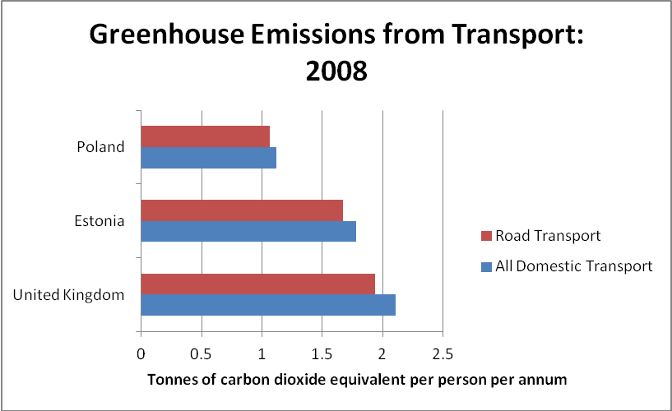

Figure 1. CO₂ emissions from transport per person per annum (TSGB, 2010).

However, the size of the UK economy is larger and the economic output per person is larger than in Estonia and Poland so it could be expected that per capita emissions are higher. When compared to the size of the economy, the UK has a lower level of emissions with each euro of economic output relating to 71 grammes of carbon emitted by domestic transport compared to 145 grammes in Estonia and 118 grammes in Poland. Thus the transport carbon intensity of Estonia is double that of the UK.

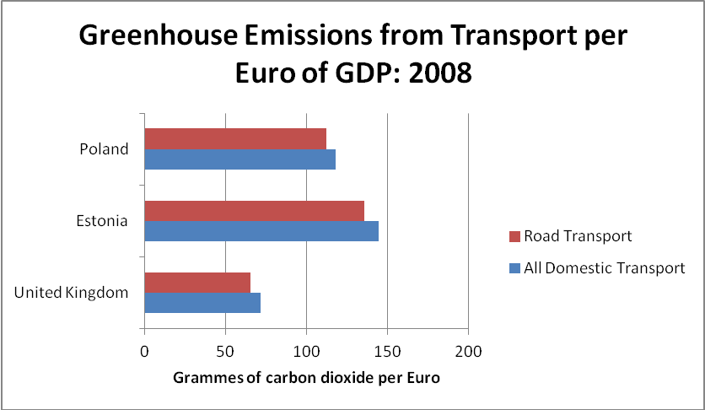
Figure 2. CO₂ emissions from transport per Euro of GDP (TSGB, 2010).

If Estonia and Poland are to reduce their intensity levels to that of the UK, it will require the following:

- considerable economic growth.
- a significant decarbonisation of transport.
- a reduction in demand for transport.

or more likely a combination of all three.

This report outlines the possible schemes, methods and mechanisms by which the reduction of carbon intensity can be achieved. The TraCit pilot studies focused on the potential to encourage economic growth and to predict such growth and how demand for travel by car can be managed, with a further emphasis on personal travel as opposed to freight. The potential of less carbon intensive transport technology and fuels has not been explored as part of this guide as these two issues form the focus of two other POWER programme projects which are:

ITACA (ITACA Innovative Transport Approach in Cities and metropolitan Areas)
http://www.powerprogramme.eu/projects.php?project=ITACA
E-Mob (E-Mobility accelerator)
http://www.powerprogramme.eu/projects.php?project=EMob

Description of Pilot Studies

An integral part of the TraCit project has been the implementation of a number of pilot studies throughout the duration of the project. A number of schemes, plans and initiatives were identified by each project partner before finalising those that could form the basis of an interesting and valuable pilot study.

In total, there have been 12 pilot studies undertaken within the TraCit project; these are as follows:

CURe, University of Portsmouth

1. Big Green Commuter Challenge (BGCC)
2. Land Use Transport Interaction (LUTI) Modelling
3. Design Charrette

Krakow University of Technology (CUT)

4. Promotional Tram event
5. Promotional 'Bike Happening' event
6. Transport policy measures
7. Simulation Modelling

Viismi Municipality

8. Various alternatives of public transport
9. Coastline development incorporating leisure facilities
10. Viimsi Bike event

Stockholm Environmental Institute, Tallinn (SEIT)

11. Interactive internet cartoon
12. Estonian transport carbon audit and policy pathway

The collective set of pilot studies have managed to cover a broad range of different but related issues from raising awareness in order to change behaviours (education and publicity), represented by the bike events, the tram event, the interactive Internet cartoon and the BGCC, to studies seeking to achieve integrated sustainable developments by connecting settlements and facilities with various sustainable transport options (various alternatives of public transport, the coastline development incorporating leisure facilities and the Design Charrette). In addition, studies have been undertaken which have utilised simulation models in order to estimate the impacts of various transport policies and land use scenarios on reducing CO₂ emissions (LUTI modelling, Transport policy measures and Simulation modelling). A short description of each pilot study is provided below. The final section of this report contains a more detailed account of each pilot study along with the results, lessons learnt, policies affected and good practices that have been transferred.

Big Green Commuter Challenge (BGCC)

Portsmouth, UK
For this pilot study the CURe team carried out the analysis and evaluation of a scheme currently run by Portsmouth City Council. This scheme is executed on an annual basis during the month of May and aims to reduce CO₂ emissions from commuter and business travel in Portsmouth by raising the awareness and acceptance of the need for modal shift to more sustainable forms of transport.
(see http://www.portsmouth.gov.uk/CommuterChallenge).
The study utilised existing data sources where possible, supported by retrospective recalled data from people who took part in the commuter challenge this year. This study capitalised on data available from previous years; in particular the results from last year (2010) showed that a total of 1195 people took part from 32 different organisations and that the overall total number of miles saved was 78,000 as well as total emissions savings of 28,832 kg of CO2.
The bus was the most popular mode shifted to for commuters, whereas the train and car sharing were the most popular for business travellers. Of 1,029 people questioned, 63% stated that they would continue to travel using this new more sustainable mode.
The evaluation of the scheme has been enhanced through the pilot study by revising the emissions savings formulae calculations, producing a bespoke spreadsheet template and by looking specifically at the reduction in emissions as a result of the scheme.

Land Use Transport Interaction (LUTI) modelling

South Hampshire, UK.
For this pilot study the CURe team undertook a review of current practise with regards to how the Transport Carbon Intensity of various interventions are estimated and how this informs decision makers as to those interventions that are funded.
The review investigated the way in which various forms of a traditional four stage transport are used in the UK and in Poland in order to estimate the likely impacts of new transport schemes and to a lesser extent development plans and other interventions. While these various forms of traditional model were found to be useful in determining the likely transport outcomes of some interventions, these outcomes were rarely expressed in terms of CO₂ emissions and their ability to determine the full economic impacts is limited. The potential for Land Use Transport Interaction (LUTI) models to predict more fully the economic, land use and transport impacts of new transport infrastructure, changes to public transport levels of service, development plans as well as the effects of national and regional levels of economic growth and migrations of people and businesses were explored as part of the pilot study.
The Transport for South Hampshire model has been used as an example of current best practise, which has been developed over the same time period as the TraCit project. The ability of the model to better reflect the full range of economic impacts in addition to the transport impacts of various schemes can allow for better decision making.
Findings from the LUTI modelling pilot study have contributed to Department for Transport consultations on how economic impacts of transport schemes can best be modelled.

Design Charrette

Viimsi, Estonia.
A Design Charrette was introduced and implemented as a collaborative activity bringing together the two projects running under the Power Programme, TraCit and SILCS (SILCS Strategies for Innovative Low Carbon Settlements is the only project running under the Eco-innovation and Environmental Technologies theme and CURe are the lead partner). The main reason for the introduction of this collaborative project was to provide innovative solutions in support of the TraCit project partners’ objectives drawing upon the expertise that the CURe team possess and to ensure good practice transference within the life time of the Power projects.
In their proper form, Charrettes are intensive workshops that last between 4 and 7 consecutive days; this is the shortest amount of time to produce a feasible yet visionary plan that motivates client and community action. The event is an open forum that includes all interested parties in a collaborative process involving a wide range of disciplines. It adopts a generalist, holistic approach to solving the problems under discussion and sets out to produce a plan that is, above all else, practicable. Charrettes increase the likelihood of getting projects built, by gaining broad support from citizens, professionals, officers, elected officials and cabinet members. Plans and design solutions are improved through diverse input and involvement; a key attribute of communicative development solutions. The Charrette took place in Viimsi and Tallinn, Estonia from 9th - 13th April 2011 and comprised of a design workshop in which 11 students from Portsmouth and students from the Estonian Academy of Arts, worked intensively on the issues outlined in the Viimsi Municipality’s two pilot studies. The Charrettte was supervised by 3 members of academic staff from the University of Portsmouth and supported by the Mayor of Viimsi and his regional development department, the Viimsi consultants Stratum and Kava Kava and SEI Tallinn. The Charrette involved students and practitioners from a range of disciplines (Transport Planners, Architects, Urban Designers, and Sustainable architecture students etc) to contribute to and explore this process, which was a new experience for both Estonian project partners (Viimsi Municipality and SEIT).
This intensive, multi-disciplinary design workshop was designed to facilitate open discussion between collaborative student teams supported by academic and practice experts (staff and students with expertise in architecture, urban design, sustainable architecture, transport planning, transport technologies and sustainable technologies).
The collaboration resulted in the development of solutions for integrated sustainable transport modes connecting Viimsi with Tallinn and the design proposals for the development of a new promenade, including leisure facilities. In addition, students were asked to incorporate sustainable housing development which would reinforce and strengthen the identity and distinctiveness of Viimsi towards a future vision of a new municipal centre.
Students, working in teams, were asked to focus on developing integrated design solutions that brought together sustainable transport solutions, leisure facilities, sustainable housing with a green spaces & infrastructure strategy (including walkability as a key element), towards an integrated sustainable development, with the aim of :
1. Connecting the City of Tallinn with the Municipality of Viimsi
2. Development of the promenade Viimsi & Haabneeme Green infrastructure and walkability strategies
3. Creating a social and cultural centre for Viimsi - distinctiveness & identity

CURe stressed the need for a holistic approach for this integrated development, this is a traditional and good practice approach for successful and sustainable urban design solutions where several measures must be simultaneously applied in order to reduce CO₂ emissions. Linking the footpath and cycle track with the existing bus routes and the prospective tram route (through or close to residential areas) would better facilitate the use of public transport over the private car since it was linked to the main access route from Viimsi municipality to the City of Tallinn and its transport stops. Indeed, significant other measures in the development plan would need to occur to make this a viable alternative. Such solutions were considered in the Design Charrettte, which explored further cycle and footpath routes and urban connections to the new centre of Viimsi/Habneeme linked to cycle and footpath routes along the main transport connection to the City of Tallinn.
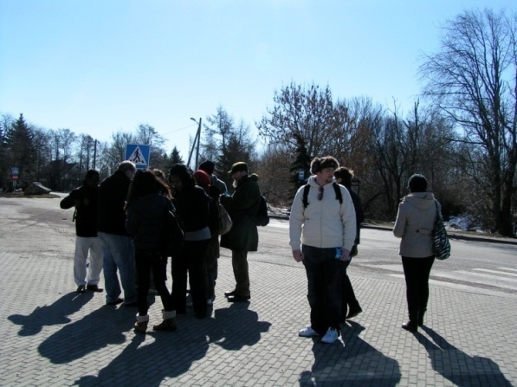
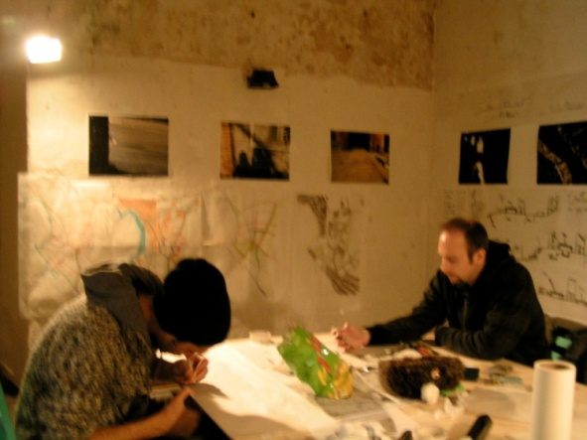
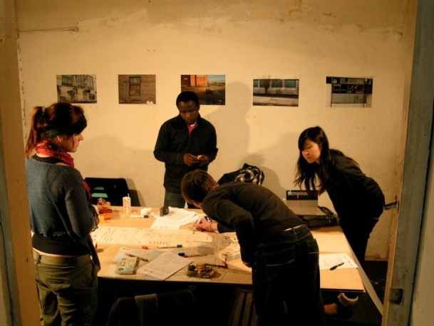
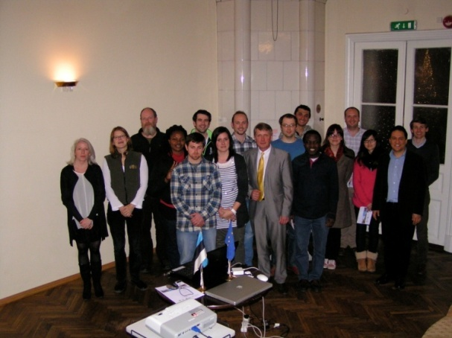
Figure 4: Architecture and Sustainable Design Students working on the design solutions for the Municipality Pilot studies
Figure3: Students commence a walk of the sites from the offices of Viimsi Municipality
sites from

Figure 5: Architecture, Sustainable Design and Transport Engineering Students `working on the design solutions for the Municipality Pilot studies

Figure 6: Photoshoot following Presentation to the Mayor of Viimsi and his team.

Promotional tram event

Krakow, Poland.
The public transport promotional event “Green Tram” in Krakow was organised by CUT (Krakow University of Technology) to promote awareness of new more sustainable public transport modes among Krakow inhabitants. The event had a more substantial educational purpose not only for raising awareness, but also to provide information about CO₂ emissions from transport and how this could be reduced by making different mode choices.
The objectives were:
- Changing perceptions and acceptance of sustainable mobility options among Krakow inhabitants.
- Promoting public transport as a mode which emits less pollutions and CO₂ than private cars.
- Raising awareness about CO₂ emissions from transport among Krakow inhabitants; its negative influence and the benefits of its reduction.
- Raising awareness concerning the POWER programme and TraCit project among Krakow inhabitants.
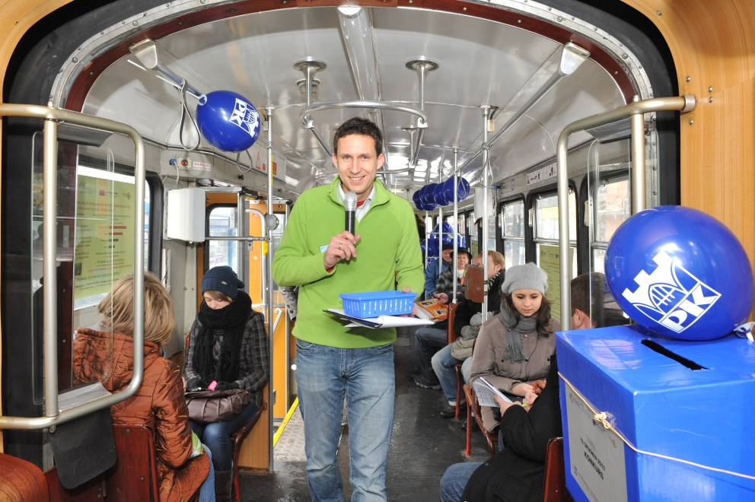
Figure 8. Passengers are informed about CO₂ emissions by the “master of ceremonies” on the tram.

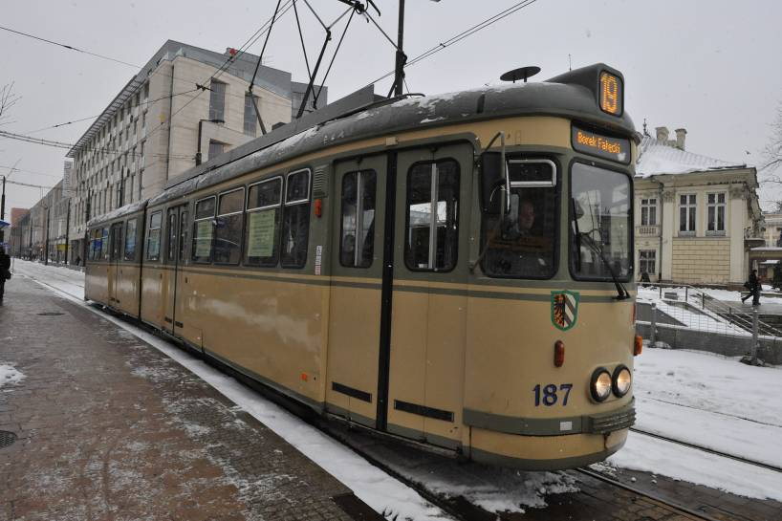
Figure 7: “Green tram” in Krakow.

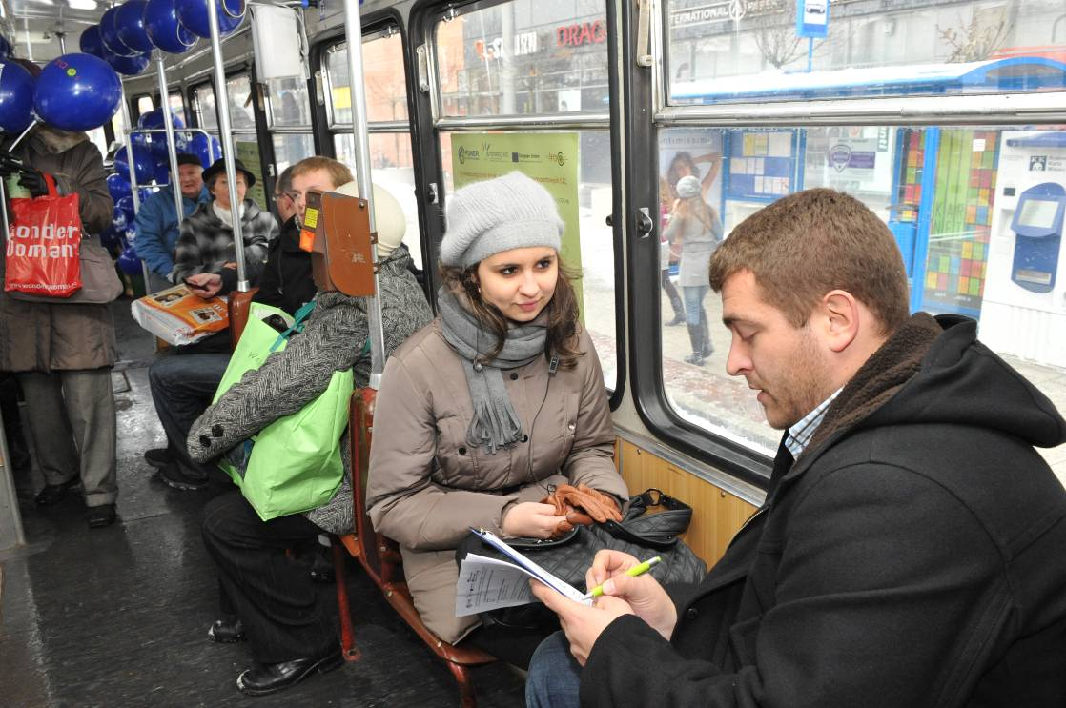
Figure 9: A survey carried out among passengers.

Promotional ’bike happening’ event

Krakow, Poland.
The ‘Bike Happening’ event was organised in order to promote bike travelling among employees and students at Krakow University of Technology. The important issue tackled by this event concerned raising awareness about CO₂ emissions from transport and ways to ensure its reduction through a modal shift. A questionnaire was carried out during the event in order to determine the readiness of participants to change their present transport mode to cycling.
The objectives were:
- Changing the perception of cycling among employees and students at the University and promoting it as a modern and environmentally friendly mobility option.
- Raising awareness concerning CO₂ emissions from transport among employees and students at the University due to existing modes of travel.
- Raising awareness concerning the POWER programme and TraCit project among Krakow inhabitants.
- Understanding and identifying the factors which could influence modal shift to cycling.
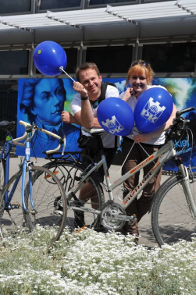
Figure.10. The winners of the competition “the most elegant cyclists”
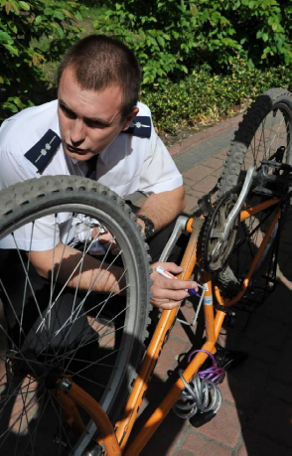
Figure.12. Bike marking by police

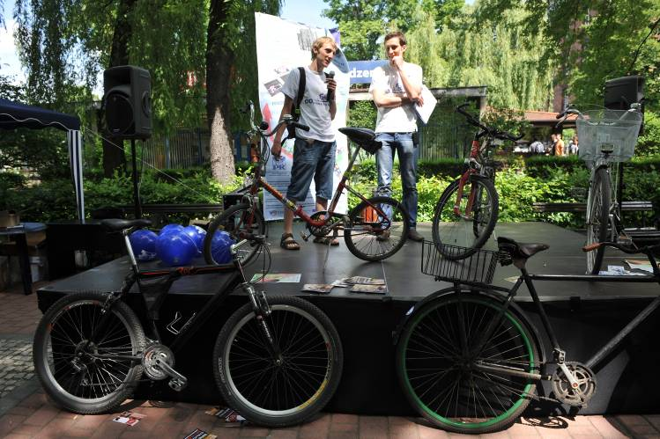
Figure.11. One cyclist tells a story about his bike.

Transport policy measures

Malopolska, Poland.
This pilot study provided a general analysis and investigation of the Transport Policy for Poland. It contained the production of a development strategy for the Malopolska Region incorporating a strategy for a CO₂ emission reduction and a detailed qualitative and quantitative impact of recommended instruments in transport policy for the city of Krakow in order to achieve this.
The main objective was to demonstrate the potential and real possibilities for the reduction of CO₂ emissions through the instruments of transport policy at different levels of regulation. This process therefore illustrated a range of typical examples demonstrating good practice.
There were three levels studied as part of the pilot analysis and evaluation:
- Transport policy at the national level
- Transport policy at the regional level
- Transport policy at the local level (the city of Krakow)

Simulation Modelling

Krakow, Poland.
This pilot study involved research into different land use schemes and different variants of transport systems development as well as the identification of the impact of innovative transport solutions in terms of CO₂ emissions.
Simulation analysis was carried out for different land use development changes and different levels of investment in private and public transport modes according to their impact on CO₂ emissions. The aim of this research was focused on the identification of the impact of innovative transport solutions on CO₂ emission reduction. This was approached by interviewing transportation experts as well as local inhabitants.
The objectives of the pilot study were:
- To show the impact of different future land use schemes and variants of transport systems development on CO₂ emissions.
- To define innovative transport solutions as well as measures that are considered to be the most and the least significant in evaluation of the impact of transport solutions on the reduction of CO₂ emissions.
- To estimate possibilities for introducing innovative transport solutions in Krakow.
- To obtain recommendations which could be helpful for decision makers in the process of conducting transportation policy in such a way, that the expected impact of transport on the environment will be minimised.

Various alternatives of public transport

Viimsi, Estonia.
This pilot study was focused towards finding optimum solutions for the re-organisation of public transport in Viimsi which would ensure a reduction of CO₂ emissions.
The study was established to explore the improvement of public transport connections and reduce environmental impacts of such transport solutions. The main focus of the study concentrated on the analysis of the development of intra-municipal connections. In the case of the Viimsi-Tallinn connection, it was thought desirable that Viimsi Municipality bus lines become the primary connection to the central city of Tallinn (advantageous for the main bus terminal in Tallinn, which is located near to the main road connection leading out from Tallinn to the municipality of Viimsi).
One of the main aims of the sustainable regeneration agenda for the Viimsi Municipality is to achieve a clean environment (reduction in polluting emissions), a balanced use of nature (which is why the green infrastructure strategy was introduced for investigation in the Design Charrette), the development of a highly cultural centre and an integration of environmental responsive solutions in development and planning of its settlements. This study contributed to that overall agenda in reducing environmental pollution through the proposals for a public transport system that is competitive with the use of the private car for travel. The municipal development plan has set a target to achieve a high-quality public transport service for all of the districts in the municipality with Habneeme possibly forming a reinforced centre of the municipality reinforcing its identity and character. To achieve this, the following activities have been undertaken and their impacts assessed through the development of the transport model CUBE:
- Improving public transport quality and availability,
- Developing municipal road networks and public transport,
- Assessing alternative modes of travel (tram, water taxi, “Park and Ride” system).

Coastline development, incorporating leisure facilities

Viimsi, Estonia.
This pilot study focused on an integrated travel route incorporating a cycling network with other mobility modes between Viimsi and Tallinn along the coast line which contribute to the reduction of CO₂ emissions. One of the aims of this study was to design new connections and evaluated the impact of integrating the Haabneeme beach area with existing footpaths, bus stops and cycle tracks as well as providing draft proposals for reducing CO₂ emissions.
The consultant’s final solutions provided an assessment of the alternative modes of transport to be used for reducing CO₂ emissions. The development plan of the Viimsi rural municipality until 2029 states that the population of the Viimsi municipality is currently 16,901, and is expected to increase to 24,000 by the year 2020. If this present trend continued and the population continued to grow, the problems arising from car traffic would accumulate to such an extent that pollution in the form of CO₂ would increase rather than decrease. It was therefore a main concern for the Municipality through this study to look at alternative modes of movement to the car. According to the Sustainable Transport Report (Jüssi et al 2010), prepared by the Stockholm Environment Institute (SEI), Tallinn, several measures must be simultaneously applied to reduce CO₂ emissions. The effect of the development of cycling and walking alone on the reduction of CO₂ as a whole would remain under 1% as estimated by SEIT; yet with the development of public transport, mobility management, local car taxes and sustainable urban planning, it could lead to a 21% decrease in pollution. The beach promenade in Viimsi supports alternative modes of transport that are more environmentally friendly than car transport. The beach promenade includes a footpath (covered with concrete) and cycle track (covered with asphalt) that on certain sections of the route run in parallel and at times branch off. In one existing section, all the road users share the same concrete road that has not been marked out. Linking the footpath and cycle track with the existing bus routes and the prospective tram route (through or close to residential areas) would better facilitate the use of public transport over the private car since it would provide better access for local people to public transport stops. It is important to note, that this route is not the main access route from Viimsi municipality to the City of Tallinn and significant other measures in the development plan would need to occur to make this a viable alternative. Such solutions were considered in the Design Charrette. In addition cycle and footpath routes need to be considered along the main transport connection to the City of Tallinn.

Viimsi Bike event

Viimsi, Estonia.
This pilot study was introduced into the project as a result of discussion and dialogue with all project partners. It was seen as an opportunity to encourage further good practice transference so that partners could run such an event within the lifetime of the project and given that CUT had considerable knowledge and guidance for running such events. The addition of the pilot study would also encourage and engage the community of Viimsi Municipality to change their mode of travel to cycling and reduce CO₂ emissions, which would encourage behavioural change and support from the community in their desire as a municipality to reduce emissions and adopt a more sustainable approach to their developments.

Bike event details were as follows:
- Event was held on 4th June 2011 in the Municipality of Viimsi.
- Around 315 participants took part, joining the cycle ride at different points along the 37 km route around Viimsi.
- Participants were informed about the area as a result of several stops at key points along the route.
- Participants answered a survey questionnaire about their travel behaviour and willingness to change mode.

Interactive Internet Cartoon

Estonia.
Due to the rapid rise in motor traffic, sustainable modes of transport, especially cycling, have not been considered and taken up in large numbers as a daily means of travel. This pilot study centred on the production of a five minute internet cartoon on cycling. It was aimed at children in an age range of 3 to 6 year olds so that parents would watch the cartoon with their children to encourage more cycling within families.
The cartoon introduced everyday cycling in the city for children and their parents, showing how cycling can be made practical and fun for all members of the family whatever daily tasks they are undertaking. The cartoon produced an explanation of how sustainable transport modes save energy, reduce emissions and make the city a more pleasant place to live, work and play. The website within which the cartoon was uploaded normally has coverage of about 40,000 hits during its first week and 100-120,000 unique hits per cartoon uploaded.
The web site used targets 3 to 6 year olds which is considered to be an optimum age group that would watch the cartoon with parents, thus enabling transfer of good practice to both younger and older generations who would be informed and hopefully transfer these ideas further (see http://www.lastekas.ee). The “hero” of the cartoon (Jänku-Juss) Peter Bunny normally drives in a car to different activities and the City of Tallinn commissioned a second cartoon which focused on how this character would change his normal mode of travel to a more sustainable mode included cycling and public transport options. These were presented in a humorous, educational and beneficial way.
The website used for this pilot study launches a new cartoon every week (usually Wednesday). It has become a popular channel for social marketing as well as becoming an arena for introducing many social and educational issues for children and their families and was therefore deemed by the partner as a useful forum to commence this dialogue of behavioural change and the reduction of CO₂ through these cartoons.

The two cartoons can be accessed at:

Juss ja linnarattad – Peter Bunny cycling in the city (launched 18th May 2011)
http://www.lastekas.ee/index.php?go=web&t=1&id=3877
http://www.youtube.com/watch?v=Wm-vscr7DiU

“Jänku-Juss unistab lahedamast linnast” - Peter Bunny dreams of a cooler city (launched 1st June 2011)
http://www.lastekas.ee/index.php?go=web&t=1&id=3896
http://www.youtube.com/watch?v=fXCW0vDhPjs

Estonian transport carbon audit and policy pathways

Estonia.
SEI-Tallinn carried out the first Estonian transport carbon audit, analysing past 10 years transport and CO2 emission trends by different transport modes. This carbon audit served as a baseline for CO2 reduction evaluation of other Estonian TraCit pilot studies.
The audit focused on several aspects in regard to which both national and local governments could enhance transport energy efficiency and increase public transport use, encouraging cycling and walking instead of intensive car use. The current transport policy in Estonia does not support the achievement of EU-level commitments in improving transport energy efficiency and limiting greenhouse gas emissions by 2020.
During the last ten years car use has increased in line with economic growth. Road freight has even increased more than GDP, while rail freight has decreased considerably. Transport energy demands and GHG emissions from transport have increased at a similar pace. The Estonian economy is transport-intensive, and if current trends continue Estonia will become one of the most transport energy-intensive Member States of the EU. The poor fuel economy of new cars and rapid growth of public transport prices compared to car price indexes are indicative of inefficient energy use and a non-sustainable transport policy.
At the same time, Estonia still has relatively low transport carbon emissions per capita and has great potential to increase transport energy efficiency and to develop a more sustainable transport system. Transport Carbon Audit carried out within the TraCit project contributed considerably into Sustainable Transport Report of Sustainable Development Committee of Estonia.

Interregional evaluation

Publicity events (Pilot Studies 1, 4, 5, 10 and 11)

1. The bike and tram events used a variety of publicity material (e.g. posters, newspapers, leaflets). These were directed specifically at members of the public (with the exception of the CUT ‘bike happening’ which had a particular focus on the university staff and students and took place on the main University campus ,although publicity material was displayed at the other campuses). In contrast, the BGCC (Big Green Comuter Challenge) was purposely directed at businesses and organisations within the city of Portsmouth who were encouraged to support the event through the participation of their employees within the study, with only a small number of indiviual members of the public participating not part of a larger participating organisation. The PCC’s (Portsmouth City Council) existing contacts with employers with travel plans (plus the recruitment of other organisations as a result of the publicity who did not have a travel plan) helped in ensuring that 37 organisations were involved in the BGCC.
2. The bike and tram events were successful in raising awareness with a large number of people attending these activities (CUT Bike event: 500 participants; CUT Tram event: 1,300 participants and Viimsi Bike event: 315 participants). Although encouraging, it was not possible to prove significant behavioural change as a result due to the self-reporting nature of the surveys used. The visual (and audible) aspects of the events (particularly in Krakow) attracted the attention of members of the public. For the CUT bike event, a highly visible tent was located in the courtyard of the University accompanied by music with a bike related theme; for the tram event, the green and yellow tram with posters in the windows was highly visible, with music played on the journey. The BGCC would have benefited from having a similar visual presence as part of an overall communication strategy across the whole of the business sector for this type of activity in Portsmouth before and during the event. This would have further enhanced knowledge of CO₂ emission reductions through such behavioural change and raised awareness among businesses and members of public on the government initiatives and incentives on climate change and the reduction of CO₂ emssions.
3. With the exception of the tram event (which was re-scheduled to a later date in December 2010), the publicity events were run during the summer months (CUT ‘Bike happening’ took place on the 25th May 2011; the Viimsi bike event took place on the 4th June 2011 and the BGCC took place between the 17th and 23rd May (an annual event within the city) which provided a better climate for participants from which it was hoped would encourage greater involvement and participation.
4. One of the main evaluation strategies of the publicity events is the essential and critical inclusion of the questionnaires and surveys analysis. This component of the pilot studies allows for a more comprehensive analysis, evaluation and understanding of the local and regional context and any national awareness of the activity and its intention to reduce CO₂ emissions. This will allow the organiser to obtain a better understanding of peoples’ perceptions and opinions in these pilot studies of using sustainable transport and reducing carbon emissions. These surveys took the form of written questionnaires at both the Viimsi and CUT bike events. In addition, interviews were undertaken at CUT’s ‘bike happening’ and tram events and the use of an internet questionnaire was incorporated for Viimsi and for the BGCC.
5. The sample sizes for the surveys varied from the smallest figure 112 for the Viimsi bike event to the largest of 1,208 for the BGCC (Viimsi Bike event: 112; CUT Tram: 120; CUT Bike Happening: 419 and BGCC: 1208). The two bike events used similar questions within the surveys. These were concerned predominantly with existing travel behaviour. This was reviewed against the decisions to why participants travelled by bike now and for this event and what factors would encourage them to cycle more in the future. Health and environmental reasons were the top two answers in both surveys for why participants cycle now (see Table 1 below). To encourage more cycling or modal shift towards the future use of a bike, the top reasons stated by participants were the presence of a good cycle network and lower traffic flows (see Table 2 below). These percentages are correlated as ratios against the numbers of participants, although only respondents who travelled by bike daily or frequently answered the question in Table 1 and only respondents who travelled by bike occasionally or not at all answered the question in Table 2. Response rates were successfully improved by the use of competitions and freebies which also enabled more pro-active participation.
Table 1: Why cycle now?
 | CUT | Viimsi
Health reasons | 18% | 37%
Environmental reasons | 13% | 8%
Avoid traffic jams | 10% | 7%
Save time | 12% | 6%

Table 2: What would encourage you to cycle more/for the first time in the future?
 | CUT | Viimsi
Good cycle network | 31% | 37%
Lower traffic flows | 21% | 18%

6. Calculating the impact of ’soft’ measures in reducing CO₂ emissions can be a difficult process. Soft measures are aimed at encouraging travellers to use more sustainable modes of travel by providing better information and opportunities to use attractive, environmentally friendly and relatively cheap alternatives to the car. Many assumptions are required with regards to the effect of the measure on people’s willingness to change their travel behaviour by using a more sustainable mode of transport as a result of the difficulties in measuring actual behaviour change. The data gathered by each pilot study has been based on people’s stated behavioural change rather a measurement of actual behavioural change. This could be addressed in the future by carrying out revealed preference surveys after the event to assess actual behavioural change. This can also be accompanied by the use of quantitative public transport data such as bus passenger numbers before and after the event to determine actual changes in the use of public transport modes (which were obtained for the BGCC; see Figure 13).
7. The BGCC provided self-reported ’before’ and ’during’ travel behaviour data which was split by mode of travel. This enabled a more accurate estimation of the reduction in CO₂ and NOx emissions to be gathered. This was supported with information about the changes made in the use of (and selection of) different travel modes.
8. As a result of these difficulties, some of the publicity pilot studies have used a percentage decrease in CO₂ emissions from literature. This previous study looked at the effects of different policy measures on car mileage and CO₂ reductions in the Stockholm region over a 10 year period (see Table 3 below).
Table 3: Percentage reduction in CO₂ as a result of soft and hard measures over a 10 year period (WSP Sweden (2007).
Soft measures:
Mobility plans of companies  Mobility plans of schools  Direct Marketing  Public Transport marketing  Awareness raising campaigns  Car sharing  Car pooling  Teleworking  Video-phone conferences  E-commerce/online shopping | -1.6%  -0.3%  -0.6%  -0.2%  -0.2%  -0.03%  -0.8%  -0.6%  -0.25%  -0.3%
Hard measures:
Stockholm congestion charging  Impact on inner city travel demand  Compact land use | -2% (county)  -14%  -1%

Table 3 shows that the ’soft’ measures combined only lead to a maximum 5% reduction in CO₂ emissions whereas ‘hard’ measures such as congestion charging can have a much more dramatic effect on reducing CO₂ emissions (14%).
The internet cartoon was seen as an ‘awareness raising campaign’ (0.2%) whereas the bike and tram events were primarily examples of ‘direct marketing’ (0.6%). The BGCC was a combination of some of the ‘soft’ measures listed such as ‘awareness raising campaigns’, ‘direct marketing’ and ‘mobility plans of companies’ (encouraging companies to adopt their own travel plans) (up to a maximum of 5%). A combination of ‘soft’ measures adopted within these pilot studies would therefore be expected to achieve up to a maximum 5% reduction in CO₂ emissions over a ten year period.
9. The interactive internet cartoon was the only pilot study using an exclusively internet based method of raising awareness of sustainable transport issues. It achieved a high number of hits on a website aimed at children and their families. It was also successfully promoted with 10 cinema screenings in Tallinn during May 2011 as part of the ‘Public Cinema Program of Mobility related cartoons for kids’. However, it was difficult to evaluate the effect the cartoon has had on raising awareness of sustainable transport issues and in reducing CO₂ as no follow-up survey of viewers was carried out, although the interactive nature of the cartoon encouraged pro-active participation.

10. Table 4 provides a summary of the results from the publicity pilot studies.
Table 4: Summary of the results for the publicity events
 | Bike event Krakow | Bike event Viimsi | Tram event Krakow | BGCC | Cartoon
Number aware (or participations) of the event | 500 | 315 | 1,300 | - | 100,000 estimated hits
Survey sample | 419 | 112 | 120 | 1,089 | -
Cost (€) | 5,500 | 15,282 | 2,000 | 3,338 | 1,296 (1st cartoon only)
Date of event | 25/5/2011 | 4/6/2011 | 10/12/2011 | 17/5/2011 -23/5/2011 | 18/5/2011 launched
% willingness to modal shift from car | 45% | - | 20% | - | -
Reduction in CO₂ (% from literature) | 0.6 | 0.6 | 0.6 | <=0 5 | 0.2
Reduction in CO₂ (kg per capita per day) | 0.25 | 0.03 (from literature) | 1.75 | 0.74 | 0.01 (from literature)

Simulation modelling (Pilot Studies 2, 6, 7 and 8)

1. The use of LUTI and other simulation models have been incorporated into four of the pilot studies in order to assess the impact of various land use and transport policy measures in CUT, various alternatives of public transport in Viimsi and various transport and land use interventions in south Hampshire.
2. The transport policy measures in CUT were attributed a significance level with regards to their effect on the reduction of CO₂ over a 10 year period in Krakow; little significance (1%), quite significant (2.5%) and very significant (5%). In addition, their potential or actual degree of implementation was another significant factor in the predicted reduction in CO₂ emissions. Where a package of measures are implemented, it can be very difficult to determine the effect of
each individual measure. Particular policy measures predicted to have a significant effect on reducing CO₂ included improving the cycle and pedestrian facilities, locating new residential developments near to existing public transport, enhancing the public transport network and stricter parking controls.

3. These models have only more recently been used
to predict the environmental impacts of various interventions (such as transport carbon emissions). The first model, using VISUM, was based on the results of a comprehensive travel study conducted in 2003 and 2007. It predicted an overall 20% reduction in CO₂ between 2007 and 2015 as a result of the implementation of a package of transport policy measures in Krakow (or a reduction in CO₂ of 116 kg per capita per year). The second model, also using VISUM, predicted the lowest CO₂ per capita for the ‘Transportation corridors’ scenario (4% lower than the existing land use development plan for Krakow with a reduction in CO₂ of 188 kg per capita per year), where trips are shortened due to the extensive development of areas to provide maximum public transport accessibility (see Figure 23). The third model will be used to assess the land use, transport and carbon emissions of various interventions in South Hampshire. The fourth model, CUBE, has been used to assess a number of public transport scenarios which were compared to a ‘do-nothing’ baseline in the Municipality of Viimsi. The assumption of a 10% modal shift from car to bus is based on improved public transport connectivity and recent trends in population and car usage. This resulted in an estimated reduction in CO₂ of 72.4 kg per capita per year.
4. The models require extensive calibration and validation of historical data in order to ensure that they provide the most accurate predictions of future economic, transport and environmental impacts. They could also be enhanced by including sensitivity analysis and a stochastic element to report uncertainties in the results. In addition, they could also measure the emissions of other pollutants which can cause air pollution problems such as NOx.

5. Table 5 provides a summary of these four pilot studies.
Table 5: Summary of the results simulation modelling
Impact | Location
Transport policy measures  (Pilot study 6)  (VISUM) | Krakow,  Poland | Measures that have little significance (1%)  Measures that are quite significant (2.5%)  Measures that are very significant (5%).  Overall, a 20% reduction over a 10 year period (2007-15)  Estimated calculations using VISUM  580,000 veh-km during afternoon rush hour  The share of rush hour traffic to daily traffic according to the “Comprehensive travel study 2003” is 0.085.  Daily readership is: 580,000 / 0.085 = 6.82 million vehicle-km.  Assuming that the annual readership is equal to 320 calculated days on weekdays, it is estimated 6.82 x 320 = 2180 million vehicle-km.  The in-traffic flow is 85% of passenger cars (with the average emission of 160g per vehicle-km) with the remaining 15% percent being trucks and buses (with the average emissions of 450g per vehicle-km). Thus the weighted average CO₂ emissions are:  160 x 0.85 + 0.15 x 500 = 202 (approx 200 g per vehicle-km).  Therefore total emissions from transport will be:  2,180 x 200 = 436,000 T  The estimated reduction in CO₂ emissions by 20%, which is the result of the performed transport policy is:  43,6000 x 0.2 = 87,200 T.  With a population of 750,000 in Krakow, the unit emission is:  87 200 / 750,000 = 0.116 T  = 116 kg of CO₂ per capita per year.
Simulation modelling of different land use schemes (Pilot study 7)  (VISUM) | Krakow, Poland | Veh-km CO₂ (T)  Land use development plan (LUDP) 4,192,000 386  Transportation corridors (TC) 4,006,000 369  (For 1 afternoon peak hour)  Krakow population: 755,000  Estimated calculations using VISUM in the reduction of CO₂ as a result of using the Transportation Corridors scenario as opposed to the Land Use Development Plan (using assumptions as above).  The weighted average CO₂ emissions = 200 g per vehicle-km  LUDP  Daily readership – 4,192,000 / 0.085 = 49.3 million vehicle-km  Annual readership = 49.3 x 320 = 15776 million vehicle-km  Total emissions = 15,776 x 200 = 3,155,200 T  TC  Daily readership – 4,006,000 / 0.085 = 47.1 million vehicle-km  Annual readership = 47.1 x 320 = 15,072 million vehicle-km  Total emissions = 15,072 x 200 = 3,014,400 T  Reduction in CO₂ of TC over LUDP = 140,800 T  = 0.188 T  = 188 kg of CO₂ per capita per year.
Various transport and land use interventions  (Pilot study 2) | South Hants, UK | No results as model is in development for future scenarios
Various alternatives of public transport  (Pilot study 8)  (CUBE) | Viimsi, Estonia | 1,223 CO₂ (T) per year  = 72.4 CO₂ (kg) per capita per year  (assuming a 10% modal shift from car to bus)  Municipality of Viimsi population: 16,901

Integrated sustainable developments (Pilot Studies 3, 8 and 9)

The three pilot studies (Various alternatives of public transport, Coastline development incorporating leisure facilities and the Design Charrette) all focused on the Municipality of Viimsi, Estonia in order to improve and develop integrated solutions that would bring together sustainable transport solutions, leisure facilities, sustainable housing solutions with a green space and an infrastructure strategy. The ‘Various alternatives of public transport’ pilot study assessed the current transport problems and possible solutions in connecting the Municipality of Viimsi with the City of Tallinn. The ‘Coastline development incorporating leisure facilities’ pilot study assessed a proposed design which would integrate the coastline beach area with sustainable transport options. The Design Charrette was an intensive participatory design process to develop integrated solutions to the current transport and development problems in the Municipality of Viimsi.
In order to assess the most appropriate sustainable transport solutions, various counts and passenger interviews were carried out in order to provide an evidence base of quantitative and qualitative of data on which any changes would be based.
The quantitative count data included trends in car ownership, urban sprawl and commuting, traffic growth, travel times and peak traffic flows and speeds between the Municipality of Viimsi and the City of Tallinn. Key results included:
- On the average workday between 06:00 – 14:00, 87% of journeys between the Municipality of Viimsi and the City of Tallinn were made by car rather than public transport.
- Travel times between Pirita (one of the eight administrative regions of Tallinn) to the City of Tallinn took between 3 and 13 minutes longer by public transport than car.
- 70% of inhabitants living in the Municipality of Viimsi worked in the City of Tallinn.
- There is regular congestion during the peak periods (with average speeds less than 40kmh) on the main road network between the Municipality of Viimsi and the City of Tallinn.

The qualitative passenger survey data was based on a sample of 231 households. Key results from the survey included:
- The majority of public transport users travelling between the Municipality of Viimsi and the City of Tallinn (from 05:00 – 09:00) were commuting to work.
- There was a low satisfaction rating with the public transport connections between the City of Tallinn and the Municipality of Viimsi. Only 19% and 3% of respondents stated that they felt that these connections were good with Tallinn and within the Municipality of Viimsi respectively.
- The main transport problem in the Municipality of Viimsi was cited by respondents as the quality of public transport (44%).
- Only 25% of respondents stated that they would consider changing their regular mode of travel in order to reduce CO2 emissions.

This data highlighted the high dependency on the use of the car and its associated problems such as congestion, pollution and the emission of CO₂. It also showed how public transport is not attracting new customers due to longer travel times and its poor quality and connections. In addition, only a minority of respondents stated that they would change their travel mode to reduce CO₂ emissions.
Achieving a significant modal shift from car to bus would require significant improvements in the quality of the service (e.g. frequency, use of new and low emission vehicles, reliability, punctuality, provision of real-time information, bus priority at signals, bus lanes). A 10% modal shift would result in an estimated reduction in CO₂ of 72.4 kg per capita per year (see section 4.2).
Other options considered the development of alternatives of travel to the car such as improving pedestrian and cycling facilities, developing the tram network, the use of water taxis and the implementation of a Park and Ride bus service.
The coastline development could have a positive effect of supporting sustainable transport modes (with the promenade including a foot path and cycle track), providing better connections between the Municipality of Viimsi and the City of Tallinn, adding to the local sports facilities and existing network of green areas and improving the safety of the area by making the promenade a car-free zone. However, it is unclear how many pedestrians and cyclists would wish to use this route in wet or windy conditions. In addition, these new facilities would need to be integrated well with other public transport (e.g. development of the tram network, provision of cycle parking at public transport stops and allowing passengers to take their bicycles on public transport vehicles).
The effect on reducing CO₂ as a result of this coastline development via the promotion of walking and cycling in the Municipality of Viimsi over a 10 year period (2010-2020) was estimated to be 1%. As a result, the potential for reducing CO₂ in 2020 is estimated at 20.5 kg per capita per year. However, if this development was combined with a number of other ‘hard’ measures, it is estimated that the total reduction in CO₂ over this 10 year period could reach 21% (mobility management - 5%, improvement of public transport - 3%, local car taxes - 7%, sustainable urban planning - 5%). However, the construction of a footpath covered with concrete and a cycle path covered with asphalt would result in increased indirect CO₂ emissions that should be taken into account in the selection of the final design. The use of alternative materials such as Bioasphalt (an alternative to asphalt made from non-petroleum based renewable resources) can reduce these indirect CO₂ emissions.
The Design Charrette set out to be an effective and efficient design process which could provide a multidisciplinary approach to a specific design problem. The transparent nature of the work enabled information to be shared between design professionals and the stakeholders leading to the transfer of knowledge and informed decision making. This was enabled by the collaborative nature of the process and the cross-functionally of the detailed design which led towards a shared vision and masterplan.
The objectives of the design process were closely linked with the Viimsi pilot studies (i.e. connecting the City of Tallinn with the Municipality of Viimsi and the development of the coastline beach promenade).
The design process for the Municipality of Viimsi had five stages. These were:
- Appreciating the Context,
- Creating the Urban Structure
- Making the Connections
- Detailing the Place
- Implementation and Delivery

The Design Charrette considered a number of key issues for creating quality coastline developments. These were as follows:
- Make public goals the primary objective
- Create a shared community vision for the waterfront
- Create multiple destinations
- Connect the destinations
- Optimise public access
- Ensure that new development fits within the community's vision
- Encourage 24-hour activity by limiting residential development
- Use parks to connect destinations, not as destinations unto themselves
- Design and program buildings to engage the public space
- Support multiple modes of transportation and limit vehicular access
- Integrate seasonal activities into each destination
- Make stand-alone, iconic buildings serve multiple functions
- Management

Conclusions & Recommendations

Advice for best practice

Implementing a publicity event to raise awareness about reducing CO₂ emissions

The publicity required to promote sustainable transport events needs to be broad in its mix of using different media as well as cost-effective in raising the awareness of the public. The use of traditional media such as newspapers, posters and leaflets can be combined with more modern methods such as internet advertising, online social networking and the use of interactive displays within public transport vehicles (e.g. Bus TV in Krakow).
Publicity events that have visual (and even audible) impact such as the tram and bike events have a greater opportunity to raise awareness with a higher proportion of the public. It is also important that members of the public can ask questions and engage with those organising the event in order that they are aware of what is happening and what the key message is.
Publicity events concerning the reduction of CO₂ emissions from transport needs to engage with the public by using practical examples of the possible impacts of people’s lives such as more extreme weather and flooding.
The use of competitions, prizes and freebies has shown to be effective ways of increasing the number of members of the public engaging in the event. This enables members of the public to be proactive participants rather than passive spectators.
To be successful, it is important that stakeholders (such as local bike companies, local authorities, environmental groups, and public transport companies) are involved in its implementation before and during the event. With the bike event in Krakow, the involvement of the police to security mark bicycles along with a local bicycle repair company providing free checks and maintenance was an added attraction of the event.
An outdoor publicity event ideally needs to be held in a strategic location in the spring or summer in order to maximize the number of participants. The bike events were held in May and June whereas the tram event had to be rescheduled to a week later due to heavy snowfall in December.
Building on an existing established event with a similar theme is a good way of the making sure the event maximizes its potential. The bike event in Krakow and the BGCC in Portsmouth had already been running for a number of years.
Attention needs to be given to the best way to lock in the CO₂ savings after the event. This may include the use of further publicity and/or follow on travel diaries for participants to fill in to encourage their continued sustainable travel behaviour. It could also include employers encouraging their employees to travel in a more sustainable way to achieve the targets outlined in the company’s travel plan.
Raising awareness of the sustainable transport issues may not necessarily result in greater acceptance or agreement of the public. In addition, greater acceptance may not necessarily lead to actual behavioural change. Respondents may in theory state their willingness to use more sustainable transport and reduce their CO₂ emissions but may not in practice due to the higher costs of using public transport. The use of revealed preference data is needed to measure actual behavioural change.

Conducting a questionnaire survey to gain a better understanding of people’s awareness, and acceptance and willingness to change mode.

The questionnaire survey provides an excellent opportunity to collect quantitative and qualitative data from a large number of people. It is important that the questionnaire survey has the following features:
- A clear description of who you are and why you are carrying out the research
- Clear instructions and question wording which is unambiguous
- A mixture of open and closed questions, providing an opportunity for the respondents to explain further their answers
- Is well presented, containing lots of white space
- Makes use of the Likert scale in questions where there is the option to measure the strength or intensity of the participants’ views or perceptions.

Other important considerations include:
- Carrying out a short pilot survey beforehand can be helpful to fine tune the questionnaire.
- Ensuring that your sample is as representative as possible
- Ensuring that the questionnaire is replicable, enabling it to be used in other partner regions so that comparisons can be made.

The use of internet surveys such as ‘survey monkey’ can provide a quick, cheap and easy way to gather data. However, response rates are normally much lower.
The use of self-report surveys do not always provide data that is reliable. There is the likelihood of socially desirable responses to particular questions. Respondents may state their willingness to travel by more sustainable modes but do not necessarily do so, particularly when it is personally detrimental in terms of cost, time and convenience. The use of revealed preference data to determine actual behavioural change can provide more accurate results. In addition, where possible it is good to benchmark stated behavioural change with more objective data such as bus patronages.
The use of travel diaries, where participants record the origin and destination postcodes of all journeys made and by which mode, can provide much more accurate and detailed information on how the participants have actually changed their travel behaviour rather than just stating they have done so. However, as seen with the BGCC, there is a trade off between collecting more detailed and accurate information (which can also be more expensive) and providing a questionnaire that is quick and easy for the participants to complete.
Asking the questions in the form of a structured interview can be a quicker process and enable a larger sample to be reached. The participants may be more likely to answer the questions using this method as opposed to filling in a survey form, particularly if they receive a freebie at the end. However, respondents may feel more inhibited and not entirely honest as they may be in a written response.

Calculating the impact of the specific measures on reducing CO₂ emissions

Calculating the impact of ’soft’ measures in reducing CO₂ emissions can be a difficult process. Many assumptions need to be made with regards to the effect of the measure on people’s willingness to change their travel behaviour by using a more sustainable mode of transport.
It is important that the carbon emission factors used for each travel mode (e.g. CO₂/km) are scientific proven and recommended values (e.g. from DEFRA) in order to make sure that the estimated carbon emissions savings as a result of modal shift is as accurate as possible.
In order to get the most accurate estimates of carbon savings from modal shift, the information collected from the questionnaire survey needs to include details of the mode of travel for a typical week (or before) and the new stated mode of travel (or after).
Selecting the most suitable carbon metric for a particular measure is very important. It is recommended that for larger schemes, a measure of carbon emissions from transport per value of GDP is used in order to be able to assess the link between growth in GDP and growth in carbon intensive travel; for smaller schemes (where impacts on economic growth are negligible), a measure of the reduction in carbon emissions per person or per passenger kilometre should be used.
In addition to the calculation of estimated carbon emissions, emission factors are also available for other pollutants such as NOx which can be of particular important to local authorities in urban areas who are wishing to improve their local air quality.
Carbon pricing could be used to put an economic cost on the emissions generated and so provide an economic incentive to reduce carbon emissions.

The use of transport policy measures to reduce CO₂ emissions from transport

In order for a package of ‘soft’ measures to be successful (such as the BGCC), other ‘hard’ measures may need to implemented in order to facilitate modal shift and achieve more substantial CO₂ emission reductions. These may include improving bus services (including Park and Ride), road pricing, stricter parking controls, access restrictions and improved pedestrian and cycling facilities.
Implementing certain measures aimed at reducing carbon emissions from transport can actually result in an increase in indirect emissions in the short term (e.g. building of new transport infrastructure). However, a long-term assessment of the effects on carbon emissions should be made in order that the right decisions are made for the future.
The ease of encouraging and facilitating behavioural change to more sustainable travel modes can vary from city to city as a result of a number of factors such as the number of households owning a private vehicle, the availability and quality of public transport, the connectivity of different modes of transport, the quality and availability of walking and cycling facilities, the population and population density, the climate, land use patterns and the geography, demography and topography of the area.
The use of cleaner vehicles and fuels has helped to reduce the increase in CO₂ emissions from road transport. More innovative measures can also be used to reduce pollutants from city centres (e.g. special road paint or a catalytic cement road surface which can absorb some of the noxious gases from vehicle exhausts such as NOx). This is particularly important with local authorities in the UK and that have a statutory requirement to reduce local air pollution.
There can be a conflict between national transport policy and the regional economic strategy. This can result in the rapid development of the road network and air transport alongside the promotion of public transport and other sustainable modes of travel.

The use of LUTI and other simulation modelling to predict reductions in CO₂ emissions

The use of LUTI and other simulation models can be a useful tool to predict the economic and transport impacts of particular schemes, plans or scenarios such as changes in land use, the development of a new residential development or the construction of new transport infrastructure. They can also be used to assess the impact of more innovative transport solutions. As in Krakow and south Hampshire, they can be used to support political decisions.
The benefits of using such models are that they are relatively easy to use by acquiring data concerning the travel patterns and economic growth occurring as a result of the interventions implemented. The results can be used to generate transport carbon intensity savings in terms of emissions per measure of GDP growth. However, the use of these models to predict the environmental impacts (such as transport carbon emissions) of such schemes is still a relatively new concept. In order that these models provide the most accurate predictions of future economic, transport and environmental impacts, it is important that they are extensively calibrated and validated with historical data. The models could include sensitivity analysis and a stochastic element to report uncertainties in the results. They could also measure the emissions of other pollutants such as NOx.
In large conurbations such as Krakow, a package of ‘soft’ and ‘hard’ measures may be implemented in order to reduce the carbon emissions from transport. It is therefore very difficult to predict and measure the precise impact of one specific policy measure and therefore be able to evaluate which measures in particular were successful and which were not.
Modelling can be used to estimate the CO₂ percentage reduction as a result of a specific measure and divide them into categories such as ‘little significance’ ‘significant’ or ‘very significant’. However, another key parameter to be considered is the likelihood and ease of implementation by the local authority.
The modelling highlighted that measures such as improving the cycle and pedestrian facilities, locating new residential developments near to existing public transport, encouraging the use of cleaner cars and fuels, enhancing the public transport network, providing priority to public transport vehicles, excluding vehicles from the city centre and stricter parking controls can have a significant effect on reducing CO₂ emissions from transport.

Encouraging companies to produce a travel plan

In the UK, companies only have a legal requirement to produce a travel plan of how their employees will get to work if it is part of a new development. Most of the organisations who took part in the BGCC event had an existing travel plan. With regards to the production of a travel plan, the Department for Transport (DfT) have produced best practice (DfT, 2008). This includes:
- Appointing a co-ordinator to be responsible for the implementation of the plan and the regular reviewer of its progress
- Setting specific, measurable, achievable and realistic targets over a particular time period (e.g. reducing single car occupancy commuting by 15% within the next 3 years)
- Listing a number of measures to be taken in order to achieve the targets set (e.g. providing discounts of public transport tickets, secure bike racks and restricting on-site parking).
- Providing a budget in order to implement the measures in the plan.
- Regularly reviewing progress through the use of an employee survey.

Many companies wish to be able to promote their environmental credentials. Incentives for companies to produce a travel plan may be required in the same way that ‘Safer Routes to Schools’ funding has been made available to schools who have completed and submitted their travel plan to the local authority and had it approved.

Internet publicity: cartoon

The interactive internet cartoon was successful in achieving a high number of hits although it wasn’t clear specifically what affect it had on changing travel behaviour. However, a number of lessons have been learnt from the pilot study. These are:

- Decide on the target audience (e.g. age group) that the publicity/cartoon is intended to reach. If aimed at children, it is still important that it’s still suitable to be watched by the rest of the family.
- Select a website which has a high number of unique visitors and which has a high visibility on the internet.
- Make sure that the publicity/cartoon has a wide appeal
- Ensure that the script used for the cartoon is checked by experts who work with children so that the content and language used is clear and understandable.
- Make sure that the experience of accessing the publicity/cartoon has a fun element to it.
- Ensure that the publicity/cartoon has an interactive element to it to enable viewers to participate as well as spectate.

Integrated sustainable developments

In order to achieve an integrated sustainable development (where residential areas, commercial areas and leisure facilities of are connected by sustainable modes of travel), the following measures could be implemented:
Quality Bus Partnerships (QBP) – These are agreements (either formal or informal) between one or more local authorities and one or more private bus operators in the UK for measures, to be taken up by more than one party to enhance bus services in a defined area. Within the QBP, the local authority has the responsibility for implementing measures to improve the infrastructure for bus services such as bus priority (lanes and at signals), passenger information (including real time) and passenger infrastructure (bus stops and interchanges). The bus operator has the responsibility for implementing measures to provide an improved bus service such as quality vehicles (new, low floor and low emissions) and an enhanced service (increased frequency and discounted flexible ticketing). QBPs often set targets for service reliability, patronage growth and passenger satisfaction (Wall et al 2006 and 2008).
The development of good pedestrian and cycle facilities – this could include cycle lanes, advanced stop lines for cyclists, cycle tracks, the provision of a good cycle network, the installation of secure cycle racks located in strategic places, provision of Bike and Ride, pedestrian walkways, precincts, pedestrian crossing points (including PUFFIN crossings).
Reducing the number of motor vehicles entering the city centre by the use of measures such as Park-and-Ride, stricter and more expensive parking, restrictions on freight and the exclusion of high polluting vehicles.
Encouraging the use of cleaner vehicles and fuels
Providing good quality public transport information easily accessed by the internet, mobile phone or public information kiosks.
The location of freight distribution centres outside of the urban area so that freight deliveries can be coordinated and reduced in number.
The provision of integrated public transport ticketing by the introduction of a smartcard that can be used on all public transport in the city.

Policies influenced

The BGCC was a measure contained within the Second Local Transport Plan 2008 to help achieve a number of targets within travel planning such as increasing the number of workplace and school travel plans as well as reducing the proportion of journeys made by car to primary and secondary schools. The scheme has also influenced policies to reduce air pollution within the city outlined in the Draft Air Quality Action Plan 2010. The plan outlines softer measures such as raising public awareness as well as encouraging active and sustainable travel. It is believed that the BGCC could be a specific measure outlined in this plan following its successful implementation and evaluation in 2011. It therefore contributes to PCC obligations outlined in the Environment Act 1995, Road Reduction Act 1998 and the Transport Act 2000.
The TraCit project has contributed to the Department for Transport consultation on The Wider Impacts Sub-Objective TAG Unit 3.5.14 (DRAFT FOR CONSULTATION, September 2009, Department for Transport).
The Transport Policy measures pilot study undertaken by Krakow University of Technology has been disseminated to decision makers regionally and nationally in order to influence policy, with the adoption of those strategies that are most likely to have significant impacts in terms of reducing CO₂ emissions.
Policies at a national level have been adopted on the basis of the SEIT pilot study, “Transport Carbon Audit and policy pathways for CO₂ reduction in Estonia. Sustainable Transport Report of sustainable development committee that presented 10 key sustainable transport policy recommendations to
the Prime Minister. Adopted policies include:

- Better integration of land use and transport planning to reduce further dependence on private cars
- Introducing new energy/CO2 labelling of cars (green-yellow-red system similar to domestic appliances)
- Including green energy certificate demand in the electric car support scheme due to the fact that average electricity production is very carbon intensive

TraCit policy work by SEI-Tallinn also contributed to: Environmental Strategy of Tallinn 2030, most of the comments and suggestions were adopted in the strategy.

Transfer of best practice

The pilot studies within TraCit were carried out with the aim of becoming examples of best practice, providing the opportunity of transferring the best practice to another partner region or local stakeholder.
Best practice was identified in how to organize and evaluate a successful bike event for the promotion of sustainable transport modes and by increasing the awareness of CO₂ transport emissions. Transfer of best practice was achieved in its transfer from Krakow to Viimsi. The report about Krakow’s ‘Bike Happening’ event (25 May 2011) in English describing the good practise was prepared and sent to our partners in Viimsi with further advice about its organization. The questionnaire survey used to evaluate the event was translated from Polish to English and was used by our Estonian partners in their bike event on 4th June.
There is the potential for the Internet cartoon to be used in both the UK and Poland following the translation of the script from Estonian into English and Polish (Polish version due for screening during mobility week). Publishing the cartoon triggered new ideas with Tallinn Transport Department and as a result an extra cartoon was published in co-operation with CIVITAS Mimosa project.
Best practice from the BGCC has been transferred to PCC by the production of a bespoke spreadsheet template to calculate transport carbon intensity impacts directly from the survey data. This spreadsheet was also used by Havant, Fareham and Gosport District Councils which provided a much more accurate way of calculating the emission savings from the scheme. The Travel Plan Officer (Amanda Morris) at PCC spoke about the BGCC at our first workshop where the concept was disseminated to our 89 attendees (which included representatives from all partner regions).
The Design Charrette demonstrated the ‘Transference of Good Practice’ for the TraCit project, providing support and expert knowledge transfer for Viimsi Municipality pilot studies. In addition it was considered advantageous to combine the activities of the SILCS project at this event promoting further ‘Transference of Good Practice’ whilst responding to the POWER programme’s ambition for collaboration and integration across projects in the POWER programme.
Project partners at the Krakow University of Technology (CUT) have stated that they will endeavour to incorporate a LUTI element to the sub-regional models being developed in the Malopolska region following on from the presentations given by Professor Marcial Echenique (University of Cambridge) and David Simmonds (David Simmonds Consulting) at the TraCit workshop held in Portsmouth in November 2010 and the presentation and discussions held with Andy Dobson (David Simmonds Consulting) at the TraCit workshop hosted by Krakow University of Technology in May 2011.
SEI-Tallinn transport carbon audit methodology was transferred to another Power sub-project – SEECA to calculate emissions for Tallinn transport in more detail.

Detailed Results from Pilot Studies

CURe University of Portsmouth Pilot Studies

Big Green Commuter Challenge (BGCC)

1 Title of the pilot study | Smarter Choices: Big Green Commuter Challenge (BGCC)
2 Precise theme/ issue tackled by the practice | Reducing CO₂ emissions from commuter traffic in urban areas through voluntary, employer lead, smarter choices measures.
3 Objectives of the best practice | Provide guidance on how to raise awareness and acceptance of commuters in reducing their CO₂ emissions from travelling to work. The specific objectives of the BGCC are to :  - Increase the number of journeys using sustainable modes,  - Decrease single occupant vehicle journeys,  - Encourage individuals to explore healthier options,  - Recognise/reward these individuals/groups.  In addition, this pilot study seeks to evaluate the success of the scheme in terms of:  - Reducing CO₂ emissions per mile and per passenger,  - Reducing NOx emissions per mile and per passenger,  - Raising awareness of the scheme and sustainable transport issues amongst employees and members of the public,  - Achieving a modal shift amongst commuters towards more sustainable modes of travel.
4 Location | Portsmouth, UK
5 Detailed description of the best practice | Origin: Portsmouth is the second largest city in Hampshire and is the UK's only island city (see map in Figure 25 in Appendix 1). It has a population of 203,500 and is the most densely populated city in the UK with 5,100 people per km² (The News, 2011).  In Portsmouth, 13 Air Quality Management Areas (AQMA’s) were set up in 2005 (through the Environment Act, 1995) as a result of its levels of Nitrogen Oxides (NOx), primarily from road traffic. As a result of measures taken to reduce NOx in the Air Quality Management Plan (AQMP), the number of AQMA’s was reduced to 5 in 2010. Measures aimed at reducing NOx from road traffic such as the BGCC are therefore still a key objective for PCC (see map of the AQMA’s and how the level of NOx has fallen in Figures 26 and 27 in Appendix 1). Levels of CO2 from road transport in Portsmouth have also been falling mainly due to cleaner vehicle technology and the use of cleaner fuels (see Figure 28 in Appendix 1). Portsmouth also has a lower proportion of households with no car or van (33%) as opposed to the whole of Hampshire (20%) (see Figure 30 in Appendix 1). Appendix 1 contains a number of transport indicators for Portsmouth collected as part of the Second Local Transport Plan (LPT2).  The BGCC was inspired in part by an existing scheme in Canada. The history of the Commuter Challenge in Calgary goes back to 1991 when the Corporate Commuter Challenge began as an internal competition at the Alberta Energy and Utilities Board. In 2000, local events from across the country were united under the Commuter Challenge Canada umbrella. The main driver was to improve the personal, social and environmental health of people living in the local area. The scheme also includes ‘Complete Streets’ one day workshops and ‘Saddle up’ personalized trip reduction program (Sustainable Alberta Association, 2011).  The timescale of the BGCC in Portsmouth is as follows:  Planning, Publicity and Co-ordination – January 2011 to May 2011  Spreadsheet analysis, Questionnaire design and Data analysis – February 2011 – June 2011.  The following bodies are involved in the coordination and implementation of the event:  Portsmouth City Council  Cycle Exchange – Discounted bike services  Cycleworld – £50 cycleworld voucher & discounted bike services  FIRST – 3 x First month tickets to 3 different winners & Discounted rail travel  Gosport Ferry – 8 x 10 trip tickets to one winner  Key Recruitment – Champagne  Lucketts Travel – Travel short break  Southern Rail – Discounted rail travel  Stagecoach – Discounted bus travel & 3 x SouthHants Megarider tickets  SWT – Discounted rail travel  Velocity – 10% of free accessories and parts when you purchase a bike from velocity  Process and detailed content of the practice:  The scheme (now in its 7th year) operates through contacts made by the PCC Travel Plan Officer with employers in the city. Many of these employers have an existing contact with the Travel Plan Officer as a result of formulating a travel plan, although many other employers who did not have a travel plan also participated. Each employer appointed a co-ordinator to encourage as many of their employees to take part in the BGCC and record their mileage for a typical working week and for the BGCC week, split by mode. They were also asked other questions such as how they were made aware of the BGCC (see Figure 31 in Appendix 1). After the event, each co-ordinator entered their completed forms into the online ‘survey monkey’ questionnaire (which could also be used by members of the public). The BGCC is also supported by a number of employers and public transport organisations who meet on a Steering Group on a regular basis to discuss the best ways of implementing the scheme.  Legal Framework:  The Environment Act 1995 – this contains a requirement for all local authorities in the UK to undergo a review and assessment exercise of air quality in their area. Where the local authority found that the standards would not be achieved by 2005, an AQMA had to be declared relating to the relevant geographical area. In such cases, an AQAP was required detailing the measures the local authority would implement to ensure the standards were achieved in future (Government Legislation UK, 2011a).  The Road Traffic Reduction Act 1997 - this requires each local traffic authority to produce a report containing an assessment of existing levels of traffic on those roads for which it is the highway authority and a forecast of expected growth in those levels. It should also contain targets for reducing the level of local road traffic in their area or its rate of growth, although authorities have the option of not setting targets for part or all of the area for which they are responsible, should they consider them to be inappropriate. They would, however, need to make clear in their reports the reasons for not setting targets (Department for Transport, 2011).  The Transport Act 2000 requires local authorities to produce a Local Transport Plan (LTP) which outlines the transport baseline, sets achievable targets and plans to achieve them as well outlining bids for the implementation of schemes to be funded by central Government (Government Legislation UK, 2011b).  Planning Policy Guidance 13 (PPG13) (2001) sets out the requirements for the production of a workplace travel plan (e.g. when a new development is being constructed) (Department for Communities and Local Government, 2001).  The Department for Transport (DfT) have produced a number of best practice documents concerning the production of workplace travel plans (Department for Transport, 2008).  Financial framework:  Due to the cuts in the PCC budget for this financial year, the amount available to spend in promoting the BGCC was just under £3000, which was a 50% reduction from the previous year. Printing 5000 leaflets cost around £300 and was the second most effective way of making the public aware of the event (after being informed by their employer). The budget breakdown for the event was as follows:  Prizes £390  Designing publicity £290  Printing publicity £900  Entrance to city’ posters £620  Bus vinyls £650  Photo £90  Total £2940  Budgets for the BGCC events in Havant, Fareham and Gosport were much lower (£530, £300 and £780 respectively).  This best practice concerns reducing CO₂ emissions from commuter and business travel in urban areas by raising the awareness and acceptance of the need for modal shift to more sustainable forms of transport. This scheme, run by Portsmouth City Council, has already been set up and has data available from previous years.  The scheme has being enhanced by revising the emissions savings formulae calculations by using figures endorsed by Defra (Defra, 2007), producing a bespoke spreadsheet template to calculate transport carbon intensity impacts directly from the survey data and by looking specifically at the reduction in emissions due to the scheme. The University of Portsmouth have worked with Portsmouth City Council and have revised the survey in order to better record carbon savings. The spreadsheet produced by the University enabled the data collected to be automatically translated into measures of carbon savings.  At the first TraCit workshop in November, the Big Green Commuter Challenge which forms the basis of the pilot study was presented by Amanda Morris (Travel Plan Officer, Portsmouth City Council).
6 Carbon metrics used and why | CO₂ emissions/passenger  CO₂ emissions/miles  The scheme is locally based and was unlikely to affect the local or national economy. As a result, the metric CO2 per € GDP has not been used.
7 Evaluation | Table 6 shows the key results from the BGCC 2011 event. It includes the carbon metrics calculated for “Before event’, ‘During event’ and for the ‘2010 event” (although the results for 2010 were calculated in a different way).  Possible demonstrated results:  Table 6: Summary of key results from the BGCC  Results showed that a total of 1,208 people took part in the 2011 scheme from 37 different organisations. 180 participants from 3 organisations did not enter their mileage for a typical week before the BGCC which explains why the mileage was noticeably higher during the 2011 event. The results show that there was a slight reduction in CO₂ emissions per passenger and a 48% reduction in CO₂ emissions per mile. Overall, there was a total reduction of 2,773 kg of CO₂. Although NOx emissions rose slightly during the 2011 event due to the increased mileage, there was still a 20% decrease in NOx emissions per mile.  Table 7 shows the modal split of commuters travelling to work in Portsmouth for the Census in 2001 (see Figure A5 in Appendix 1), ‘Before event 2011’, ‘During event 2011’ and during the 2010 event. The census carried out in 2001 showed that 50% of Portsmouth residents travelled to work by car or van; 37% of BGCC participants did so before the 2011 event. During the 2011 event, there was a reported 18% increase in bus travel, 6% increase in car share and 6% increase in train travel.  Table 7: Modal split of commuters travelling to work  Figure 13 shows the number of passengers travelling on a Stagecoach bus within Portsmouth (along with the total miles travelled by these buses) for April and May 2011. Stagecoach had a fleet of 64 buses (11 Euro II, 28 Euro III, 23 Euro V). The data shows that passenger numbers dipped during Easter but rose to over 120,000 during the BGCC week. However, passenger numbers and mileage remained similar during the last 3 weeks of May.  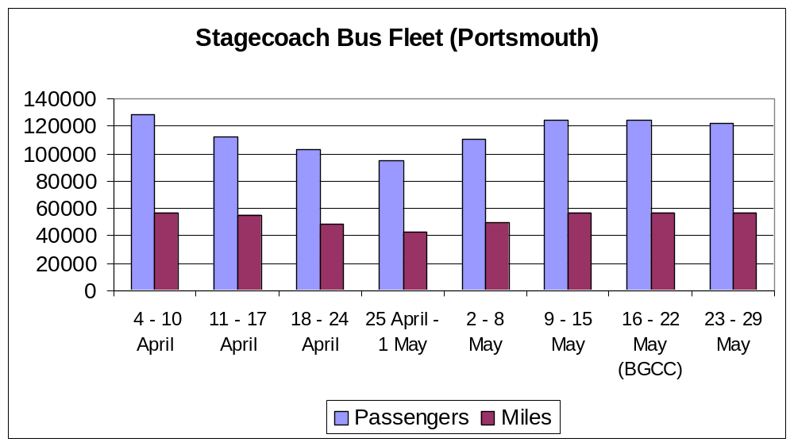  Figure 13: Bus passenger numbers and mileage for April and May 2011  Passenger numbers for First Bus also showed no noticeable change; 125,880 (9 – 15 May) 124,550 (16 – 22 May). During the BGCC, there was total of 38 Promotional season tickets sold (Stagecoach 18 and First Bus 20). Figure 14 shows how participants were made aware of the BGCC; ‘my employer’ was the main method followed by leaflets, PCC, word of mouth and posters.  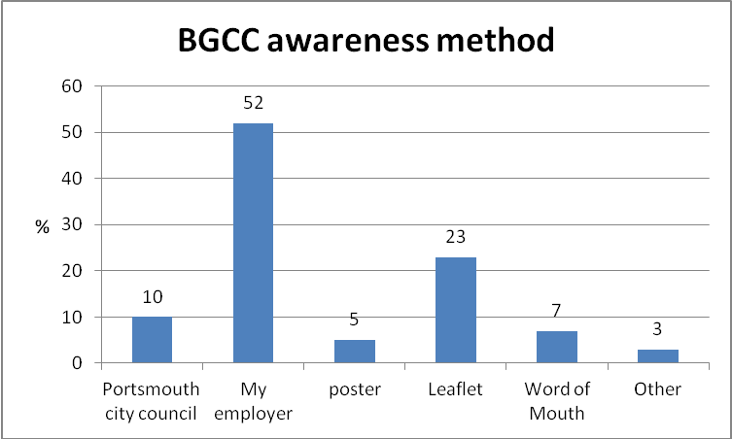  Figure 14: Awareness publicity statistics for BGCC 2011.  Possible success factors:  - An increase in the number of organizations participating (as well as employees)  - The 48% reduction in CO₂ emissions per mile  - The 20% reduction in NOx emissions per mile  - The modal shift towards more sustainable modes of transport (18% increase in bus travel, 6% increase in car share and 6% increase in train travel).  Difficulties encountered:  - The mileage recorded by participants in the survey is self reported and cannot be independently verified.  - The scheme requires voluntary participation.  - Companies without travel plans can be difficult to encourage to participate.
   | Before event 2011 | During event 2011 | During event 2010
  No. of Miles Travelled (All Modes) | 65,574 | 96,904 | 78,510
  No of Participants | 928 | 1,208* | 1,195
  No of Organisations | 34 | 37 | 34
  CO₂ emissions (kg) | 11,800 | 9,027 | 12,000
  NO_{x} emissions (kg) | 73 | 83 | 119
  CO₂ emissions (kg) / passenger | 12.7 | 7.5 | 10.0
  NO_{x} emissions (kg) / passenger | 0.070 | 0.065 | 0.100
  CO₂ emissions (kg) / mile | 0.180 | 0.098 | 0.150
  NO_{x} emissions (kg) / mile | 0.0011 | 0.00086 | 0.0015
  % of work and business based trips. | Census 2001 | Before 2011 event | During 2011 event | 2010 event
  Walk | 15 | 4 | 5 | 6
  Cycle | 7 | 21 | 21 | 16
  Car or Van | 50 | 37 | - | -
  Car Share | 7 | 12 | 20 | 17
  Bus | 9 | 4 | 22 | 29
  Train | 2 | 16 | 22 | 21
  Ferry | - | 2 | 3 | 2
  Motorbike | 1 | 2 | 3 | 3
  Work from home | 7 | 1 | 3 | 5
  Others | 1 | 1 | 1 | 1
8 Lessons learnt from the best practice | To improve the accuracy of the recorded mileage, origin and destination postcodes could be entered so that more accurate distances can be calculated. Participants need to be encouraged to fill in their mileage for a typical week and the BGCC week so that the evaluation can be as complete as possible.  The on-line ‘Survey Monkey’ questionnaire could be set up to ensure that all data fields are completed by participants before submission.  Other measures need to be implemented in order to facilitate modal shift and achieve more substantial CO₂ emissions. In the AQAP, these include the introduction of a daily Park and Ride bus service, road pricing and stricter parking controls. More innovative measures to reduce NOx such as special road paint or a catalytic cement road surface which can absorb some of the noxious gases from vehicle exhausts could also be implemented (PCC, 2010).  Attention needs to be given to the best way of locking in the CO₂ savings after the event to avoid road capacity freed up being utilised by other travellers.  Financial cuts required a cost effective approach in promoting and publicising the event.  PCC were primarily concerned about reductions in NOx (which can have effects on people’s health) as a result of the AQMA’s than reductions In CO₂ (which have longer term climate change effects).  The demographic, geographical and transport characteristics of Portsmouth encourage commuters to use more sustainable modes of travel. With the highest population density, located on an island and with a higher proportion of households not owning a car (see Figure A6 in Appendix 1), sustainable transport initiatives have the potential to have a greater impact in Portsmouth than other similar size cities in the UK.  Copies of the presentations made at our workshop regarding best practice in this area are available on the CURE, University of Portsmouth website (See http://www.port.ac.uk/departments/academic/architecture/CURe/2010/tracit)
9 Contact information | Contact person: Catherine Teeling, CURe, University of Portsmouth  Tel: +44 02392 84 2098 & +44 02392 84 2083, Email:tracit@port.ac.uk, Website: www.port.ac.uk/architecture/research/cure, www.tracit.org.uk
10 Other possible interesting information | Department of Energy and Climate Change, (2009). http://www.dft.gov.uk/pgr/statistics.  Department of Energy and Climate Change, (2009). http://www.dft.gov.uk/pgr/statistics.  Department for Transport (2008) The essential guide to travel planning. http://www2.dft.gov.uk/pgr/sustainable/travelplans/work/essentialguide.pdf  Portsmouth City Council. The Big Green Commuter Challenge 2011. http://www.portsmouth.gov.uk/commuterchallenge/index.html.\  Portsmouth City Council (2008). The second local transport plan for Portsmouth, 2006/07 to 2010/11: 2008 progress report. http://www.portsmouth.gov.uk/media/Portsmouth_LTP_Progress_Report_Dec_2008.pdf  Portsmouth City Council (2010). Draft air quality action plan. http://www.portsmouth.gov.uk/media/cab20100628r2appB.pdf  Department for Environment, Food and Rural Affairs (2007). Guidelines to Defra's GHG conversion factors for company reporting: Annexes updated June 2007. http://archive.defra.gov.uk/environment/business/reporting/pdf/conversion-factors.pdf
11. Best practice transferred | Best practice from the BGCC has been transferred to PCC by the production of a bespoke spreadsheet template to calculate transport carbon intensity impacts directly from the survey data. This spreadsheet was also used by Havant, Fareham and Gosport District Councils which provided a much more accurate way of calculating the emission savings from the scheme. The Travel Plan Officer (Amanda Morris) at PCC spoke about the BGCC at our first workshop where the concept was disseminated to our 89 attendees.  The BGCC was a measure contained within the Second Local Transport Plan 2008 to help achieve a number of targets within travel planning such as increasing the number of workplace and school travel plans as well as reducing the proportion of journeys made by car to primary and secondary schools. The scheme has also influenced policies to reduce air pollution within the city outlined in the Draft Air Quality Action Plan (PCC, 2010). The plan outlines softer measures such as raising public awareness, encouraging active and sustainable travel. It is believed that the BGCC could be a specific measure outlined in this plan following its successful implementation and evaluation in 2011. It therefore contributes to PCC obligations outlined in the Environment Act (1995), Road Reduction Act (1998) and the Transport Act (2000).

Land use transport interaction (LUTI) modelling

1 Title of the pilot study | LUTI Modelling: Capturing economic and emissions impacts.
2 Precise theme/ issue tackled by the practice | Evaluating the carbon emissions and more fully capturing the economic impacts of various transport and land use interventions to better inform decision makers.
3 Objectives of the best practice | To explore through consultation with experts, the literature and through a case study, the potential of Land Use Transport Interaction (LUTI) models to better estimate the carbon emissions and economic impacts that are likely to occur as a result of changes to the transport system (improved infrastructure and public transport services) and changes to land use resulting from planning. Having better knowledge of these impacts will enhance the decision making process as to which schemes should be funded.
4 Location | South Hampshire, UK
5 Detailed description of the best practice | Origin:  Transport models are required to predict future traffic levels, test the impact of new roads, railways, policies etcetera and to determine what transport effects will occur if particular spatial development plans come to fruition. In some circumstances such a transport model might also be used by private developers to determine the impacts of a specific large development.  Transport models tend to be regional in size, ranging from one city at the smaller end, to a whole country at the other. Transport models have usually followed a traditional four stage transport model process. This process assumes that land use causes transport; that where particular things are built determines transport flows. These models serve their purpose well in determining the transport impacts of different schemes; however they are not able to model the more complex associations between land use and transport that is thought to exist in reality. In conventional transport models, the land uses are assumed to be fixed, partially due to the difficulties in modelling changes in land uses and gathering the data required to do so, but also in part because the exact mechanism by which the two interact is still debated. In conventional models this means that improvements to the transport system enabling faster travel are assumed to result in changes in the number of trips, the destinations and routes for each origin. Or, the same trips are made, but more quickly creating travel time savings to the traveller. However, research has shown that the time spent travelling remains fairly constant as a result of improvements to the transport network, thus the result of these improvements is increased mobility. People are able to travel further to access the goods and services they require, at a price they are willing to pay. The greater choice of goods and services available to the traveller can be said to reduce local monopolies and hence drive down costs. How in the medium to long term, businesses and markets respond to such changes in travel times and mobilities is less well understood and difficult to capture in a conventional transport model. It is highly plausible for example that business respond to the increased mobility by agglomeration (for example the growth in out of town retail parks) which in turn would have a considerable impact on travel behaviours. In perfect, unregulated markets, such changes would be relatively straight forward to capture. The relationship is further complicated however by the imperfect nature of land use markets as land use is heavily regulated by policy through planning.  LUTI models try to capture this more complex relationship between land use and transport and in so doing produce a number of different outputs that are of interest. They can model for example the impacts on property prices, industrial competitiveness, migration, etcetera as a result of both particular land use plans and changes to the transport system. They can be used to predict the economic impacts of not only transport schemes but also land use plans in more detail. LUTI modelling has been developed over the last thirty years or so, primarily in the UK but with notable examples elsewhere. The focus of this development has been by industry although examples exist of LUTI modelling or land use transport modelling with land market enhancements to test the sustainability or emissions impacts of different development and transport scenarios such as Cooper et al (2001) and Cooper and Smyth (2001) although the empirical evidence underpinning such models is less well clear, either in the case of the UK or indeed elsewhere in the world (Adhvaryu, 2010). Examples of studies where LUTI models have been used to test future carbon emissions from transport include the Scottish Carbon Footprint project which predicted that compared to 2007, by 2021 emissions from road transport will be approximately 10% higher. Having detailed simulation models that are able to estimate emissions in the future and what influence policy will have on future levels is obviously of critical importance. However examples where such LUTI models have been fully utilised to determine transport carbon intensity measures for new schemes remain extremely rare. This in part is likely to be due to the additional considerable cost involved with developing a LUTI model as opposed to a more conventional transport model and the fact that there is currently no requirement for modellers to consider the issues discussed here in their appraisal of proposed transport schemes. Current guidance on how to appraise the various impacts of large transport schemes is described in Transport Appraisal Guidance (TAG) produced by Department for Transport (DfT). Recognising the potential for LUTI models to enhance the assessment of economic impacts of schemes, the DfT have undergone a period of consultation as to how better capture some of the economic impacts (TAG Units 3.5.14 & 2.8). These draft documents discuss amongst other things, how the following wider economic impacts of transport schemes might be assessed:  - Agglomeration Impacts,  - Output change in imperfectly competitive markets,  - Labour supply impacts,  - Move to more or less productive jobs.  It should also be possible to model the knock on effects of the above on travel behaviours and the transport system.  The DfT consultation documents recognise the potential for LUTI models to capture these along with other economic, land use and transport impacts associated not only with improved transport systems but also as a result of development planning.  One example is of a state of art LUTI model currently being developed to test real life planning, transport and other scenarios is that being developed on behalf of Transport for South Hampshire (TfSH). While it is not possible to carry out model test runs within the scope of the TraCit project, the TfSH model provides a useful example of the potential of LUTI modelling to better determine the transport carbon intensity impacts of various interventions. The model consists of the following sub-models:  - Main Demand Model,  - Local Economic Impact Model,  - Road Traffic Model,  - Public Transport Model, and  - Gateway Demand Model.  It is the interaction of the Local Economic Impact Model (LEIM) with four other models in particular that creates the enhancement when compared to a traditional four stage transport model.  The LEIM is based on the DELTA package developed by David Simmonds Consultancy. It uses outputs from the Main Demand Model in terms of transport costs to predict the impact these costs would have in terms changes in land use, migration of people and businesses, levels of employment and parking and then feeds these changes back into the Main Demand Model to determine the impact the revised land uses, employment, population and parking levels would have in terms of transport.  The LEIM models how the transport network is expected to function, how land is expected to be used, and indicate economic activity (jobs) in the South Hampshire region up until 2041 (2036 for the transport network) through :  - top-down inputs of economic and demographic scenarios for the area (which may be modified as a result of local transport and development policies); and  - bottom-up inputs of transport changes (e.g. investments in the networks) (input to the transport model) and of planning policies.” (TfSH, 2011)  Timescale:  The model build was due for completion in Spring 2011, approximately two years after the consultants were appointed.  Bodies involved / implementation:  LUTI models are not common and hence it is difficult to draw too many conclusions about a general case in terms of costs and, to a lesser extent, stakeholders. However, transport models are usually developed on behalf of Local Authorities or groups of local authorities. A smaller number of transport models might be commissioned by governments such as the Transport Model for Scotland. LUTI models are no different but perhaps work better at a slightly larger geographical scale than a more traditional transport model and hence are more likely to be commissioned by groups of local authorities or from regional planning organisations. In the past, simpler transport models were more likely to be developed in-house by local authorities, whereas now, most transport models are developed by external consultants. LUTI models are almost exclusively developed by external consultants given their relatively complex and specialised nature. Indeed LUTI models are usually developed through a collaboration of a transport modelling consultancy and a land use modelling consultancy on behalf of the client. These models once developed are then maintained, usually by the consultants, for whatever period is specified and model runs are performed usually by the consultants but in other instances the models are handed over to the clients along with suitable training to maintain and run the model as required. The TfSH model is no different in that is it commissioned by Transport for South Hampshire which is a collaboration between:  - Hampshire County Council  - Portsmouth City Council  - Southampton City Council
6 Carbon metrics used and why | A suitably specified LUTI model including the TfSH model, can produce total vehicle distances driven, journey speeds, stops, delay etcetera. Given additional information on vehicle fleet combined with information from the Vehicle Certification Agency or by using simple average emissions values for the UK fleet of vehicles, carbon emissions values can be determined for powered road transport expressed in terms of:  - Transport CO2 emissions/capita,  - Transport CO2 emissions/billion passenger kilometre.  Similarly passenger count information is available enabling similar simple calculations of the above for bus and rail transport also. Walking and cycling are not captured, and while both modes of transport produce emissions, these emissions are considered to be negligible.  Combined with the evaluations of economic impacts discussed, the further metrics can be produced:  Change in CO2 emissions/ Change in economic output.
8 Lessons learnt from the best practice | To more fully capture the economic impacts; particularly the impacts in terms of agglomeration, output change in imperfectly competitive markets, labour supply impacts, and move to more or less productive jobs, a LUTI modelling approach is advisable.  Sensitivity analyses or stochastic element could be built into future models to reflect uncertainties in some of the modelling assumptions, including assumptions on national economic growth and migration, which have proved to be inaccurate in the past.  In addition to considering the carbon emissions impacts, the modelling approach allows other noteworthy impacts of transport schemes to be estimated including:  - Other vehicle emissions including NOx, which is a particular cause for concern in the South Hampshire subregion,  - Improved diversity of choice,  - Social inequality and integration,  - Access to affordable housing.  The additional resources needed to fund the development of a LUTI model as opposed to a more conventional model, may be difficult to justify in a climate of public sector budget cuts, although the potential savings or boost to the economy resulting from funding projects based on fuller knowledge of their impacts may well offset such costs.  Copies of the presentations made at our workshop regarding best practice in this area are available on the CURE, University of Portsmouth website (See  (http://www.port.ac.uk/departments/academic/architecture/CURe/2010/tracit/)
9 Contact information | Contact person: Catherine Teeling, CURe, University of Portsmouth  Tel: +44 02392 84 2098 & +44 02392 84 2083, Email:tracit@port.ac.uk, Website: www.port.ac.uk/architecture/research/cure, www.tracit.org.uk
10 Other possible interesting information | Russo, F., Musolino, G. (2007) Urban land-use transport interaction modelling: state of the art and applications. In Urban Transport XIII, Urban Transport and the Environment in the 21st century, Brebbia C.A. (ed.), WIT Press, Southampton, pp. 525-534  Feldman, O, Nicoll, J, Simmonds, D, Sinclair, C, Skinner, A (2008): Integrated Transportation Land Use Models for Calculations of Wider Economic Benefits. Paper published in Transportation Research Record, Journal of the Transportation Research Board, No. 2076.  Transport for South Hampshire Evidence Base. (http://www3.hants.gov.uk/tfsh/tfsh-what-tfsh-does/tfsh-projects-evidence-base.htm)
11. Best practice transferred | The TraCit project has contributed to the Department for Transport consultation on The Wider Impacts Sub-Objective TAG Unit 3.5.14 (DRAFT FOR CONSULTATION, September 2009, Department for Transport).  Project partners at the Krakow University of Technology (CUT) have stated that they will endeavour to incorporate a LUTI element to the sub-regional models being developed in the Malopolska region following on from the presentations given by Professor Marcial Echenique (University of Cambridge) and David Simmonds (David Simmonds Consulting) at the TraCit workshop held in Portsmouth in November 2010 and the presentation and discussions held with Andy Dobson (David Simmonds Consulting) at the TraCit workshop hosted by Krakow University of Technology in May 2011.

Design Charrette

1 Title of the pilot study | Design Charrette Viimsi (SILCS & TraCit) Participatory Activities & Community Engagement – (Behavioural Change -engagement of stakeholders)
2 Precise theme/ issue tackled by the practice | Two Pilot studies proposed by Viimsi Municipality as part of the TraCit project – CURe brought expertise and live best practice to assist in the development of Viimsi’s pilot projects. A transfer of best practice event combining SILCS & TraCit was organised by CURe with Viimsi in Tallinn supported by SEIT. The two pilots were: 1. Development of the Promenade & 2. Transport links between Viimsi & Tallinn
3 Objectives of the best practice | An inclusive, open and engaging process to provide a comprehensive solution to complex problems. Through Charrette process as best practice; the project brief focused on the following issues:  - The improvement of the living environment of residents at Viimsi and increasing overall satisfaction by improving the overall environmental situation and by improving the quality of public transport service;  - Public transport solutions; providing various alternatives for achieving a reduction in the volume of CO₂, that is, the identification of optimum solutions in the organisation of public transport;  - Improving the quality and availability of public transport;  - Developing the road network and public transport within the Rural Municipality;  - Identification of alternative mobility options (tram, water taxi, a “park-and-ride” scheme) for maintaining a transport link to Tallinn;  - Alternative solutions, development and evaluation of the effects of the integration of the existing beach area Haabneeme Viimsi rural footpaths, bus stops and bike paths in order to reduce CO2 emissions in the region;  - Work out a mapping of existing foot trails, bike lanes and bus stops and the light traffic lane;  - Acquiring new locations to offer the best way to build;  - To improve communication between Pirita, Viimsi, Haabneeme and Tallinn in order to increase the availability of different services;  - Increase the popularity of physical activity;  - Direct population to healthier and greener activities in environment. Sports and recreational purposes, access to the sea;  - Improve road safety;  - Connect existing light traffic network ---The development of alternative solutions (at least 3) and the best solutions for preparation of draft project of the beach promenade in the integration of existing footpaths, bus stops and bike path.
4 Location | - VIIMSI Municipality & Tallinn  - Harju County  - Estonia
5 Detailed description of the best practice | - Innovative engagement process led and implemented by CURe UK  An inclusive, open and engaging process to provide comprehensive and appropriate solutions to complex problems. The Charrette process – A method of community and stakeholder engagement leading to more holistic and inclusive solutions. This process reduces conflict and planning appeals. Stakeholders develop knowledge through transfer of skills with the support of experts and they have ownership of the resultant scheme.  The event in Viimsi ran for 3 days, 11 Students from the UK and students from EAA, 3 staff (UK) & 2 from Tallinn & SEIT worked together on the Viimsi Pilot projects.  - Brief attached  - Regeneration strategy; & policy for community engagement adopted by Viimsi  - Sustainable developments presented for Viimsi  The Design Charrette was proposed as a way of demonstrating ‘Transference of Good Practice’ for the TraCit project providing support and expert knowledge transfer for Viimsi Municipality pilot studies. In addition it was considered advantageous to combine the activities of the SILCS project at this event promoting further ‘Transference of Good Practice’ whilst responding to the POWER programme’s ambition for collaboration and integration across projects in the POWER programme. – Timescale: 10.-16.04.2011  Bodies involved / implementation: the Estonian Academy of Arts, The Technical University Tallinn and the University of Portsmouth, Viimsi Municipality  Process and detailed content of the practice  Portsmouth University use this process when developing design solutions in real situations when involving their students working on a large, collaborative projects; It can consist of various forms in relation to its duration, the involvement of experts and or the community. For the Viimsi/Tallinn charrette they suggested an event that takes place over 2¹/₂ to 3 days (see proposed outline below). Portsmouth University brings staff and students with expertise in architecture, urban design, sustainable architecture, transport planning and transport technologies to work on an integrated design solutions combining Viimsi and Tallinn’s requirements for a sensitive environmental response for the coastline development and integrated transport road network and mobility modes between Viimsi and Tallinn with respect to reduced CO₂ emissions. The intensive nature of the charrette process means results are achieved quickly and the resulting design proposals would be presented to Viimsi Municipality and Tallinn City Government at the end of the charrette.  Portsmouth University proposed to collaborate with staff and students from the Estonian Academy of Arts.
6 Carbon metrics used and why | - Students presented work over 3 days which the ‘government have taken three years to achieve’ – quote by the Mayor of VIIMSI  - Mayor has asked CURe to present a report on this project, which has influenced the strategic plans for the development of the promenade.  VIIMSI & CURe are preparing to work together on further development of this project, a meeting is scheduled for the end of July 2011 in order to drive the SILCS project further within this region.  From our TraCIt Partners: ‘The TraCit Charrette provided an innovative solution for the TraCit project partners, and Viimsi Municipality in particular to fulfil one output required of the TraCit project and could be considered as an example of best practice in partner collaboration within the POWER programme. Design Charrette involved 63 participants; Design Charrette was a good example of transference of good practice from one partner region to another as well as it is good example of fruitful cross-border co-operation.’
7  Evaluation | Regionally – Inclusivity, community and stakeholder engagement.  How to execute successful Behavioural Change activity.  The teams analysed and evaluated these issues and worked together to find integrated design solutions combining Viimsi requirements for a sensitive environmental response for the coastline development incorporating leisure facilities and integrated sustainable transport links, road network and mobility modes between Viimsi and Tallinn with respect to reduced CO₂ emissions.
8 Lessons learnt from the best practice | - Catherine.teeling@port.ac.uk &  SILCS@port.ac.uk  - www.silcs.net
9 Contact information | - Presentation by CT at the Viimsi workshop. Many of the presentations at the CURe workshop cover some form of community engagement and participatory activities  This intensive, multi-disciplinary design workshop was designed to facilitate open discussion between collaborative student teams supported by academic and practice experts (staff and students with expertise in architecture, urban design, sustainable architecture, transport planning and transport technologies). The teams analysed and evaluated these issues and worked together to find integrated design solutions combining Viimsi requirements for a sensitive environmental response for the coastline development incorporating leisure facilities and integrated sustainable transport links, road network and mobility modes between Viimsi and Tallinn with respect to reduced CO2 emissions. The intensive nature of the charrette process means results are achieved quickly, it was expected that the design solutions were result in a clear, detailed, realistic vision for future and the resulting design proposals were presented to Viimsi Municipality and Tallinn City Government at the end of the charrette.  Materials are uploaded to the power programme website www.powerprogramme.eu
10 Other possible interesting information | Charrette process to the VIIMSI Municipality Estonia – Enabling Behavioural Change  The SILCS/TraCit project Design Charrette demonstrated ‘Transference of Good Practice’ for the TraCit project providing support and expert knowledge transfer for Viimsi Municipalities pilot studies.

CUT Pilot Studies

Promotional Tram event

1 Title of the pilot study | Public transport promotional campaign in “Green Tram” in Krakow
2 Precise theme/ issue tackled by the practice | The public transport promotional campaign “Green Tram” in Krakow was organised as a form of promotion of public transport modes among Krakow’s inhabitants. It had also an educational purpose: awareness raising and provision of information about transport CO₂ emissions.
3 Objectives of the best practice | - Change of perception and acceptance of sustainable mobility options among Krakow’s inhabitants.  - Promotion of public transport as a transport mode that emits less pollutants and CO₂ than private cars.  - Raise awareness among Krakow’s inhabitants concerning CO₂ transport emissions, their negative influence and the possibility of their reduction.  - Raise awareness among Krakow’s inhabitants concerning the POWER programme and TraCit project.
4 Location | Poland, Malopolska Region, City of Krakow
5 Detailed description of the best practice | Origin:  The city of Krakow is located in the southern part of Poland and has about 750 000 inhabitants. The share of public transport modes (buses and trams) in non–pedestrian journeys in the city is approximately 60%. However, the car ownership rate is systematically increasing, especially among young people, resulting in increased private car trips and traffic jams on the streets. In Krakow, there is a need to keep the current public transport users as well as attract new bus and tram travellers. An important issue is raising awareness among the city’s inhabitants about the negative impact of transport CO₂ emissions as well as the necessity of and ways towards their reduction.  Timescale:  Planning, Publicity and Co-ordination – October 2010 to December 2010  Spreadsheet analysis, Questionnaire design and Data analysis – November 2010 – January 2011.  Bodies involved / implementation:  Krakow University of Technology  Supporting company:  Miejskie Przedsiębiorstwo Komunikacyjne S.A. (public transport operator in Krakow) – informational and promotional activities, tram rental.  Process and detailed content of the practice:  The public transport promotional campaign was organised by the TraCit team at Krakow University of Technology – employees of the Chair of Transportation Systems. Strong support for the action was provided by MPK S.A.; a public transport operator in Krakow.  The action was carried out on 10th December 2010 on board one of the city’s trams. The tram ran around the city for about 6 hours (including the afternoon peak period) on route no.19. This line was chosen on purpose as it provided a connection between the city centre and the most densely populated areas of Krakow, as well as serving stops in the area of Krakow University of Technology.  The event was conducted on an “old timer” tram. The vehicle had green & yellow colours so the whole event was called: the “Green tram” Promotional campaign. The other meaning of this slogan was related to green as a symbol of ecology – so the “Green tram” was the epitome of a pro-ecological transport mode that emits less CO₂ than private cars.  Figure 15. “Green tram” on the Krakow street.  The ride was free of charge for all inhabitants of Krakow. Passengers travelling by tram were informed about the disadvantageous impact of CO₂ emissions on climate and could learn about the ways of reducing transport CO₂ emissions.  The tram journey was accompanied by music; songs concerned the sustainable mobility theme – public transport, bikes or walking trips. Participants in the event received free items such as balloons or sweets and calendars with data related to sustainable mobility, CO₂ emissions from transport, their negative influence and the possibility of their reduction.  Figure 16. Passengers are informed about CO₂ emissions by the “master of ceremonies”.  In order to increase participation by Krakow’s inhabitants, special posters with information about CO₂ emissions were placed in the tram windows. Everybody who was waiting at public transport stops could see the posters and learn about the action and its aims. The posters were two-sided, so passengers had the opportunity to read the information located inside the tram and learn a lot of facts concerning sustainable transport, safety and the security aspects of public transport trips.  Moreover, during the campaign a short competition with prizes was organised. Everybody who filled in a questionnaire took a part in the competition (see Appendix 2). The form included two questions about CO₂ emissions from transport. Three people gave the correct answers and received special prizes such as picture albums about Krakow trams.  In order to obtain data about the current awareness of the city’s inhabitants about transport CO₂ emissions, a questionnaire survey was carried out. It also included an evaluation of the campaign.  Figure 17. An inquiry carried out among passengers.  The whole event was publicised among city residents in the mass media (local radio, city newspapers, BUS TV – a form of advertising in trams and buses) and through informational posters placed in the area of Krakow University of Technology.  Legal Framework:  Implementation of soft measures such as the organisation of promotional and educational public transport campaigns were included in the regulations of “Krakow Transport Policy” established in 2007 as a way of achieving policy purposes.  Financial framework:  Possible costs of the whole event together with earlier informational activities included expenses related to:  - tram rental  - sound system rental  - advertising, e.g., in local newspapers, TV or radio  - preparation and printing of posters, leaflets, questionnaire forms  - preparation of appearance and workmanship of promotional items  - purchase of prizes for the winners of competitions  - alternatively, the cost of subcontracting the carrying out of questionnaire research  The cost of running the tram event in Krakow was 2,000 Euros.
6 Carbon metrics used and why | In order to evaluate the amount of CO₂ saved during the campaign, respondents who filled in questionnaires were asked:  • Whether the information about the campaign had contributed to their decision not to use the car today and choose the tram instead?  • Whether the respondents chose to use the tram despite the fact they had the opportunity to travel by car, even if they hadn’t heard about this event previously?  Respondents were also asked to provide the estimated travel distance or the location of their origin and destination journey points that would have been travelled by car.  During the process calculating the CO₂ saved, a special CO₂ calculator created by Aeris Futuro Foundation (http://www.aeris.eko.org.pl/projekty/kalkulator/kalkulator-co2) was used.  The calculation was done in the following way:  - Assessment of all kilometres which would have been made by car by respondents who could have used a car but took the tram instead  - Assessment of the CO₂ that would be emitted as a result of car journeys  - Assessment of the CO₂ that was emitted as a result of tram journeys made by respondents instead of car trips.  The following values of CO₂ (kg) emitted per km of journey were used for individual transport modes:  Car – 0.17 kg/km  Tram – 0.02 kg/km  By subtracting the amount of CO₂ emitted by the realization of tram trips from the amount of CO₂ that would have been emitted by car trips, the value saved was approximately 42 kg of CO₂ (the value of CO₂ saved was calculated only for passengers who filled the inquiry and admitted that they resigned from car in that day when campaign was organised). This resulted in an average of 1.75kg per capita saved as a result of the event (based on 24 respondents who stated that they travelled by tram instead of car for this event).  If all those respondents who travelled by tram for the event instead of by car would continue this travel behaviour in the future, the amount of CO₂ saved per year by all these people would be over 10.5 tonnes (taking into consideration only working days). It should be emphasized that the amount of CO₂ saved is based only on data from the surveys – it could be the case that this amount is much bigger.
7 Evaluation | The following indicators can be used to evaluate the marketing action in public transport vehicle:  - number of participants (passengers)  - number of people with increased awareness about transport CO₂ emissions  - number of questionnaires completed  - number of people who left the car at home and travelled instead by public transport due to the event.  In the Krakow promotional campaign approximately 1,300 city inhabitants took part in the whole event. The awareness of transport CO₂ emissions was raised to the same extent at least among these 1,300 travellers. 120 interviews were carried out among city residents concerning their awareness of transport CO₂ emissions. 14% of people who filled in questionnaire forms admitted that they left their cars at home and had travelled by tram that day because of the event organisation.  It could be expected that in a city with similar public transport conditions and much the same number of inhabitants, similar results could be achieved.  Difficulties encountered:  The Krakow promotional tram campaign was organised in December. Because of unexpectedly large snowfalls on the day before the due date of the event, which resulted in paralysis of the urban public transport system, the date of the campaign had to be shifted to the following week. This caused some informational misunderstandings. Because of this, it is suggested to organise similar events in more friendly weather conditions, in the spring-summer-autumn period.
8 Lessons learnt from the best practice | Information before organisation of the event is a very important issue – use as many sources of information as possible to publicise the campaign among city inhabitants.  Freebies can attract many participants – they are a type of publicity and provide information.  Organisation of attractions like competitions can support active participation of respondents and increase the effectiveness of the surveys.  Music makes the event more attractive, whilst the informational and promotional elements like posters on windows make it more visible.  People more gladly take part in questionnaire research when they are asked by the pollsters and do not need to fill in the questionnaire form themselves (there were no suitable places to fill in the questionnaire on board the tram, with many having to stand).  Organising this kind of campaign can provide a great opportunity to promote transport modes which emit less CO₂ than private vehicles as well as raise the awareness about other similar issues.
9 Contact information | Contact person: Krakow University of Technology, Chair of Transportation Systems, Katarzyna Nosal, tracit@aries.one.pl, www.ksk.pk.edu.pl.
10 Other possible interesting information | Presentation “TraCit Green Tram”, questionnaire form. All materials available at www.tracit.org.uk

Promotional 'Bike happening' event

1 Title of the pilot study | Bike Happening at Krakow University of Technology and research concerning people’s willingness to change to cycling as a mode of transport.
2 Precise theme/ issue tackled by the practice | The Bike Happening was organised as a form of promotion of cycling among employees and students of the University. The second important issue tackled by the event concerned raising awareness of transport CO₂ emissions and ways of reducing them. Research via questionnaires was carried out during the happening in order to gain knowledge of people’s readiness to change their present mode of transport to cycling.
3 Objectives of the best practice | - Change of perception of the bicycle among employees and students of the University and promoting it as a modern and environmentally friendly mobility option  - Raise awareness among employees and students of the University concerning transport CO₂ emissions, their negative influence and the possibility of their reduction,  - Raise awareness among employees and students of the University concerning the POWER programme and TraCit project,  - Learning more about those factors that could influence changing one’s present transport mode to cycling.
4 Location | Poland, Malopolska Region, City of Krakow, Krakow University of Technology
5 Detailed description of the best practice | Origin:  Krakow University of Technology is one of the most important technical universities in Poland. The institution employs over 2,000 staff and educates approximately 18,000 students every year. The university campuses are located in different city districts and the largest one, Warszawska St. Campus, is situated in the city centre. Travel to and from home and work by the academic community generates a considerable amount of car traffic. The University Authorities thus have, for several years, focused on activities aimed at decreasing car journeys and increasing the share of public transport, cycling and walking.  As a form of promotion for cycling, the University has already organised two bike happenings (in 2007 and 2008) within the framework of the integrated mobility plan implemented for the institution within the CIVITAS CARAVEL project (2005-2009). The happening carried out under the TraCit project continued this type of event, which had been very popular among students and employees. Additionally, it had a greater importance than previous events in that it focused not only on the promotion of bikes but also on the distribution of information about transport CO₂ emissions and the necessity to reduce them.  Timescale:  Planning, Publicity and Co-ordination – March 2011 to May 2011  Spreadsheet analysis, Questionnaire design and Data analysis – April 2011 – June 2011.  Bodies involved / implementation:  Krakow University of Technology  Supporting companies:  Kraków Miastem Rowerów (bike related organization) – informational and promotional activities, participation in debate  Bike One, the city bike rental operator – promotional activities, free tickets for participants and winners in competitions  TWR - free of charge maintenance point to repair bikes  Krakow Police – marking bikes to protect them from theft  Process and detailed content of the practice:  The TraCit Bike Happening was organised on 25th of May 2011 (9.00 a.m – 1.00 p.m) in close cooperation with bike related organisations in Krakow as well as BikeOne, the operator of the city bike rental scheme in Krakow.  The Bike Happening was preceded by many preparatory activities such as:  - activities concerning the preparation of promotional items – public tender, choice of item supplier, item appearance details etc.,  - organising the location of the happening – proceedings related to rental of the stage and sound system etc.,  - contact with entities connected with the Bike Happening (Bike related organisations in Krakow, the city bike rental operator, University Units), agreeing cooperation details,  - contact with the press officer, editor of the University Newspaper and the University Photographer, and discussion with them about the promotion of the Bike Happening,  - preparation of the Bike Happening plan; preparation of competitions and related attractions,  - printing up posters with information about the Bike Happening and sticking them up in locations in Krakow as well as at all University campuses,  - printing leaflets and questionnaire forms for participants in the Happening, preparation of deposit box for questionnaires.  In order to ensure a large number of participants the following information channels were used:  - posters in the area of the University  - local newspapers  - information on city bike related websites  - e-mail information and invitations sent to employees and students who had contact and/or classes with the event organisers.  The location of the Happening was the main courtyard of the University – well known to all employees and students as the main place for meetings. The whole event was highly visible (the TraCit tent was placed in the courtyard) and because of energetic bike related music, everybody could hear what was going on. A special stage was erected for the master of ceremonies, for competition participants and others involved in the event. The ceremonial opening of the Happening was performed by the University Rector. Participants in the Happening could make use of a free of charge maintenance point to repair their bikes and the police were marking bikes to protect them from theft.  The event was accompanied by many attractions:  - promotion of city bike rental by BikeOne – the operator provided free one-week tickets for participants in the Happening.  - short competitions: question & answer - in order to check basic knowledge about bike travel and infrastructure in the city. All prizes were related to bike travel, e.g: bells, water bottles.  - competition: “Two wheels are better than four” - everybody who showed a meter or indicated their trip origin and transport mode gained information on how much CO₂ was saved (calculation of distance). The prize was a 3-week ticket for city bike rental in Krakow.  - competition “Pimp my bike” – the most original bike. Prize: a one-week ticket for city bike rental in Krakow.  - competition “The most elegant cyclist” (boy and girl) – original, unusual, interestingly dressed cyclists. Prize: photo session in the University newspaper.  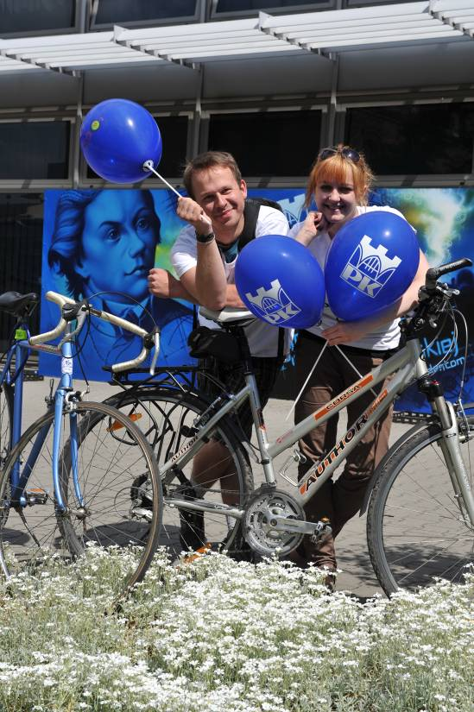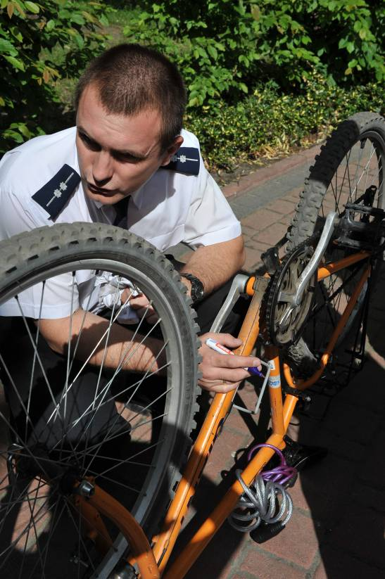  Figure 18. The winners of the “the most elegant cyclist” competition and the Police anti-theft bike marking.  A debate was also held: “Is Krakow a bike friendly city – how much CO₂ can be saved by cycling?” During the discussion every participant could say something about cycling in the city and share his/her experience.  Participants received items such as stickers with the notice: “Krakow University of Technology – a University of cyclists”, fluorescent visibility bands and balloons.  Figure 19: One of the cyclists telling a story about his bike.  The research questionnaire on readiness to change your current transport mode to cycling was carried out among participants. The questionnaire also contained an evaluation of the happening. Everybody who filled in the questionnaire and put it in a special box got a T-shirt with the slogan: “Two wheels are better than four”. At first, only 300 questionnaire forms were printed, but interest was so great that it was necessary to print more forms. In total 419 questionnaire forms were filled by participants.  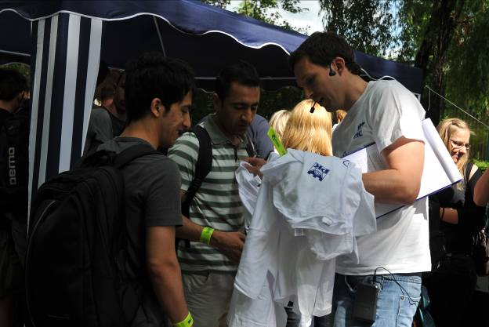  Figure 20. Participants received bike related items.  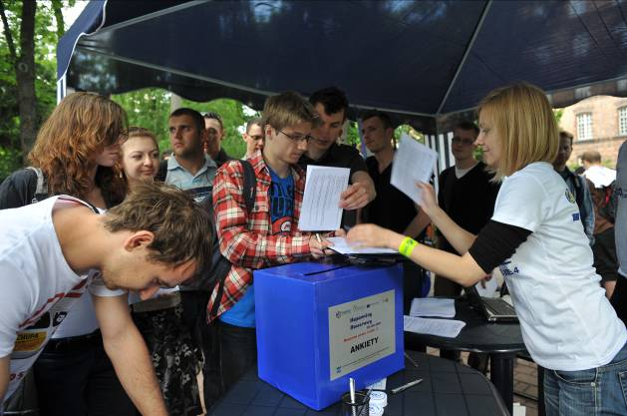  Figure 21 Participants filling in questionnaire forms.  Willingness to change current transport mode to cycling and the factors influencing this change were very important issues for the happening’s organisers, and thus participants were asked how often they travelled by bike (almost every day, often or occasionally), what factors encouraged them to cycle every day or often, what were the reasons for occasional bike travel? They also provided information on which factors could encourage them to change their usual transport mode and travel by bike. The questionnaire form used during the Bike Happening is included with the TraCit Advice Guide in Appendix 3. Results from the questionnaire research are presented in Table 8.  Similar questionnaire research was carried out within the framework of the TraCit project during the Transport Conference “Problems in cities in conditions of increased traffic congestion” on 15 -17th of June 2011 in Poznan, and among students of the Architecture Faculty of Krakow University of Technology on 16th June 2011 (in total 73 questionnaire forms). The intention of the research was to carry out an inquiry among transport and land use professionals from different Polish cities (transport engineers, planners, local authority officers, decision makers as well as academics and students of technical universities) and compare the results with those achieved during the Bike Happening. The questionnaire form included more questions than those carried out among participants of the Happening. It also focused on conditions related to bike travel such as: infrastructure, safety and security aspects, weather conditions, etc. The questionnaire carried out among transport and land use professionals is included with the TraCit Advice Guide in Appendix 4.  * There was the possibility to choose more than one answer; results were normalised to 100%.  As presented in the above table, the main reasons for Bike Happening participants travelling by bike daily or frequently are: low cost of bike journey and concern about their health and independence from traffic jams. This is not surprising when taking into account the status of the participants. Most of them (75% of respondents) are students who do not usually have a large amount of money and for whom cycling is the cheapest mode of transport. They are also likely to take care of their health and fitness. For the experts (most often working people) the main reasons for regular bike travel are: time savings, independence from traffic jams and also concerns about health. They don’t usually have problems with money but the important issues for them are speed, independence from traffic jams and quick access to destination places allowing them to save time.  The most important reasons for occasional bike travel are: for bike participants - too great a distance between origin and destination points, heavy car traffic flows and fear of bike theft; for experts – the lack of the possibility to take a shower at the destination point, too great a distance between origin and destination points and the lack of the possibility to park the bike safely at the destination point. As mentioned above, the experts are mostly working people, usually having meetings with clients, associates, etc., thus the need for taking a shower after a bike journey is understandable, while the happening participants (more often students) are concerned about losing their means of cheap mobility. So the provision of secured bike racks in every place possible, the development of bike paths separated from streets with large traffic flows and the creation of showers in work places could result in an increasing share in bike trips. A good solution could also be the development of Bike & Ride systems to reduce the distance travelled by bike between origin and destination points. Other activities which are also necessary to implement in order to encourage users to change current transport modes to bikes are the following: development of a good density of cycle paths, a continuous cycle path system and enforcing lower car traffic flows on streets with bikes.  More results and final conclusions from both questionnaires are presented in the special report “Factors influencing readiness to change transport mode to bicycles in Polish conditions”, which is available on the TraCit website.  Legal Framework:  Implementation of soft measures such as promotional and educational bike happenings was included in the regulations of “Krakow Transport Policy” established in 2007 as a way to achieve policy aims. The University Authorities present a very friendly attitude towards the organisation of this kind of event for employees and students, and declare a readiness to promote pro-ecological transport modes. With regards to event implementation there is no need to comply with special legal regulations apart from those resulting from public tender (in the case when a public entity is the happening organiser).  Financial framework:  Possible costs of the whole bike happening together with earlier informational activities can include expenses related to:  - stage rental  - sound system rental  - advertising e.g. in local newspapers, TV or radio  - preparation and printing the posters, leaflets, questionnaire forms  - preparation of appearance and workmanship of gadgets  - purchase of prizes for the winners of competitions  - alternatively, the cost of subcontracting the questionnaire research  The cost of bike happening at Krakow University of Technology was 5,500 Euro.
  Table 8: Selected results of inquiry research carried out among Bike Happening participants and among experts.
  Questions | Answers | Inquiry among Bike Happening participants | Inquiry among experts
  Reasons for daily or frequent bike travel  (only people who travel by bike daily or frequently gave answers) | Lack of car | 9% | 12%
   | Risk of car theft or car damage | 1% | 0%
   | Lack of car parking places | 7% | 7%
   | Low cost of bike journey | 19% | 2%
   | Time of journey saving | 12% | 21%
   | Independence from traffic jams | 16% | 17%
   | Bike path network | 7% | 12%
   | Possibility to carry the bike on public transport | 2% | 0%
   | Low quality of public transport | 2% | 5%
   | Care about the environment and climate change e.g. care about reduction of CO2 emissions | 8% | 10%
   | Care about health | 18% | 14%
   | In sum | 100% * | 100% *
  Reasons for not travelling by bike or only occasionally  (only people who travel by bike occasionally or not at all gave answers) | Attachment to car travel | 7% | 9%
   | Lack of bike | 7% | 9%
   | Lack of possibility to store the bike at home | 11% | 5%
   | Too great a distance between origin and destination points | 14% | 14%
   | Lack of access to bike paths | 9% | 9%
   | High volume of car traffic | 13% | 9%
   | Lack of possibility to park the bike at destination point | 6% | 11%
   | Lack of possibility to take a shower at destination point | 8% | 16%
   | Good public transport service | 8% | 4%
   | Fear of accident | 3% | 5%
   | Fear of bike theft | 12% | 9%
   | In sum | 100% * | 100% *
  Factors that would encourage changing the present transport mode to cycling  (only people who travel by bike occasionally or not at all gave answers) | Possibility to rent a bike | 18% | 14%
   | Access to good bike path network | 31% | 31%
   | High number of secure bike racks at destination point | 19% | 19%
   | Lower car traffic flows on streets with bikes | 21% | 14%
   | Possibility to take a shower at destination point | 11% | 23%
   | In sum | 100% * | 100% *
6 Carbon metrics used and why | In order to evaluate the amount CO₂ saved during the Bike Happening, participants who filled in questionnaires were asked:  - what mode of transport did they use “yesterday” when travelling to the University?  - whether information about the happening had contributed to the decision to leave the car that day and travel by bike instead?  They were also asked to provide an estimated travel distance or point of departure of their journey that was made by bike to the University.  During the process of calculation of the CO₂ saved, a special CO₂ calculator made by Aeris Futuro Foundation (http://www.aeris.eko.org.pl/projekty/kalkulator/kalkulator-co2) was used.  The calculation was made in the following way:  - checking what modes of transport were used by Happening bikers “yesterday”,  - assessment of all kilometres per individual transport mode travelled “yesterday” by Happening bikers,  - assessment of CO₂ emitted “yesterday” by Happening bikers as a result of using individual transport mode.  The following values of CO₂ kg emitted per km of journey were used for individual transport modes:  Car – 0.17 kg/km  Bus – 0.04 kg/km (off peak hours); 0,01kg/km(peak hours)  Tram – 0.02 kg/km  Long distance bus - 0.01kg/km  Train – 0.02 kg/km  Motorcycle – 0.13 kg/km  Happening bikers (only respondents who filled the questionnaire forms) emitted 47kg of CO₂ “yesterday” as a result of travelling by different transport modes, so it could be evaluated that, because of the Bike Happening, they saved approx. the same value of CO₂ on the day of the event. This resulted in an average of 0.25kg per capita saved as a result of the event (based on 188 respondents who stated that they travelled by bike instead of car for this event).  If all respondents who used bikes during the Happening changed their current mobility modes and cycled to the University in the future during the cycling season (April-June, October-November), the overall amount of CO₂ saved per season by all these people could be as much as 5 tonnes of CO₂.
7 Evaluation | Possible success factor:  The following indicators can be used to evaluate the bike happenings:  • Number of participants.  • Number of people with increased awareness of transport CO₂ emissions.  • Number of questionnaires completed.  • Number of people who left their car at home and travelled by public transport because of the Happening.  Over 500 participants took part in the Bike Happening at the Krakow University of Technology and 419 of the above-mentioned questionnaires about readiness to change transport mode were carried out. 24% of respondents stated that they didn’t use their car and travelled by bike that day because of the event. It could be expected that in an institution, e.g. university, with much the same number of students and employees, similar results could be achieved.
8 Lessons learnt from the best practice | • Information prior to the organisation of a bike happening is very important – use as many sources of information as possible to publicise the event among the target group.  • It is essential to invite people from cycling related organisations who have considerable knowledge about bike travel in the city. These people can give practical tips and can in various aspects of the event.  • When giving information about CO₂ emissions (trying to raise the knowledge and awareness of the target group), it is important to talk about the CO₂ emissions from cars and indicate concrete values. This needs to be repeated from time to time in order to ensure a higher number of people remember what was said.  • Giving practical information about the possible results of climate change (e.g.: glaciers melting, increasing downpours, floods and windstorms as well as no skiing, no snow, extremely high temperatures, bad conditions to go on holiday, and even to live, as a result of climate changes in the future) is very helpful because it shows practical effects that can effect the life of every citizen.  • Promotional items can attract many participants as well as increase the effectiveness of the questionnaire survey (sometimes, if you want to participants to give information, you have to give something in return).  • The questionnaire form used for research carried out during such events has to be short, at most 2 pages, because of the risk of unanswered questions or obtaining ill-considered answers made ad hoc by respondents.  • Organising a lot of activities such as competitions or debates where everybody can say something based on his/her experience can attract people who are recipients of this information.  • Simple competitions with a few questions concerning basic knowledge about bikes in the city, (e.g. the approximate number of km of bike paths), raise the knowledge of all participants. Prizes in competitions should be related to bikes and cycling (e.g. water bottle or bell).  • A very good idea is to organize a free bike maintenance point and protective anti-theft bike marking by the police; usually people have little opportunity or time to do it themselves. During the event, these features draw many people. For companies that produce bike maintenance accessories, it forms part of their promotion.  • Music makes the event more attractive, while the informational and promotional elements like posters, banners and tents make it more visible. Both elements attract people passing by, making the event more noticeable in the neighbourhood.  • Organizing bike happenings could be a great occasion to promote transport modes that emit less CO₂ than private vehicles as well as raise awareness about this issue.  • Distribution of questionnaires during events provides useful data related to bike travel as well as a great opportunity to raise the awareness of important questions.  • In a country like Poland that still has a small share of bike journeys and poor quality bike infrastructure, the key factors which could encourage the change of transport mode to cycling are:  • development of good density, continuous bike path systems,  • development of bike paths separated from streets with busy traffic flows,  • the provision of secured bike racks in every place where it is possible,  • availability of showers in work places,  • Bike & Ride systems to reduce the distance travelled by bike between origin and destination points.
9 Contact information | Contact person: Katarzyna Nosal, tracit@aries.one.pl, www.ksk.pk.edu.pl.
10 Other possible interesting information | Report “Factors influencing readiness to change transport mode to bicycles in Polish conditions”, www.tracit.org.uk  Presentation “Bike Happening at Krakow University of Technology”  Questionnaire form used during the Bike Happening  Questionnaire form used among transport and land use professional  All materials available at www.tracit.org.uk
11. Best practice transferred | The transfer of best practice concerned the implementation of the Bike Happening concept from Polish conditions to Estonian soil. Information about the Polish Bike Happening including a few tips about event organization as well as a description of results from Polish happenings was prepared and given to Estonian partners – Municipality of Viimsi. A questionnaire form for evaluation of the event and for obtaining data concerning people’s readiness to change present transport mode to cycling was translated from Polish to English and was used by our Estonian partners in their bike event. The transfer of best practice was very successful with the Estonian bike event was organized on 4 June 2011.

Transport Policy measures

1 Title of the pilot study | Instruments of transport policy for Poland, the Malopolska Region and the City of Krakow as measures supporting reduction of CO₂ emissions.
2 Precise theme/ issue tackled by the practice | General overview of the Transport Policy for Poland, Development Strategy for the Malopolska Region in terms of CO₂ emissions decrease and detailed qualitative and quantitative impact of recommended instruments in transport policy for the city of Krakow on reduction of CO₂ emissions.
3 Objectives of the best practice | Showing the potential and real possibilities of influence to reduce CO₂ emissions through instruments of transport policy at different levels of regulation; signalling typical examples of best practice.
4 Location | Poland,  Malopolska Region,  Municipality of Krakow
5 Detailed description of the best practice | Timescale:  Data analysis – March 2011 – June 2011.  Bodies involved / implementation:  Krakow University of Technology  Process and detailed content of the practice:  Transport policy at the national level  National Transport Policy for the years 2006 – 2025. Ministry of Infrastructure, established by the Council of Ministers, Warsaw 2005.  State policy recommends the rapid development of networks of motorways, express roads, and air transport, but also emphasises the revitalization and modernisation of rail transport and increasing the role of urban public transport.  In the chapter “Transport policy and the environment”, the document indicates that Poland continues to develop private motorisation, leading to the need for development of road infrastructure. On the other hand, the authorities are trying to reduce the negative impacts of transport, especially road transport, on the environment. In particular, threats expressed among others are emissions of greenhouse gases, contributing to climate change.  Forecasts indicate the potentially serious threat that may come with the uncontrolled development of motorisation, leading to an increase in greenhouse gas emissions (emissions from mobile sources by up to 80 percent in 2015 compared to 2005).  Therefore, the policy considers it necessary to increase the competitiveness of transport other than by road and air, including:  - rail transport through improved rail links between major Polish cities, increasing the attractiveness and competitiveness of railways at regional and local levels and to promote the integration of rail with other transport means (creating nodes of integration train - bus – transfer point, etc.);  - support the development of intermodal transport operators and logistics operators;  - promote the development of short sea shipping and inland ferries in order to create land-sea multi-modal transport and logistics chains;  - promote and support local initiatives aimed at the activation of inland waterway transport for servicing cities, including the development of distribution centres located at the river ports;  - support the idea of external costs for decision-making processes, both as to the directions of transport development and travel behaviours of inhabitants and transport companies.  This important governmental initiative was the creation of the Polish National Advisory Committee on Reducing of Emissions, which has been set up by the Polish vice-premier. Chairman of the Committee is Prof. Buzek, president of the European Parliament, and Vice-chairman is Prof. Kleiber, president of the Polish Academy of Sciences. The location of the committee is the Ministry of Economy. The committee includes 17 commissions (working groups) covering all sectors, including transport. The members are scientists, politicians, managers, consultants, engineers, economists, ecologists, journalists and representatives of NGOs.  The tasks of the Committee are the following:  - consulting strategy documents, e.g. Policy of energy effectiveness;  - consulting law regulations, e.g. Act on Counteraction of Climate Changes;  - consulting reports, e.g., prepared by McKinsey;  - consulting and help for program of information promotion, education in the field of energy and climate policy;  - citizens’ initiatives in all mentioned tasks;  - detailed task: preparation of assumptions for programme of reducing emissions in the transport sector.  The Committee’s Activity scope is:  - preparing of instructions and document contents;  - consulting of instructions and document contents prepared by others;  - assessing the conformability of prepared documents with instructions;  - preparing road maps for particular programs and sectors;  - contacts with similar bodies in other countries, including the Committee on Climate Change in Great Britain and the Dutch Energy Transaction Board.  I  n preparation is the Document “Green Paper of the National Program on Reducing Greenhouse Gas Emissions”, including among others:  - Development of technology, including low emission transport.  - Creating social awareness in the fields of: education, information, promotion, dialogs, cooperation, and co-responsibility.  Tasks, including: reorganization of transport, change in structure of space and land use.  Investment areas (recommended content in the transport sector - titles of chapters):  - gas supply for road transport.  - electrification of road transport.  - rationalization of transport.  - bio-fuels in transport.  - modernization and development of rail transport.  - multimodal transport.  - development of low-energy and low-emission vehicles.  Scope of legislative activities (including laws on supporting of low-emission transport):  - Reduction of emissions in road transport.  - Reduction of emissions in rail transport.  - Park & Ride facilities.  - Amendments to the laws on public roads.  - Sources and methods of financing.  - Mechanism of public communication, including: news and educational actions, non-investment ways for reducing of energy use.  Relations between the TraCit project team from Krakow University of Technology and the Polish National Advisory Committee on Reducing of Emissions are beneficial for both:  Benefits for the project:  - important patronage of the Committee and its political power,  - promotion and transferring of project activities to the National Program,  - inspiration with methods recommended, e.g. in the field of promotion for idea of CO2 reduction.  Benefits for the Committee:  - enriching the Program with TraCit’s experiences,  Transport policy at the regional level  Elements of transport policies are contained in the document “Strategy for the Development of the Malopolska Region for 2007-2013” approved by Regional Parliament, Krakow 2006. Generally, as a state policy, the strategy recommends the rapid development of road networks and air transport, but also emphasises the improvement of public transport.  In terms of transport infrastructure, the strategy includes:  - The development of interregional and intraregional road links, with key actions:  - Construction of new sections of roads (national, provincial, country).  - Reconstruction of existing road sections to parameters compatible with EU requirements.  - Construction of bypasses for towns.  - Linking motorway and expressways junctions with the existing road network.  - Construction and reconstruction of existing roads to motorways and expressways.  - Construction and reconstruction of existing roads to neighbouring provinces and the neighbouring country (Slovakia).  - Improve access to border crossings.  - Balancing the system using environmentally friendly transport.  - Support for modern techniques of management and maintenance of roads.  To enhance the role of public transport in the region the Strategy uses these indicators:  - increase the number of passengers carried by public transport,  - increase the number of passengers handled by air transport,  - increase the number of kilometres of upgraded railway lines.  The strategy recommends the following actions in the field of transport management:  Change the modal split, increasing the share of rail transport at the cost of road transport,  Re-orientate heavy road transport on to rail,  Diversification of service providers involved with the railway network and railway carriers,  Improve the standard of passenger services  Create integrated intermediate points and tariffs,  Development of regional rail services, including tourist rail routes,  Form a competent organization for collective transport system.  In the chapter “Protection of the air and increasing the use of unconventional energy sources”, the strategy calls for reducing emissions through: development of public transport while decreasing its nuisance, development of rail and rail-tram network, improvement of road conditions and creating conditions for the development of cycling.  Transport policy at the local level (the City of Krakow)  Assessment of the terms of impact on CO₂ reducing concerns in force: “Transport policy for the city of Krakow for the years 2007 – 2015”, which was approved by the City Council, Krakow 2007. The main part of the policy is a long list of instruments, which should comply with the postulate of sustainable development of the urban transport system.  All given instruments have been subjected to examination with the viewpoint of degree of implementation and significance level in reducing CO₂ emissions.  Four verbal degrees of implementation for individual instruments were taken: low, average, high and very high. Three verbal significance levels of emission impact for individual instruments were taken: little significance, quite significant, very significant. The appraisal had an expert feature, coupled with individual subjective assessments.  Table 9: Instruments of transport policy for the City of Krakow that could have positive impact for reduction of CO₂ emissions.  Instruments of transport policy for the City of Krakow which could have negative impact for reduction of CO₂ emission.  The following estimations for the size of reduction resulting from the policy of transport in Krakow have been used:  Impact on CO₂ reduction after full implementation: insignificant - 1 percent, quite significant – 2.5 percent, very significant - 5 percent.  Degree of implementation till now for given instrument of transport policy: low – 10 percent, average – 30 percent, high – 60 percent, very high – 100 percent.  The same values have been applied for increase of emissions.  Taking under consideration the above-mentioned values the total impacts on reduction of CO₂ emissions were calculated:  For the groups of the instruments:  Planning for urban development: 4.7 percent.  Public transport: 5.3 percent.  Road system and traffic scheme: 4.3 percent.  Parking regulations: 2.5 percent.  Bicycle and pedestrian roads: 3.0 percent.  Management of transport systems: 1.3 percent.  Environmental protection and quality of life: 2.5 percent  Influences on travel behaviours: 1.8 percent.  The following activities of the city authorities that impact on the increase of CO₂ emissions have been moreover recognised (estimated value of increase in brackets).  To increase capacity of the road network, two-level or even three-level road junctions have been constructed, thus encouraging the increased use of passenger car (2 percent).  Construction of tramline with simultaneous widening to four lanes of the street running parallel to it (1 percent).  Construction of new residential area without a convenient service of urban public transport (0.5 percent).  Expenditure on development of the road system is dominated by the expenditure on public transport (1.5 percent).  Cuts in the city’s budget reducing the provision of urban public transport (2 percent).  Estimation concerning whole city takes into consideration the scale of activities.  The total impact on increase of CO₂ emission was calculated at: 9.2 percent.  Taking all positive and negative impacts and using multiplied formulae; the final effect on reduction of CO₂ emissions was calculated at 20.5 percent. This is a global assessment of approved and performed transport policy for the City of Krakow. The effect in reduction of CO₂ emissions would be greater than given above if a higher level of implementation of declared instruments has been achieved.  Legal Framework:  1) “National Transport Policy for the years 2006 – 2025”. Ministry of Infrastructure, Established by the Council of Ministers, Warsaw 2005.  2) “Strategy for the Development of the Malopolska Region for 2007-2013” approved by Regional Parliament, Krakow 2006 (document in Polish).  3) “Transport policy for the city of Krakow for the years 2007 – 2015”  http://www.bip.krakow.pl/_inc/rada/uchwaly/show_pdf.php?id=35185  The document approved by the City Council in 2007, previously in 1993 (the first urban transport policy in Poland)  Document structure:  • Aims and assumptions of the policy  • Tasks to achieve the objectives  • Policy measures in 9 groups of activities  • Efficiency in performance of the approved policy
  Instruments involved with  Planning for urban development | Degree of implementation till now | Impact on CO₂ reduction after full implementation
  Co-ordination of spatial development policy of Krakow and neighbouring municipalities | low | quite significant
  Tackling of urban sprawl | low | very significant
  Development of settlements in connection with railway and tramway | average | very significant
  Balancing the supply of jobs with the number of working-active population | low | very significant
  Create or transform the residential and commercial structure which will be friendly for walking, cycling and public transport | low | very significant
  Investment location decisions take into account the availability and the efficiency of transport | average | quite significant
  Protection of terrain reserves, particularly for infrastructure which integrates transport system, eg. Park & Ride | average | quite significant
  Instruments involved with planning for urban development | Degree of implementation till now | Impact on CO₂ reduction after full implementation
  Co-ordination of spatial development policy of Krakow and neighbouring municipalities | low | quite significant
  Tackling of urban sprawl | low | very significant
  Development of settlements in connection with railway and tramway | average | very significant
  Balancing the supply of jobs with the number of working-active population | low | very significant
  Create or transform the residential and commercial structure to be friendly for walking, cycling and public transport | low | very significant
  Investment location decisions taking into account the availability and the efficiency of transport | average | quite significant
  Protection of terrain reserves, particularly for infrastructure that integrates with the transport system, e.g. Park & Ride | average | quite significant
  Instruments involved with  Public transport | Degree of implementation till now | Impact on CO₂ reduction after full implementation
  Coherence of transportation systems: local (urban and suburban), regional, national and continental | average | quite significant
  Spatial, functional and tariff systems integration, eg., interchanges, Park & Ride | low | little significance
  Enhancing the role of the tram as the primary means of public transport, including intensive development of the network | average | very significant
  Rationalisation of the line network and timetables | average | little significance
  Traffic priorities (e.g., dedicated tramway tracks, special lanes for buses, traffic light priorities) | average | quite significant
  Encourage the use of gas vehicles and others using "clean fuels” | low | very significant
  Advanced dispatching control systems and systems for passenger information | low | little significance
  Promoting customization services to individual needs of travellers, using vehicles with small capacity, eg., on demand PT (Dial & Ride) | average | little significance
  Inclusion of water transport on the Vistula River as a subsidiary form of urban transport | low | quite significant
  Ensure appropriate standards of travel, including the permitted density for standing passengers in vehicles | low | very significant
  Articulating and defending the interests of customers in public transport | low | quite significant
  Instruments involved with  Road system and traffic scheme | Degree of implementation till now | Impact on CO₂ reduction after full implementation
  Selective development of road network, including ring and bypass roads for through traffic, streets for buses | average | quite significant
  Design and implementation of advanced area traffic control systems (ITS); provide priority for public transport vehicles | average  average | very significant
  Promotion of Car-pooling system (increasing number of persons in a car) | low | very significant
  Zoning of accessibility by car in different areas of the city; extending of zones with traffic calming | average | very significant
  Establish a system to inform passengers about conditions in the road network | low | little significance
  Instruments involved with parking regulation | Degree of implementation till now | Impact on CO₂ reduction after full implementation
  Limiting the number of parking spaces to balance the capacity of street network, taking into consideration the accessibility of public transport | average | very significant
  Creation of advanced systems to inform passengers about free parking places and directions to car parks | low | quite significant
  Reduction in the number of subscriptions of entitlement to park in downtown areas | average | quite significant
  Instruments involved with bicycle and pedestrian roads | Degree of implementation till now | Impact on CO₂ reduction after full implementation
  Development of barrier-free transportation system for pedestrians and cycling (e.g. public bicycles) | average | very significant
  Intensive development of the network of cycling routes in accordance with accepted technical standards | low | very significant
  Construction of footbridges over rivers and subways under railway lines, streets | low | quite significant
  Maintain convenient density of pedestrian crossings; traffic lights adapted to the needs of cycling and walking | average | quite significant
  Instruments involved with management of the transport system | Degree of implementation till now | Impact on CO₂ reduction after full implementation
  Mobility management by creating the spatial, social and economic conditions to reduce travel needs and/or to meet them “friendly” means of transport | low | very significant
  Organization of storage, handling and transportation of goods – creation of urban logistics system | low | quite significant
  Introduction of congestion charging to the centre or other areas of the city, in order to reduce use of private cars | low | very significant
  Instruments involved with environmental protection and quality of life | Degree of implementation till now | Impact on CO₂ reduction after full implementation
  Striving to increase the share of public transport and non-motorized traffic (pedestrian and bicycle) | average | very significant
  Formulation and evaluation of options for developing Krakow’s transport system around the criterion of the level of emission of pollutants | low | very significant
  Promoting the purchase of clean vehicles to prevent entry to central areas of vehicles not complying with environmental requirements | low | very significant
  Instruments involved with influence on travel behaviours | Degree of implementation till now | Impact on CO₂ reduction after full implementation
  Creation of an intermodal passenger information platform allowing for individualized travel planning | average | quite significant
  Promoting by public education, information and advertising campaign a “culture of mobility”, i.e., the use of non-motorized traffic (pedestrian and bicycle) and public transport and responsible, self-restricting use of the car | low | very significant
  Informing people about the negative impacts on the health of individual transport (air pollution, noise) | low | quite significant
  Development of forms of education and information about travel behaviours that are friendly for the city ​​and the environment | low | quite significant
  Instruments involved with road system and trafficscheme. | Degree of implementation till now | Impact on CO₂ reduction after full implementation
  Building of bypass roads for outer through traffic and street rings for inter-district traffic | low | quite significant
  Building of roads linking to the motorway and the express road | average | very significant
  Implementation of the advanced system for management and control of traffic | low | very significant
6 Carbon metrics used and why | Unit carbon emission does not taken under consideration.
7  Evaluation | Possible demonstrated results (e.g. through indicators) have been give above.  Possible success factors: Taking all positive and negative impacts individual instruments, the final effect of transport policy in the City of Krakow on reduction CO₂ emissions was calculated about 20 percent.  Difficulties encountered: There are difficulties in assessment of impact for each policy instruments for reduction of CO₂ emissions.
8 Lessons learnt from the best practice | The state transport policy and the regional strategy on the one hand recommend the rapid development of road networks and air transport, but also on the other hand emphasize improvement to public transport.  At state and regional level regulatory policies in their regulations dedicate to large attention on reducing of CO₂ emission.  An important initiative was the creation - under high level political patronage - of the Polish National Advisory Committee on Reduction of Emissions, with the working group for the transport sector.  Transport policy for Krakow is a policy of sustainable development. It formulates a grand number of measures that potentially have an impact on CO₂ reduction. But some of them can have a negative impact on CO₂ emissions.  These effects can generally be quite significant or very significant. The degree of implementation of policy instruments in Krakow now is usually moderate, although in many cases it is still low. This indicates:  there is a gap between declarations and implementations  some instruments require more time and money.  The degree of implementation of instruments of sustainable development in Krakow and the degree of their impact on CO₂ reduction estimated above is still qualitative and preliminary and quantitative. Taking all positive and negative impacts, the final effect of transport policy in the City of Krakow on reduction of CO₂ emissions was calculated at approximately 20 percent.  The challenge would be a full and objective parameterized quantification of all these influences. Only a few of them have been included in the project TraCit.  How to improve efficiency of the transport policy?  Procedures for assessment of conformity with policies (budgets, local master plans, investment and organizational projects)  Monitoring of policy implementation  Periodically assess and update policy
9 Contact information | Contact person: Katarzyna Nosal, tracit@aries.one.pl,  Andrzej Rudnicki, ar@transys.wil.pk.edu.pl,  www.ksk.pk.edu.pl.
10 Other possible interesting information | “National Transport Policy for the years 2006 – 2025”. Ministry of Infrastructure, Established by the Council of Ministers, Warsaw 2005 (document in Polish).  “Strategy for the Development of the Malopolska Region for 2007-2013” approved by Regional Parliament, Krakow 2006 (document in Polish).  “Transport policy for the city of Krakow for the years 2007 – 2015” approved by the City Council, Krakow 2007 (document in Polish).  “Study of Preconditions and Development Policy of Land Use for the City of Krakow” approved by the City Council in 2003 (document in Polish).  Impact of recommended instruments in approved transport policy for the city of Krakow on CO2 reduction. PP presentation during TraCit Workshop, Krakow, 17.05.2011.  Relations between TraCit project team and Polish National Advisory Committee on Reducing of Emissions. PP presentation during TraCit 3rd Project Management Meeting & Interim Review. Krakow, 22.02.2011.
11. Best practice transferred | Best practice has been transferred from CUT and others to regional government through the pilot study.  It is suggested that this process could be adopted by other cities.

Simulation modelling

1 Title of the pilot study | Research into different land use schemes and different variants of transport systems development as well as identification of the impact of innovative transport solutions in terms of CO₂ emissions.
2 Precise theme/ issue tackled by the practice | Within the framework of the TraCit project, Krakow University of Technology carried out simulation analysis of different land use development changes and different levels of investment in private and public transport modes according to their impact on CO₂ emissions. The aim of the University research was also to identify the impact of innovative transport solutions on CO₂ emissions reduction. This was approached by interviewing transportation experts as well as inhabitants.
3 Objectives of the best practice | - to show the impact of different future land use schemes and variants of transport systems development on CO₂ emissions.  - to define innovative transport solutions as well as measures that are considered to be the most and the least significant in evaluation of impact of transport solutions on reduction of CO₂ emissions.  - to estimate possibilities for introducing innovative transport solutions in Poland.  - to obtain recommendations which could be helpful for decision makers in the process of conducting transportation policy in such a way, that the expected impact of transport on the environment will be minimised.
4 Location | Krakow, Poland
5 Detailed description of the best practice | Origin:  The dynamic development of city infrastructure, seen especially over the last decades has had a strong influence on the functional aspects of the road network. New residential developments, supermarkets or industrial areas are significant traffic generators that imply changes in the functioning of both public and private transport. It also refers to districts that are placed outside of downtown – the suburbs. Often housing estates are connected to the road network by only a few streets with low technical parameters. This can increase time lost, increase operating costs, influence modal split and diminish the quality of life in cities.  The next problem is the effect of urban sprawl, which can be observed in many Polish cities. Mostly it is the reason for the high price of apartments in downtown areas, and that tendency has escalated during the last few years. The main problem, from a transportation point of view, is increasing journey length in conurbations and associated difficulties in public transport service planning in the suburbs.  In response to the increasing number of building investments and displacement of traffic origins and destinations, city authorities are planning and implementing many infrastructure investments, and heading towards modernization and development of public transport systems. Each city has reached a state of equilibrium between private transport and public transport modes, and the main goal of the planned development is to decrease the share of private transport among non-pedestrian trips. Public transport priorities, separate bus lanes, access restrictions for private cars, congestion charges, Park and Ride, car-pooling, car-sharing and many other tools can all be used to reduce and rationalize private transport demand and in effect to reduce traffic congestion.  Within the framework of the TraCit project at Krakow University of Technology, simulation analyses of different land use development changes as well as for different levels on investment in private and public transport were carried out. These analyses will state the basis for estimation of CO₂ level as a chosen environmental parameter.  In addition, research was carried out on identification of the impact of innovative transport solutions (such as separate bus lines, fast trams, car-pooling or car-sharing systems etc.) on reduction of CO₂ emissions.  Timescale:  Planning – November 2010 to January 2011  Spreadsheet analysis, Questionnaire design and Data analysis – February 2011 – June 2011.  Bodies involved / implementation:  Krakow University of Technology  Process and detailed content of the practice:  I. Research into different land use development changes and different levels of investment in private and public transport in terms of impact on CO₂ emissions.  For the simulation analysis, research was carried out using a simulation model of Krakow for 2010 defined using VISUM software. The model was based on the results of the Comprehensive Travel Study (CTS) conducted in Krakow in 2003 and 2007, and is embedded in the traditional four step approach (trip generation, trip distribution, modal split, assignment). The model was calibrated according to traffic count data. Results of the assignment are presented on Figure 22.  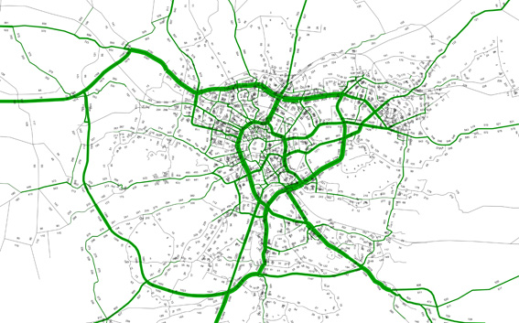  Figure 22: Results of assignment procedure in simulation model of the Krakow Conurbation in 2010 [veh/h] – afternoon peak hour.  Next, a forecast for 2030 was created. For this purpose the following set of assumptions were made, regarding both supply and demand level:  • Supply – it was assumed that the network would change according to investments approved or planned in 2010 for the time horizon 2030. Investments taken into consideration refer both to public and private transport systems. The mutual impact of private and public modes of transport was estimated via application of the modal split procedure.  • Demand – for the purpose of future OD matrix estimation, formulas based on CTS 2003 and 2007 were used, but final values of trips generated by traffic zones were then changed according to estimated mobility balance. This procedure assumed that the mobility rate in non-home based trips would increase on the prognostic horizon (the home based trips rate would not significantly change) and this gives a total increase in mobility rate from 2,02 [trips/day/inhabitant] to 2,85 [trips/day/inhabitant]. This was of course an individual assumption, but according to trends observed in European countries would seem reasonable.  The most important data stating the basis for forecast analysis refer to changes in spatial land use development. These changes were illustrated by different numbers of inhabitants, students, employees, working places, etc., estimated for each traffic zone and varying development directions. For this purpose three scenarios for different directions of land use changes were assumed:  • Land use data changes according to Land Use Development Plan (LUDP) for Krakow, in which changes in the value of variables vary according to political decisions on future development of the city;  • Land use changes will take place only for zones located in the transportation corridors (TC);  • Land use changes will be implemented in all traffic zones, with no relationship to location of transportation corridors – this was called the decentralized (DC) variant.  For each scenario the full simulation model was calculated in order to obtain traffic volume on road sections.  To simplify calculations appropriate software, e.g. COPERT 4 software and manuals (http://www.emisia.com/copert) which estimates emission levels for many substances using actuated values of parameters, can be used. However, the approaches mentioned require detailed information about traffic and its composition for the full network. In the case of a simple analysis, focused on just a few streets, it is possible to conduct traffic surveys and collect the necessary data. But for the whole transportation network, it is necessary to apply simulation software and a full transportation model for appropriate emissions calculation. In the second chapter of this paper simulation model and chosen land use scenarios have been described. The simulation model has significant simplifications, e.g., it is focused only on private transport (with one, constant in each scenario, OD matrix for Heavy Goods Vehicles). For this purpose it was necessary to fix certain assumptions concerning CO₂ emission calculation: traffic composition on road sections was averaged as well as type of fuel, the engine capacity share and year of the rolling stock. According to “Instruction for forecast model of estimated CO₂ emissions for the City of Warsaw” it was assumed that the average emission of CO₂ is equal to 92 [g/veh.km]. The assumed value of CO₂ emissions is averaged and will be used only to compare the impact of different land use scenarios on the level of CO₂ emissions. For detailed calculations it will be necessary to estimate parameters that were simplified.  Each scenario related with land use changes was calculated using VISUM software and the VKT (Vehicle Kilometres Travelled) parameter was then assigned. Table 10 presents results of the simulations for all scenarios:  Based on assumptions concerning traffic composition on road sections, share of different types of fuel, engine capacity and vehicle year it was possible to estimate level of CO₂ emission for whole agglomeration (see Figure 23).  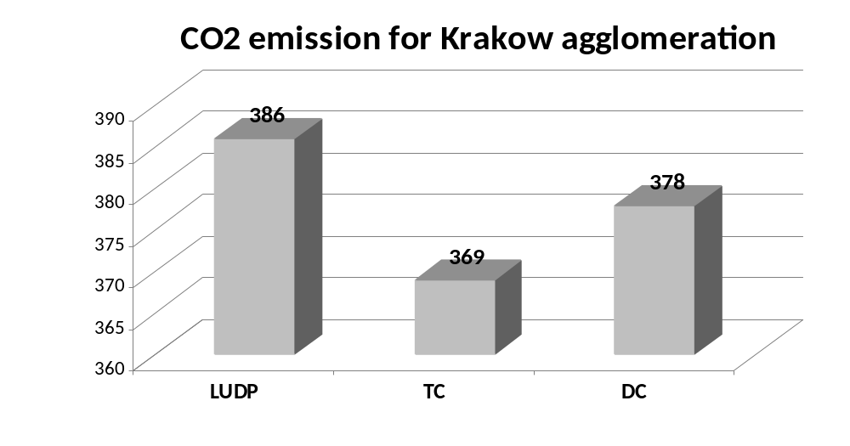  Figure 23: Estimated level of CO₂ emissions for three land use scenarios in the Krakow conurbation during one afternoon peak hour of the simulation [tons].  In this approach, the level of emission is in simple relationship to VKT, so results are as expected: for the scenario with land use development changed within transportation corridors (TC) the level of emission achieved the lowest value. This is the result from shortened trips due to extensive development of areas to give better transport accessibility. This gives a lower trip distance and as a result a lower value of average trip length. In other scenarios values of emission are not significantly higher (3 – 5 percent), but the difference is noticeable. It is worthwhile emphasizing that in the decentralized scenario (DC) we would expect the worst results, but they were in fact a bit better than for the LUDP scenario. This means that it is recommended the LUDP assumption be verified in order to minimize the future level of transport absorption, which may affect future CO₂ emissions.  The simulations were each calculated according to one scenario of transportation system development – for each scenario the same investments for both private and public systems were assumed. For further calculations more detailed premises were assumed concerning the level of transport investments and their effect on modal split. One scenario was chosen for further analysis – for decentralized land use development calculated demand it was defined using four variants:  • Variant 1 – maximum level of private transport network development according to official planning documents and minimum level of public transport infrastructure development (in this case only investments for which formal procedures of building permission were running in 2011 were chosen). This variant was created to show what would happen if infrastructure investment efforts were only directed towards private transport needs;  • Variant 2 – both transportation systems (private and public) were invested in to an averaged level – only highly feasible investments were chosen. This variant has averaged and sustainable character;•;  • Variant 3 – reliable public transport oriented. For this variant it was assumed to have a minimum level of private transport investments and the most important and probable public transport ones.  • Variant 4 – public transport oriented variant. Taken into consideration were only the most probable private transport investments and all planned public transport ones.  The application of different network investments had a significant impact on modal split in the city. For the purpose of precise analysis of the simulations, the share of different trip modes was estimated both for whole model and for a smaller area, located in the city centre. The values of modal split for each scenario are presented in Table 11.  For each variant simulations were conducted using VISUM simulation model. As a result values of VKT were obtained both for the whole conurbation and for the assumed area of the city centre. Figure 24 presents the results of the simulations (in tons of CO₂) calculated for each variant on the basis of VKT.  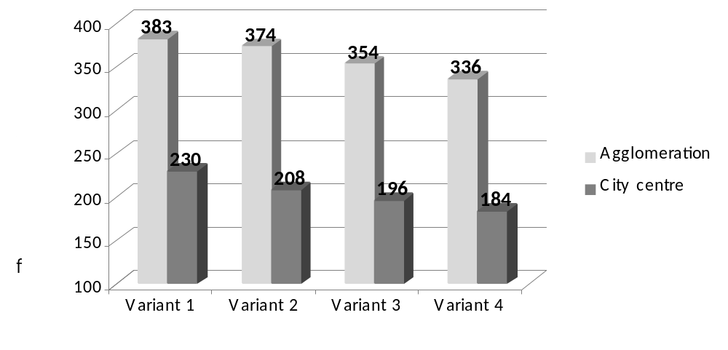  Figure 24: Level of CO₂ emission for analyzed variants – results refer to one hour of simulation period for afternoon peak hour [tons of CO₂].  The level of CO₂ emission is decreasing (as was expected) if we assume more investments in public transport than in private transport. These differences are even more significant for the city centre, where the difference between the worst and best investment levels are over 25% (46 tons of CO₂ less in the city centre for Variant 4 in comparison to Variant 1). For the whole conurbation the results are not so significant, but still noticeable – over 8% between the 1st and 4th variants.  II. Research into identification of the impact of innovative transport solutions on CO2 emissions reduction.  Introduction of innovative transportation measures usually causes a reduction in CO2 emissions. However, it is rather easy to simulate, e.g., what CO₂ emissions reduction introducing a car-pooling system may cause if 10 % of inhabitants use the system; the real impact is harder to estimate. One of the possible ways out is to ask commuters if they are eager to change their transportation habits and mode of transport, or use developed system. On the other hand the same group could be asked how they perceive the impact of a particular measure on CO₂ emissions reduction. Those with the highest rates might be considered the most “popular” after introduction, if of course inhabitants are willing to change their transportation habits.  The other way is to take advantage of transportation experts’ knowledge. Relying on their experience and knowledge experts may be able to estimate the significance of particular measures on CO₂ emissions reduction.  Those two approaches were used to estimate the influence of innovative transport solutions on CO₂ emissions reduction. A paper questionnaire and a workshop discussion were used to gain results from experts and an internet based questionnaire was used to gain results from inhabitants.  The questionnaire consisted of three questions. In the first question respondents were asked which transport solutions in their opinion are innovative. They had to apply an innovation index from 1 (least innovative) to 5 (most innovative). The second question was about which solutions, in the opinion of respondents, have the highest (5) and the lowest (1) influence on CO₂ emissions reduction. Finally, in the third question respondents were asked if particular solutions were possible, impossible or risky in Polish conditions. Twenty-five responses were gathered among the experts and 75 among inhabitants. The number of inquiries is small and results should be considered as a pilot study.  Table 12: Innovation index of transport solutions  * less than 5 answers; 4.04 – maximum values  The innovation index was calculated as an average from the given responses. In a majority of measures the indexes of innovation are close for both inhabitants and experts. The differences are less than 10 %. Moreover inhabitants consider underground, park & ride and pedestrian zones more innovative than experts do. On the other hand, only city centre access charges, mobility management and car-sharing are more innovative in opinion of the experts. City centre access charge schemes are at present not legally allowed and won’t be accepted by inhabitants. The other two might be little known, which might be a reason for the lower rate.  Table 13: Influence on CO₂ emissions reduction  * less than 5 answers; 4.00 and 4.50 – maximum values  The CO₂ emissions reduction index was calculated as an average from given responses. Mobility management is the most underestimated measure by inhabitants in terms of CO₂ emission reduction. However, fast tram and underground also have lower ranks given by inhabitants than solutions that are considered by both groups to be the most CO₂ emission reducing measures. On the other hand, inhabitants overestimated the influence of park & ride systems.  Analysing the five transport solutions that gained the highest ranking, there’s only one difference between experts and inhabitants: inhabitants indicated among them public bike rental while experts indicated mobility management.  Table 14: Top 5 CO₂ emissions reduction transport solutions  A majority of respondents think it’s possible that all measures could be introduced in Poland. In fact many of them already exist in different Polish cities. The most difficult to introduce are: car-sharing system (in the opinion of inhabitants) and city centre access charges (in the opinion of experts).  Legal Framework:  “Study of Preconditions and Development Policy of Land Use for the City of Krakow”. Document approved by the City Council in 2003.  Financial framework:  Possible costs could include software licenses, access to city simulation models and data about land use and transport systems schemes, etc. Possible costs of the inquiry are dependent on the number of persons questioned. In the case of a monkey survey the only cost is to prepare, publish and analyse the results. Conducting an internet based survey is almost costless.
  Table 10: Results of simulation for analyzed scenarios Result refers to one hour of afternoon peak period simulation.
  Scenario | VKT [veh.km]
  Land Use Development Plan LUDP | 4 192 000
  Transportation Corridors TC | 4 006 000
  Decentralized DC | 4 112 000
  Table 11: Estimated modal split for different level of infrastructure development
  Analysed variant | Level of investment development |  | modal split – whole conurbation | modal split – city centre
  1 Variant | PrT* | Max level of development | 60% | 40%
  1 Variant | PuT* | Min level of development | 40% | 60%
  2 Variant | PrT | Averaged level of development | 47% | 30%
  2 Variant | PuT | Averaged level of development | 53% | 70%
  3 Variant | PrT | Min level of development | 46% | 30%
  3 Variant | PuT | Averaged level of development | 54% | 70%
  4 Variant | PrT | Min level of development | 33% | 20%
  4 Variant | PuT | Max level of development | 67% | 80%
  * PrT - private transport; PuT public transport
  No | Transport solution | Innovation index  Inhabitants | Innovation index  Experts
  1 | Separated bus lanes | 3.15 | 2.90
  2 | Fast tram | 3.52 | 3.29
  3 | Underground | 3.87 | 3.24
  4 | LPG/CNG/LNG vehicles | 2.99 | 2.89
  5 | Park & Ride | 3.76 | 3.05
  6 | Public bikes rental | 3.97 | 3.78
  7 | Electric vehicles | 4.04 | 4.06
  8 | City centre access charge | 3.72 | 4.26
  9 | Pedestrian zones | 3.35 | 2.95
  10 | Car-pooling | 3.73 | 3.74
  11 | Car-sharing | 3.70 | 3.95
  12 | Mobility management | 3.72 | 4.45
  13 | ITS | 3.78 | 4.33*
  14 | Integrated ticketing | 3.61 | 5.00*
  15 | Traffic calming / Traffic limited zones | 3.44 | n/a
  16 | PT priorities | 3.75 | 4.00*
  17 | Electronic charging system | 3.60 | n/a
  18 | Real time information | 3.99 | n/a
  No | Transport solution | CO₂ emissions reduction index  Inhabitants | CO₂ emissions reduction index  Experts
  1 | Separated bus lanes | 3.20 | 3.11
  2 | Fast tram | 3.80 | 4.32
  3 | Underground | 4.00 | 4.50
  4 | LPG/CNG/LNG vehicles | 3.28 | 3.26
  5 | Park & Ride | 3.60 | 3.05
  6 | Public bike rental | 3.92 | 3.60
  7 | Electric vehicles | 3.89 | 4.05
  8 | City centre access charge | 3.71 | 3.74
  9 | Pedestrian zones | 3.61 | 3.65
  10 | Car-pooling | 3.19 | 3.00
  11 | Car-sharing | 3.00 | 2.83
  12 | Mobility management | 3.19 | 3.83
  13 | ITS | 3.22 | 4.67*
  14 | Integrated ticketing | 3.19 | n/a
  15 | Traffic calming / Traffic limited zones | 3.29 | 5.00*
  16 | PT priorities | 3.64 | 4.00*
  17 | Electronic charging system | 2.57 | n/a
  18 | Real time information | 2.45 | n/a
  No | Inhabitants |  | Experts
  No | Transport solution | CO₂ emissions reduction index | Transport solution | CO₂ emissions reduction index
  1 | Underground | 4.00 | Underground | 4.50
  2 | Public bike rental | 3.92 | Fast tram | 4.32
  3 | Electric vehicles | 3.89 | Electric vehicles | 4.05
  4 | Fast tram | 3.80 | Mobility management | 3.83
  5 | City centre access charge | 3.71 | City centre access charge | 3.74
6 Carbon metrics used and why | The average unit of CO₂ emission 92 [g/veh.km] has been taken from “Instructionfor forecast model of estimated CO₂ emissions for the City of Warsaw”, Kassenberg A. and others, Institute for Sustainable Development, Warsaw 2008.
7  Evaluation | The conducted analyses were simplified in terms of proper estimation of CO₂ emissions – mostly as a result of plenty of simplification in the transportation model and lack of detailed data that would be necessary in a full approach. However, the results obtained are important from a transport planning point of view and could be useful as a support tool in important decisions that affect the future development of the city’s land use and its transport system.
8 Lessons learnt from the best practice | Simulation analysis of different land use schemes and variants of transport system development could be very helpful tools supporting political decisions  In the case of land use change scenarios, results from the simulation give information about risk in planned policy of land use development and show the advantages of land use activation within transportation corridors – the difference in CO₂ emissions is almost 5% lower. When we assume a share of afternoon peak hour traffic equal to 8,35% (according to travel study in Krakow), and the number of working days in a year as equal to 300, in this case we can produce over 58 500 tons CO₂ per year less than in the case of the official Land Use Development Plan.  Expected results were obtained for analysis of different levels of investment in transportation systems. The lowest CO₂ emissions were for the variant with well-developed public transport investments in comparison to the minimum level of development for private transport oriented variants.  Internet based questionnaires are very cheap and quick method of gathering responses from target groups.  Innovative transport solutions might be understood in many different ways, even among a group of experts.  Solutions considered by inhabitants to be the most CO₂ reducing are likely to be most intelligible when mentioned solutions would be implemented.
9 Contact information | Contact person:  Krakow University of Technology, Chair of Transportation Systems,  Katarzyna Nosal, tracit@aries.one.pl,  Andrzej Szarata, aszarata@pk.edu.pl,  www.ksk.pk.edu.pl.
10 Other possible interesting information | A paper, ”Simulation analysis of CO₂ emissions for different land use development schemes” is being prepared to act as a good practice guide to the development of land use transport modelling.

Viimsi Pilot Studies

Various alternatives of public transport

1 Title of the pilot study | Various alternatives for public transport
2 Precise theme/issue tackled by the practice | Evaluation of optimum solutions in the organisation of public transport in Viimsi with respect to reduced CO₂ emissions.
3 Objectives of the best practice | The study was undertaken in order to analyse and evaluate improvements for public transport connections which, if implemented, would provide a reduction in carbon and other polluting emissions providing a sustainable environmental development incorporating a range of transport solutions. In addition the study explored the development of intra-municipal transport solutions and connections along with a more useful and sustainable link between Viimsi and Tallinn City, it was deemed important and advantageous for the latter connection to provide solutions that would work in-conjunction with Tallinn city bus system.
4 Location | - Estonia  - Harju County  - Viimsi Municipality
5 Detailed description of the best practice | One of the main aims of the sustainable regeneration agenda for Viimsi municipality is to achieve a clean environment (in particular a reduction in polluting emissions), a balanced integration of nature, sustainable developments providing high cultural and environmental values in its regeneration practice and future settlements. By reducing environmental pollution through the development of a sustainable public transport system, Viimsi aims to provide a competitive public transport system compared to domestic private car use in order to reduce its importance as a preferred option of mobility choice. Thus the municipal development plan has set a target to ensure provision for a high-quality public transport service for all of the districts in the municipality connecting with the centre of the municipality and with the city of Tallinn. To achieve this, the focus has been on solutions relating to the following areas:  - Improvement of public transport quality and availability;  - Development of municipal road network and sustainable public transport system;  - Assessment of alternative modes of travel (tram, water taxi, “Park&Ride” system) for connection with Tallinn and their impact on the reduction of CO₂ emissions.  To achieve set targets, passenger interviews/counts were conducted on bus lines travelling within the municipality during typical workdays between 6:00 - 14:00 in March 2011. At the same time in the local newspaper “Viimsi Teataja” and also on homepage of Viimsi municipality passengers were asked to reply to a more extensive electronic questionnaire. The gathered data was analysed, described and used as part of the public transport modelling provided by consultants, especially during the following stages:  - Origin-destination matrix building;  - Model calibration and validation;  - Creating new scenarios of the public transport network.  Travel habit analysis of residents of Viimsi municipality was complemented by experiences from different European countries that had developed environmentally sustainable public transportation systems.  The study produced short-term descriptions of scenarios for the current and two proposed line networks with a socio-economical cost-benefit analysis that takes account the environmental effects caused by transportation. The pilot study included all of the public transport lines within Viimsi Municipality and the lines of the public transport system connecting Viimsi municipality with the city of Tallinn.  This survey counts and questionnaire were undertaken in order to obtain data about travelling habits and attitudes towards the current public transportation networks in Viimsi. The counts and questionnaire were carried out on all of the municipalities lines along with the bus lines connecting Viimsi with Tallinn (routes: 1A, 38, 260). During the counting survey all boardings and disembarkations were recorded at all stops on all routes identified, the passengers were identified by their age and class (pre-school, pupil, young adult/student, adult, elderly- separated visually) during the survey period. This data provided an overview of the present transport usage and loads during the variety of hours (from 6:00 AM to 2:00 PM by hours) and at different locations.  Passengers were questioned on the following data:  - Origin location of the travel (accuracy- village, street).  - Usual mode of transportation.  - Views on the present PT service – evaluation of existing public transport service quality (separately for the municipal and city connections).  - Identifying conditions under which passengers would change your travel habits (e.g. using Public Transport and not personal cars travel)  - Is the reduction of CO₂ emissions important for you and are you ready to change your personal travelling habits in order to reduce CO₂ emissions? (i.e. would it influence your mobility choice?)  A copy of the Questionnaire titled (“Viimsi ankeet” ) can be found in Appendix 5 of the report.  The answers were analyzed and published in the report (figures and tables in chapter 2.1 and 2.3). The results of the survey shows that the peak period of the public transport usage is in Viimsi Municipality is between 7:00 - 8:00, when during one hour, public transport is used for making more than 900 trips. Within the Viimsi municipality public transport was used by 673 passengers during peak period (between 5:00 -14:00 altogether 2,670 passengers). At the same time 190 passengers headed to Tallinn (during 5:00 -14:00 altogether 1,253 passengers) and in direction to Viimsi 79 passengers (during 5:00 -14:00 altogether 599 passengers).  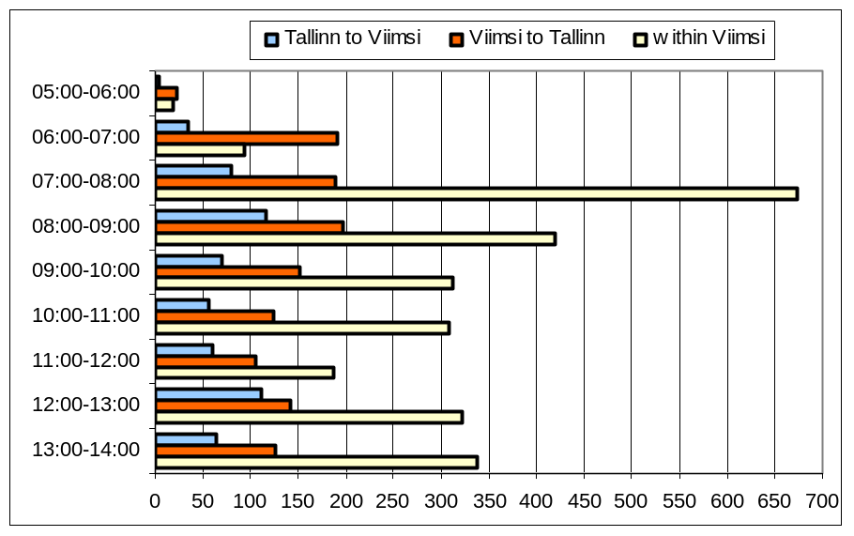  During peak period majority of the passengers are working-age adults (61.9%). School age students form 34.5% of all passengers. Elderly people and preschool age children form considerably lower shares.  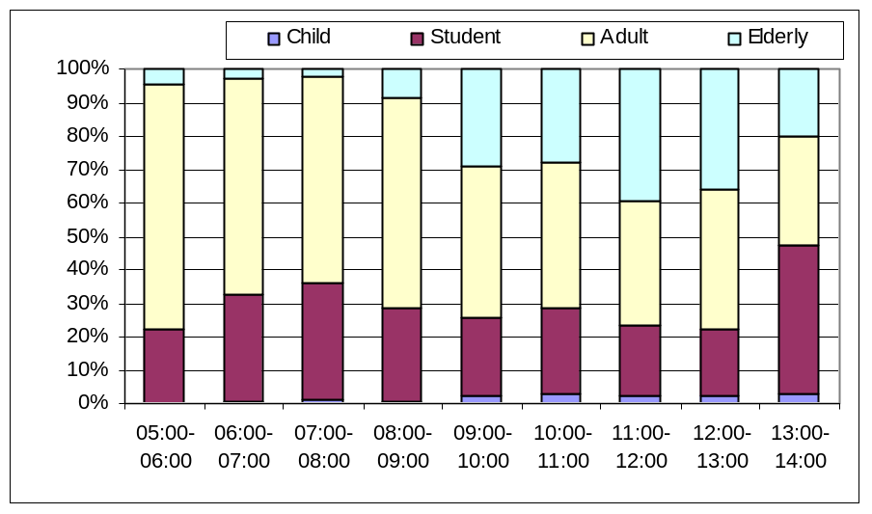  Mainly Tallinn city bus lines (1A, 38) are used. Usage of municipal lines remains considerably lower. If city bus lines are used during morning peak hour (7:00 -8:00) almost seven hundred times, then municipal lines are used by almost 250 passengers.  A greater share of the users are women (65.1%) and their share is higher on Tallinn city bus lines (68.4%) and lower on municipal lines (58.8%). The most typical public transport user is a working-age woman. The share of working-age women of all passengers is 34.7%, working age men form only 12.7%.  Trip purposes vary dependent on the period of the day. During morning peak hour (7:00 - 8:00) trips are made mainly to work or to school. Movements related to school and work form 93.8% of all trips during this period. Other trip purposes are considerably less represented. During the day the share of trips related to work and school reduces and other purposes become more important.  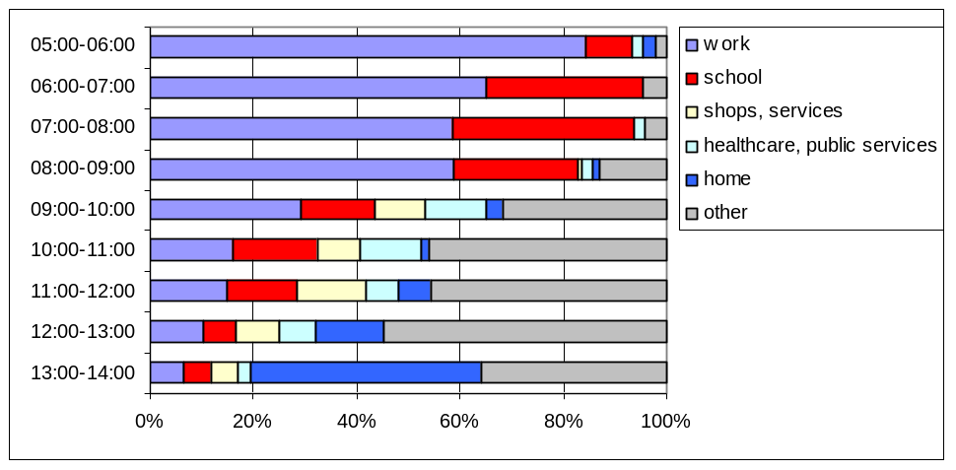  Almost 22.5% of the users of municipal lines and 16.5% of the users of city bus lines had to transfer to another bus. The rest of the respondents did not make any transfers or did not reply to the question. Transfer from the municipal lines was mainly made to city bus lines to continue the trip towards Tallinn. Mainly transfers were made to head for work, school or nursery school. As the majority of the services and commercial institutions are close to home, there is no need to transfer for visiting them.  In addition, the inhabitants of Viimsi were invited to fill in a similar questionnaire located within the Viimsi website, it received 231 responses from individual households.  The majority of the respondents were working-age people 19-64 years old (89.2%). Elderly people (over 65- years) formed 5.2% of the respondents and 5.2% were residents of the municipality that were up to 18 years old. 0.4% of the respondents did not state their age. Approximately 70% of the respondents were women and 30% men. 63.2% of the respondents moved daily in direction to Tallinn and 35.1% within the municipality. The current study was foremost aimed to road users travelling by public transport or private car and thus pedestrians and bicyclists did not take part of the questionnaire. 52.8% of the respondents used public transport and 45.5% moved daily by car. The share of public transport users was almost similar for intra-municipal and Tallinn-related trips.  The majority of the respondents were not satisfied with intra-municipal transportation. Only 6.4% of the respondents were satisfied with the public transport within the municipality. 66.7% of the respondents rated the state of municipal lines rather bad. Satisfaction with public transport connection with Tallinn is higher compared to municipal lines. 19.1% of the respondents considered the connection with Tallinn good. 40.9% rated bus connection with Tallinn satisfactory and 40% were dissatisfied. Dissatisfaction was greater among those travelling daily in direction to Tallinn.  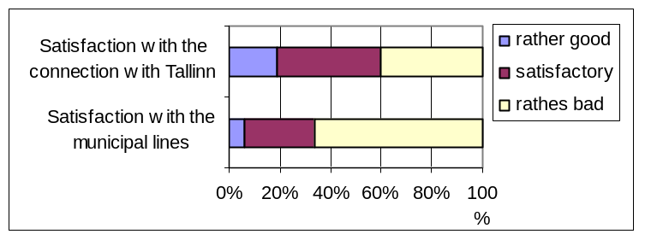  The main problem with the public transport was the service quality. To a lesser extent roads for pedestrians and cyclists were missed and dissatisfaction with traffic jams was mentioned.  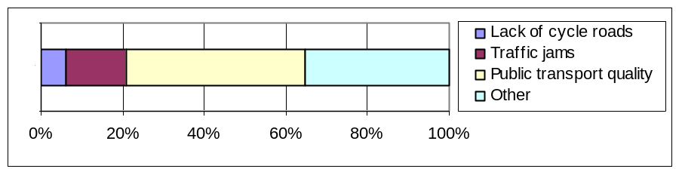  Public transport could be more attractive if connection speeds were increased. 46.3% of the respondents found that the connection speed should be at least the same as for private cars. Almost 18% of respondents would use public transport only if it would be considerably faster than private car. 18.2% did not respond to this question or did not find that their travel mode choice would be directly influenced by connection speed.  Also respondents found that current ticket prices are too expensive and to increase public transport usage the prices should be lower. Almost 22.5% of respondents found that the price should be considerably lower than at the moment. 50.2% of the respondents found that the ticket prices should be at the same level as at the moment. Also important factor for people is the comfort of public transport. Almost the same amount of respondent answered that they would prefer public transport in case it would be considerably or slightly more comfortable than at the moment.  With the question about importance of air pollution, answers divided almost equally. The majority of the respondents (39.9%) stated that air pollution does not have an important role in their travel mode choice. Car users were more inconsiderate to environmental issues compared to public transport users. A somewhat important issue was air pollution for almost third of the respondents and 24.8% were certainly considering minimal environmental effects when choosing their travel mode.  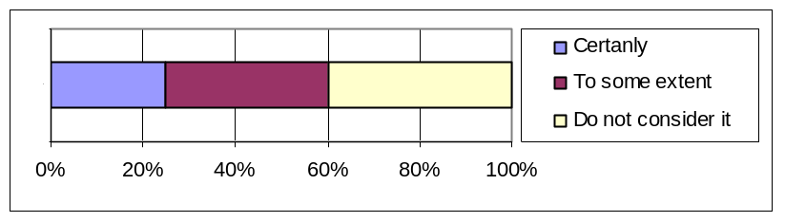  Future analysis will be undertaken on the public transportation strategies for the most effective solutions for Randvere and Miiduranna Schools (which will be opened in 2013) and for EstStein centre as planned in the development plan of schools of Viimsi Municipality.  Financial framework:  Total cost of the surveys, analysis and evaluation of the results, including production of the CUBE transport model presented by the consultants were : 38,148 €  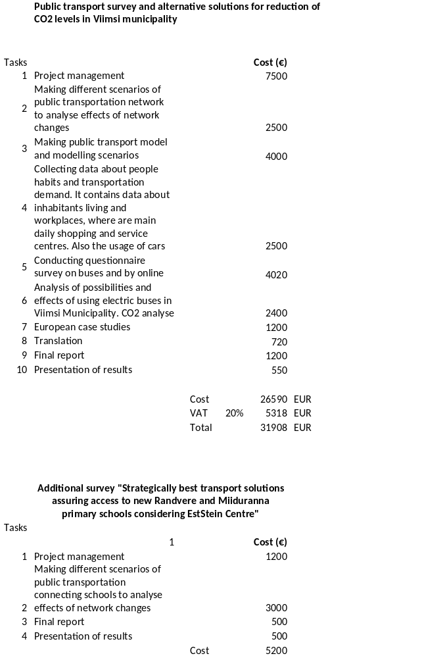  
6 Evaluation | Public transport must be seen not only as a cost item (in the viewpoint of subsidies and travel discounts) but also as a cost-effective and environment friendly travel opportunity that has a direct and great effect on the reduction of CO₂ emissions.  Among actions aimed to reduce CO₂ levels, public transport development and increasing its usage are one of the cheapest and effective ways to actually contribute to CO₂ reduction. Recent surveys show that cities with a higher modal share of public transport, walking and cycling produce less CO₂ from passenger transport per capita than cities which rely mainly on private motorized mobility. Ref.: PUBLIC TRANSPORT AND CO2 EMISSIONS, UITP, 2009.:  When applying this information to the Viimsi situation, it can be estimated that especially the shifting of the present modal share from car usage (which is very high today in Viimsi) towards public transport usage gives a bigger potential of CO₂ emission.  CO₂ calculation  CO₂ calculation is based on the following CO₂ emission figures across different transport modes:  - Private car 0,2 kg/km;  - Diesel bus 0,6 kg/km;  - Electric bus (oil-shale) 0,9 kg/passenger-km  - Electric bus (wind) 0,00 kg/passenger-km  Energy consumption of electric buses is estimated 0,8-1,5 kWh/km (estimation based on following sources: Kari Mäkilä LIPASTO -emission calculation system, VTT Technical Research Centre of Finland, 2010; Postnote October 2006 Number 268 Carbon footprint of electricity generation; Brian Shorter, Guidelines on greenhouse gas emissions for various transport types, 2011 )  For alternative electricity no indirect emissions have been considered.  CO₂ emissions from electricity production in case of different sources:  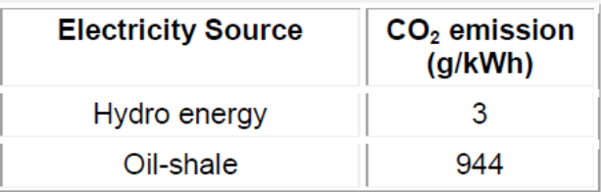  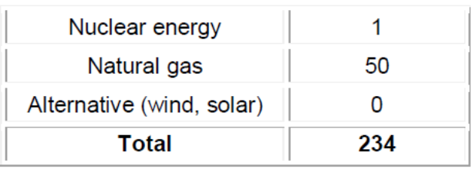  Source: Paul Chefurka, Sustainable Development Commission  The present public transport survey together with regularly collected data of traffic flows and average occupancy on the boarders of the city of Tallinn (the last is provided by the survey results of Tallinn University of Technology) shows that during the peak hour 2,200 persons use a private car in the direction of Tallinn and at the same time 180 people move by public transport. Average passenger numbers in each car is surveyed to be between 1.35 and 1.4 (survey by Tallinn University of Technology.(ref: Tallinna liiklusvoogude uuring, TTÜ; 2010).  We have assumed that 10% shift of the total passenger flow could be a good estimation. Ten per cent is taken as a basis for the calculations’ scenario, as:  This is considered to be easy to achieve (questionnaire survey shows that 10 per cent as minimum of passengers are willing to change the travel mode if the local public transport network is developed);  10 per cent of passengers shifting is enough to balance the additional cost of network enlargement with ticketing income, thus the municipality does not need to direct additional finances;  It is understandable, that the bigger share of shifting gives also the bigger positive effects regarding the CO₂ emissions, thus this 10% shift is taken as a minimum for the scenario.  If 10% of current car users would change their transport mode, the number of cars during peak period would decrease by 160. If 12 km is taken as the average distance to the city centre of Tallinn, then minimal savings on the expense of CO₂ emissions would be:  12 * 160 * 0.2 = 384 kg (Compared to the present).  Increasing passenger numbers increases the demand for more public transport departures (instead of 4, there should be 8 departures during peak period). The increased number of departures has been estimated to be needed because of the following:  Longer headways are causing the longer journey times;  It is expected by the inhabitants (as mentioned in the survey) to decrease the headways, and this is considered to be an important issue to raise quality;  The smaller headways are also causing the lowered occupation in the buses, which is also one important factor for the public transport quality.  At the same time an increased number of departures is causing also the increase in CO₂ emissions:  12 * 4 * 0,6 = 28.8 kg (Compared to the present )  As a result of the calculations it concludes that if 10% of current car users would change their travel habits during peak hour, it is possible to reduce CO₂ emissions by 355 kg. Annual reduction of CO₂ emission under this scenario would be:  355 * 10 * 365 = 1,223 tonnes CO₂  At the moment, average energy consumption of electric vehicles per km is 0.2 – 0.3 kWh. In Estonia, where electricity is still being produced from oil-shale, an electric car would on an average emit much more carbon dioxide per km compared to other types of new cars. For example, in Estonia on average 1.18 kg CO₂ is emitted into the air per 1 kWh of electricity produced (European Union average is 0.34 kg). For new cars the average CO₂ emission level in Estonia is 170 g/km. Electric cars based on oil-shale produce 250-300 g CO₂/km; i.e. twice as much as is the European Union target for new cars by 2015. When considering climate change aspects, then application of electric vehicles in Estonia is justified only in the case that electricity is produced from considerably more sustainable (especially considering CO₂ emissions) sources than oil-shale. (Jüssi, M., Poltimäe, H., Sarv, K., Orru, H. Säästva transpordi raport 2010. Säästva Arengu Komisjon, Tallinn, 2010, lk 49).  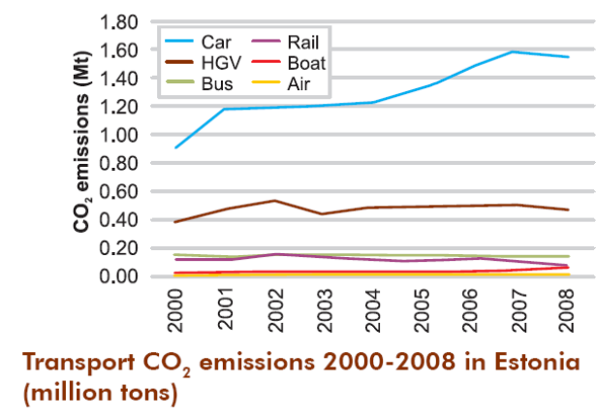  Introduction of electric buses would bring considerably smaller effect compared to changes in travel habits (i.e. travel modes). Using oil-shale energy for electric buses the CO₂ emission is even higher compared to conventional diesel buses. Usage of electric buses could be considered only in case of wind or other types of renewable energy sources. Alternative energy sources demand great investments and also there is a lack of research on issues concerning potential degradation of quality of life in the surrounding area (noise of the wind generators etc.).  Based on this, the following suggestions have been made.  During the next few years electric vehicles in public transport are suitable only for certain niche markets (problems with emissions, noise etc.).  Possible scenarios for CO₂ emission reduction in Viimsi:  - Usage of public transport with lower CO₂ emissions  - Electric buses;  - Gas buses;  - Development of light transport modes  - Building bicycle and pedestrian roads between main travel destinations  - Maintenance of existing roads (also winter maintenance!)  - Improvement of existing public transport service- “flattering” 10% of car users into public transport will require 20 extra departures, but the difference between CO₂ emissions will be 10 times.  - Usage of suitable size fleet (main attention to morning and lunch time peaks)  - Consider possibility of creation direct connections between Rohuneeme- Tallinn route (it will improve service quality but demands considerably higher costs, otherwise the availability of public transport within the municipality will suffer) ;  - Access to bus stops  In this project we have used CUBE BASE/Voyager modelling software to perform a comprehensive comparison of different public transport network scenarios.  Actually, the modelling was consisting of different steps:  First creating the model describing the existing networks, bus stop locations, bus traffic characteristics (lines’ description, headways, max capacity).  Second step was creating the origin-destination matrix, where we used different data sources (questionnaire survey, passenger survey, public databases- residencies, jobs, schools and student places, etc).  Third step is calibration. Thus we run the model using then existing network and results were validated against the survey results. Some changes and corrections were introduced; model runs were performed until the results were god enough and validated.  Next step was to create the new network options. This task was performed separately, using the present know-how, questionnaire and passenger survey, views of the municipality etc. New scenarios were described in the model, as above described for the existing network options. Please note- during the first step we did not changed the O-D data, thus performing that the present modality characteristics (location between origins and destinations as well as the amount of trips) remains unchanged, thus this gives us a possibility to compare the networks modelling results’ data in the situation, where the demand remains as it is, but the services are changed.  In total 5 new options were modelled and compared with 0-scenario (do nothing). It was shown that some new scenarios are positive against the existing one, performing better services in the means of driven kilometres and spent time. After that we also modelled the situation where we will have 10% more passengers, changed the modality after the municipality has performed new network schemes, and it was possible to show, that even 10% growth in passenger amount gives already positive results in fiscal terms, i.e. cost of more kilometres driven are covered by better services and increased usage.  10% of the current car use has been assumed to switch their transport mode – This figure is better than estimation based on present and last trends than other sources. It is a fact that during last years the most important trends in mobility and especially the choice of different (alternative transport modes) have been the following:  The population in Viimsi has been increased intensively (please also note that it is estimated that the actual population in Viimsi municipality is somehow bigger than registered population);  The motorization in Estonia has been also increased rapidly (with exception of the last year, probably caused by economic crisis), which has caused a basic trend of more intensive car usage and decrease in public transportation share. This is also very characteristic to the city of Tallinn, and especially some of its neighbouring municipalities (especially Viimsi, Rae, Saue, Harku municipalities), when the most of the jobs have been remained in Tallinn, thus causing an increased mobility on general and especially on connection routes with the city (e.g. Pirita Rd).  Thus, even understanding the problems within such development trends we can hardly expect the rapid changes in travel habits, as it needs huge investments in order to improve the quality of alternative transport modes (and not so much in Viimsi than between Viimsi and Tallinn), to make it more competitive with regular car usage.  Thus we have estimated that the improved connection quality (improved and integrated public transport networks in Viimsi and Tallinn) can break the present trends of car usage growth and 10% switch from cars to public transport could be described as the optimistic but not unrealistic scenario. Here we also took account the questionnaire survey results, which was held in Viimsi under the present project, and which shows some positive attitudes to switch from cars to public transport (or bicycling) when the networks are improved and made more competitive (in terms of travel time).  We can estimate the figures based on regular traffic counts and estimations on the modality shift from cars to public transport as follows. This calculation is based on existing situation data, i.e. if the inhabitants of Viimsi will change their travel habits immediately today as shown in the PT development scenario of PT. The data shows only the emission data inside the Viimsi municipality but there will be also an important decrease in CO₂ emissions in the city of Tallinn, as the present car usage of the Viimsi inhabitant in driven more in the city of Tallinn, than on the streets of Viimsi.  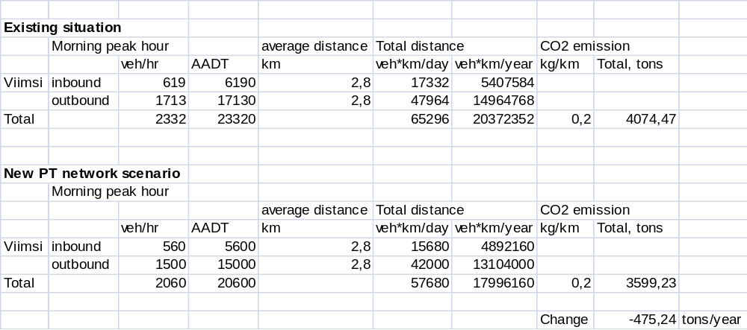
  Modal share of public transport, walking and cycling | Less than 25% | Between 25% and 40% | Between 40% and 55% | Above 55%
  Average CO₂ emissions  (kg per capita per year) | 3130 kg | 974 kg | 953 kg | 735 kg
7 Lessons learnt from the best practice | Locally - For reduction of transport related environmental effects one of the possibilities is to concentrate on travel habits and prioritise public transport and light travel modes. The other solution might be usage of alternative fuel sources. In this case reduction of emissions from public transport is important.  Possible options for CO₂ emission reduction in Viimsi could include the following measures or combination of these:  – Usage of public transport with lower CO₂ emissions  – Operation of electric buses;  – Operation of gas buses;  – Development of alternative transport modes (walking, cycling), like building bicycle and pedestrian roads between main travel destinations, maintenance of existing roads (also winter maintenance!);  – Improvement of existing public transport service- “flattering” 10% of car users into public transport will require 20 extra departures, but the difference between CO₂ emissions will be 10 times;  – Usage of suitable size fleet (main attention to morning and lunch time peaks);  – Consider possibility of creation direct connections between Rohuneeme- Tallinn route (it will improve service quality but demands considerably higher costs, otherwise the availability of public transport within the municipality will suffer);  – Improved access to bus stops.  In order to reduce CO₂ emissions in Viimsi municipality a number of measures have been proposed by the consultant. Here it can be seen that especially the changes in travel habits (illustrated by the share of different transport modes) are the most important goal to achieve. This is based on the present trends of increased motor car usage, which is shown by the regular traffic surveys, but also on the results of questionnaire present survey. As an example - If car usage were to reduce the effect on CO₂ emissions will be evident, as calculations show above. In order to receive this goal it is necessary to make alternative transport modes – bicycling, walking and public transport - more attractive and competitive to the cars.  The present survey show clearly, that if comparing the different scenarios the optimized network, which is resulted by an increased mileage but clear time savings could and will work as the real alternative for the car usage. Even if the public transport can hardly compete with motor transport in the field of quality, it is possible to create the public transport to be competitive to the car transport in the total time consumption, especially when increased car traffic causes congestion and thus additional travelling time. Of course, the one must consider the following facts:  The motor traffic congestion occurs at the present not in the municipality of Viimsi, rather than in the city of Tallinn, especially at the first key junctions, where traffic flows merge (e.g. Narva mnt/Pirita Rd). Thus the additional time consumption as well as emissions also occurs out of Viimsi mainly.  Due to the statistics, incomes of inhabitants of Viimsi are higher than the average of Estonia. It is obvious that higher income is often causing the higher motorization and also an increased car usage. This trend could be broken if one of the three key elements influencing the travel mode choice – cost, time saving and quality – could be changed.  A common thesis is that certain lifestyle groups have specified forms of mobility; even the last has several meanings. It can mean social and spatial mobility, actual movement, as well as for potential and opportunity. Even at present, mobility research still focuses on modal choice mainly. Further aspects, such as distance travelled, or time spent on travelling are also accepted, and thus are possible to analyze using the traffic modelling techniques, which is also a case here. As example, the total time spent for everyday mobility is connected to the consumption of resources and to transport emissions, including CO₂.  When focusing on public transport competitiveness the activities have been divided into two big areas. The first is the connection with the city of Tallinn, which has the most effective perspectives, as the majority of jobs are still located in Tallinn, and travelling to work is today mostly made using cars. The real alternative to the car usage here is by the introduction of a flexible, comfortable and efficient public transport system, as the distances between the residencies and jobs are long enough (average has been considered to be 12 km) to avoid cycling and walking for the most of the population. This data used here is based on Estonian Tax and Customs Administration databases, where the residence and job’s location is registered. This data also shows the following :  Commuting to Tallinn:  70% of Viimsi inhabitants work in Tallinn (5,700)  17% of Viimsi inhabitants work in Viimsi municipality (1,350).  Commuting to Viimsi:  5,160 workplaces in Viimsi, of which:  26% are occupied by residents of Viimsi (1,341);  41% are occupied by residents of Tallinn (2,100);  5% are occupied by residents of Maardu (275).  Here we can conclude that even changing the residence location (as Viimsi has an increasing trend of population) the most of inhabitants are not willing to change their jobs, where the majority are still located in Tallinn, causing increased commuting.  The integration between the Municipality and Tallinn City networks is essential in order to achieve the maximum quality of the systems and to maximise the potential of public transport use.  The Viimsi municipality itself can rearrange the municipal network to be completed with the goal of creating effective PT network between the population origins and destinations within the municipality (especially between homes and schools, services and jobs) and also the best possible interchange from the municipal busses to the busses connecting the municipality with Tallinn. Here the short interchange (both in terms of time and distance) with comfortable bus terminal environment is crucial. But this also true, that an improved urban environment and additional facilities is also crucial if this is to be effective.  It is therefore essential that Viimsi municipality work with the city of Tallinn in order to develop the effective Public Transport connections and different modal opportunities in order to be competitive with private car use. Business connections should also be able to buy into a range of travel schemes and incentives.  As the bottlenecks lay in the city but congestion is influencing both the population of Viimsi and north-eastern Tallinn the introduction of public transport priority (dedicated bus lanes, bus priority at signalised intersections etc) is important for the final goal. As an example we can provide an idea to enlarge the present bus dedicated priority scheme in Tallinn on Narva Road up to the city terminal, which can provide essential time saving for the passengers travelling also from Viimsi. This decision can be made only by the city of Tallinn; even the municipality of Viimsi has evident interest here.  Park-and-Ride system’s potential development might also be of great potential, especially for the movements from Viimsi to Tallinn; here the above listed measures will work as a part of the system. An existing park-and ride scheme does not provide obvious benefits in time savings or travelling cost in Tallinn. One of the reasons here is that locations with high potential of park-and-ride scheme are located at the neighbouring municipalities (like Viimsi), but the public transport is operated by the city of Tallinn, thus a bad cooperation does not allow to implement user friendly park-and-ride schemes (nice environment, secure parking, short and time saving transferring from car to the bus and vice versa).  A common, easy to use and understand ticketing system is also important for attracting more people to use public transportation. Today the system is not easy to understand, especially because of zoning system between Viimsi and Tallinn. Many researchers have shown that one important issue, but often badly taken into consideration, is the quality of information, regarding the public transport especially. These systems could also be developed (e.g. real time information monitors at terminals, as an example). As an example here is the idea to develop a country wide public transport information system, which can give information to the potential traveller about public transport options in every location in Estonia. This system is today under development by the National Road Administration.  And last not least. The survey showed that there is large willingness among the population of Viimsi in support of the public transport, especially if it could be turned to be more attractive- fast, comfortable and comparably cheap system, as the survey showed. The most important factor of the inhabitants of Viimsi is considered to be the time spent on commuting, then followed by the cost and quality. Many Viimsi residents view the public transport as the social system for the people who cannot use the car. Experiences from many other European countries – the Netherlands, Sweden, and others show that there are possibilities to change this attitude but it needs time and power. But we can find some good examples where especially well prepared campaigns can effort for changing travel habits together with other activities (like network design or traffic engineering measures (bus priority schemes, as an example) (CFTE 2005) The changes in attitudes towards the public transport are thus important and special campaigns supporting the alternative modes of transportation is therefore important. Similar tendencies came out from the present study- even the people look willing to change their travel habits towards more sustainable ones, the main issue is not environmentally friendly mobility, rather than savings in time or money.
8 Contact information | - www.TraCit.org  - merle.laager@gmail.com
9 Other possible interesting information | Full project documents will be made available on the www.TraCit.org.uk
10. Best practice transferred

Coastline development incorporating leisure facilities

1 Title of the pilot study | Coastline development incorporating leisure facilities
2 Precise theme/issue tackled by the practice | Cycling road network and mobility modes between Viimsi and Tallinn with respect to reduced CO₂ emissions.
3 Objectives of the best practice | The goal of this project is to evaluate the impact of integrating the Haabneeme beach area with the existing footpaths, bus stops and cycle tracks as well as to draft proposals for reducing CO₂ emissions.  Another important goal is to promote healthy habits among people and increase environment awareness through active campaigns. The beach promenade will allow for and represent a suitable use of public space.
4 Location | Estonia  Harju County  Viimsi Municipality
5 Detailed description of the best practice | The project provides the designer’s assessment of the alternative modes of transport to be used for reducing CO₂ emissions. The development plan of the Viimsi rural municipality until 2029 states that the population of the Viimsi municipality is currently 16,901, expected to increase up to 24,000 by the year 2020. If the present transport policy continues and the population keeps growing, the problems arising from motor traffic will accumulate; that is why this project seeks alternatives to them. According to the Sustainable Transport Report (2010), prepared by the Stockholm Environment Institute (SEI), Tallinn, several measures must be simultaneously applied to reduce CO₂ emissions. The effect of the development of cycling and walking alone on the reduction of CO₂ as a whole will remain under 1% as estimated by the SEI; yet with the development of public transport, mobility management, local car taxes and sustainable urban planning, it can lead to a 21% decrease in pollution. The beach promenade in Viimsi supports alternative modes of transport that are more environmentally friendly than motor transport. The beach promenade includes a footpath (covered with concrete) and cycle track (covered with asphalt) that at times run in parallel, at times branch off. In the existing Lahe tee section, all the road users share the same concrete road that has not been marked out. Linking the foot path and cycle track with the existing bus routes and the prospective tram route and its progress through or close to residential areas will facilitate prevalence of public transport over private cars since it will provide better access for the local people to public transport stops.  Financial framework: total costs was: 6,000 €
  Activity | Unit of measure | Amount | Price | Sum
  Mapping the Haabneeme beach area with the existing footpaths, bus stops andcycle tracks. | Drawings, diagrams | 1 | 1000 | 1,000 eur
  Designer’s assessment of the alternative modes of transport to be used for reducing CO₂ emissions. | Drawings, diagrams | 1 | 1000 | 1,000 eur
  Preparation of draft plan and 3 proposed solutions. | Drawings, diagrams,  explanatory note | 1 | 2500 | 2,500 eur
  Meetings with project partners 2x month |  | 4 | 30 | 120 eur
  Presentations (PowerPoint format) in project meetings (period: May/June 2011) | ppt presentation | 3 | 50 | 150 eur
  Translation |  | 1 | 240 | 240 eur
  Total costs |  |  |  | 5,000 eur
  VAT 20%: |  |  |  | 1,000 eur
  Total costs including VAT: |  |  |  | 6,000 eur
6 Carbon metrics used and why | Total CO₂ emissions/year in Viimsi 2011 and forecast for 2020 with current population forecasts.  The study resulted in a design proposal and 3 options that will be further assessed in terms of financial and environmental feasibility. The actual implementation of the plan will most likely be started in 3 years and completed in 7-9 years time. As the per capita reduction potential is relatively small we have calculated the CO₂ emission reduction per year in Viimsi in tons.
7 Evaluation | The Viimsi beach promenade will reduce CO₂ emissions as it will encourage people to use alternative modes of transport (bicycles, public transport) besides motor transport, and will promote a recreational and more environmentally friendly lifestyle among the locals. The planned footpath and cycle track will be part of a network of similar tracks and public transport, and can be used to reduce CO₂ emissions only in conjunction with them.  Positive effect of beach promenade on reduction of CO₂ emissions in Viimsi municipality  The goal of this project is to evaluate the impact of integrating the Haabneeme beach area with the existing footpaths, bus stops and cycle tracks as well as to draft proposals for reducing CO₂ emissions. The project does not assess environmental impact as defined in the Environmental Impact Assessment and Environmental Management System Act but provides the designer’s assessment of the alternative modes of transport to be used for reducing CO₂ emissions.  Recommendations on how to achieve a more sustainable transport system in Estonia, clause 2 of the Sustainable Transport Report (p. 10): ‘Public transport, cycling and walking should be given clear priority along with maintenance of existing infrastructure and sea and rail freight upon the development of the transport system.’  Table 15. Assessment of estimated reduction of CO₂ via promotion of walking and cycling in Viimsi municipality (Jüssi et al, 2010).  ** Source: http://www.viimsi.ee  *** Development plan of Viimsi municipality until 2029  **** Eurostat  Building bicycle and footpaths can also include indirect emissions of CO₂ related to construction of the new infrastructure and the materials used. The indirect CO₂ emissions should be taken into account while choosing the final design and technical solutions of bicycle paths and coastal promenade (see Table 16).  Table 16: Embodied energy and embodied carbon of common and alternative building materials. (Joseph 2010)  Bioasphalt is an asphalt alternative made from non-petroleum based renewable resources.  These sources includes sugar, molasses and rice, corn and potato starches, natural tree and gum resins, natural latex rubber and vegetable oils, lignin, cellulose, palm oil waste, coconut waste, peanut oil waste, canola oil waste, potato starch, dried sewerage effluent and so on. Bitumen can also be made from waste vacuum tower bottoms produced in the process of cleaning used motor oils, which are normally burned or dumped into landfills. Non-petroleum based bitumen binders can be coloured, which can reduce the temperatures of road surfaces and reduce the Urban heat islands.
  2010–2020 (Stockholm Environment Institute, Tallinn) | 2010 | 2020
  Number of inhabitants, Viimsi** , *** | 16,901 | 24,000
  Per capita annual CO₂ emissions from transport (tons)* | 1,727 | 2,045
  Annual CO₂ emissions from transport by Viimsi inhabitants (tons)* | 29,188 | 49,089
  Development of cycling -1%*, Viimsi reduction potential, tons annually | 292 | 491
  Development of cycling -1%*, Viimsi reduction potential, kg per capita per year | 17.3 | 20.5
  Mobility Management -5%*, total tons | 1,459 | 2,454
  Developing Public Transport -3%*, total tons | 876 | 1,473
  Local taxes and charges on car use -7%, total tons | 2,043 | 3,436
  Sustainable urban form -5%, total tons | 1,459 | 2,454
  Type of Material (1 ton) | Embodied Energy (MJ/ton) | Embodied Carbon (kg of CO2/ton)
  Asfalt  Limestone | 200  240 | 14  12
  Stone/gravel chipping | 300 | 16
  Rammed earth | 450 | 24
  Soil cement | 850 | 140
  Concrete, unreinforced (strength 20 MPa) | 990 | 134
  Concrete, steel reinforced | 1,810 | 222
  Soft-wood lumber (large dimensions, green)* | 1,971 | 101
  Soft-wood lumber (small dimensions, green)* | 2,226 | 132
  Portland cement, containing 64–73% of slag | 2,350 | 279
  Portland cement, containing 25–35% of fly ashes | 3,450 | 585
  Local granite | 5,900 | 317
  Engineering brick | 8,200 | 850
  Tile | 9,000 | 430
  Soft-wood lumber* (small dimensions, kiln dried) | 9,193 | 174
  Steel, bar and rod | 19,700 | 1,720
  Polypropylene, injection molding | 115,100 | 3,900
7 Lessons learnt from the best practice | Locally - encourage people to use alternative modes of transport (bicycles, public transport) besides motor transport; Combining Viimsi requirements for a sensitive environmental response for the coastline development incorporating leisure facilities and integrated sustainable transport links, road network and mobility modes between Viimsi and Tallinn with respect to reduced CO2 emissions.
8 Contact information | www.TraCit.org  merle.laager@gmail.com
9 Other possible interesting information | -Materials are uploaded to the Power programme website www.powerprogramme.eu
10. Best practice transferred

Viimsi Bike event

1 Title of the pilot study | Bike Event - Participatory Activities & Community Engagement – (Behavioural Change)
2 Precise theme/issue tackled by the practice | Behavioural Change – travel behaviour and the reduction of CO₂
3 Objectives of the best practice | To engage the community of Viimsi Municipality and encourage them to change their mode of travel and reduce CO₂ emissions.  This event was a transferred best practice activity from the Polish partners to the Viimsi partners in the TraCit project and was supported by the TraCit project partnership.
4 Location | Viimsi Municipality  Estonia
5 Detailed description of the best practice | A Bike event was held for one day in the Municipality of VIIMSI.  315 people joined a cycle ride over a 37 KM route around VIIMSI  Participants learned about the area with several stops at key points along this route.  Participants answered a survey questionnaire about their travel  Behaviour and possible changes.  Sample size  Viimsi bycycle event "CO₂-free Viimsi" was attended by 315 people. 112 participants answered the questionnaires which means that 35.6% answered the questionnaires.  53% of the respondents were women (59 women all together) and 44% were men (49 men). 3% (4 persons) of the respondents did not mark their gender.  The age structure of the respondents: 48% of the total number of respondents (54 persons were aged between 36-60 years). 19% (21 respondents) were aged 1-18 and 22 people were aged between 18-35 years. 10% of participants (11 persons) were aged over 60.  42% that is 47 respondents were employees, 40% (45 persons) left their status as unidentified, 11% (12 persons) were students and 4% (5 persons) were retired. 2% (2 children) were children under age 7 and 1 person who participated in the bike trip was unemployed.  Table 17: Financial framework:
  Items | Piece | Price | Total
  Security company, traffic, security plan, | 1 set | 598.60 € | 598.60 €
  Vans for transportation, catering, garbage bins, transport, helpers | 1 st | 635.00 € | 635.00 €
  Info signs, installation, transportation, dismantling etc | 1 set | 390.70 € | 390.70 €
  Toilets rental, transportation | 4 set | 40.00 € | 160.00 €
  Flags for securitycars, printing | 1 set | 86.45 € | 86.45 €
  Photographer and video | 1 set | 300.00 € | 300.00 €
  Designing | 1 set | 280.00 € | 280.00 €
  Licence of map | 1 set | 165.00 € | 165.00 €
  Printing of A3 maps, | 8000 | 680.00 € | 680.00 €
  Maps in local newspaper “Viimsi Teataja” | 700 | 75.00 € | 75.00 €
  Guides, helpers, megaphone rental | 1 set | 370.00 € | 370.00 €
  Printing of T-shirts | 225 | 8.74 € | 1,966.25 €
  Printingofmaterials | 150/70 | 1,737.00 € | 1,737.00 €
  Printing of A1 Posters | 41 | 4.25 € | 174.25 €
  Supervision | 1 set | 19 h x 50 € | 950.00 €
   |  | Tax 20%: | 1,713.65 €
  Carrying out of questionnaire research | 1 set |  | 4,999.80 €
   |  | Total Cost: | 15,281.70 €
6 Evaluation | The travel behaviour survey questionnaire was answered by 112 participants – an example of the survey questionnaire was provided by the TraCit partners from Poland and the TraCit partnership reviewed this and made suggestions to improve the questionnaire.  Results from the questionnaire survey (112 respondents) that are comparable with the Krakow event such as why people do not travel by bike, why people do travel by bike and what factors would encourage people to change mode from car to bike were as follows:  Question no. 6 “ Will today’s event encourage you to use bicycle more often?”  82% of people who answered said “yes”, 12% said “no”, 6% did not answer this question. In case this event really encouraged people to use bicycle more often then the aim of the event has been accomplished. Based on these answers it may be said that the aim has been reached.  Question nr 7 “Taking cycling into account which of the following characterizes you”  41% of the people polled answered they drive a bicycle from time to time. 32% said they use bicycle often and 27% said they use bicycle every day.  Question no. 8 “If you use bicycle every day or often, then what encourages you to do so?” aims to see the motivation behind the use of bicycles. It was possible to choose more than one correct answer.  37% (72) people who were questioned marked health as the reason. 17% (34) marked low cost as the reason for using bicycle. 13% (25) marked concern for the environment and reduction of CO2. In addition it was marked that bicycle helps to avoid traffic jams (7%). Time spent (6%) and bicycle route networks (5%) were also important indicators. Other causes were less important chosen by up to 3% of people.  Question no 10 “If you use bicycle seldom, then what would encourage you to use it more often?” aimed at understanding reasons why people choose bicycle as a means of transport. It was possible to choose more than one correct answer.  37% (43) of people who answered marked better/good road network, 22% (25) marked safety measures in destinations, 18% (21) marked calmer traffic, 11% (13) marked the opportunity to wash oneself at the destination. Other causes were less important chosen by up to 5% of people.  Impact of Viimsi Bike Event on CO₂ reduction from transport  Metrics used:  CO₂ reduction was calculated based on and Estonian transport carbon audit and estimates from international literature on effects of different policy measures on CO₂ reductions and Stockholm cities experience. These estimates will be reviewed and compared in September 2011 with questionnaire conclusions. Bike event was seen as a direct marketing event that affected directly 315 participants.  Table 18: The effect of different policy measures on car mileage and CO₂ reduction in Stockholm region in a 10 year perspective.  Source: WSP Sweden 2007 Effekter av Mobility Management åtgärder – en analys baserad på internationell litteratur.  Table 19: Impact of Viimsi Bike Event on CO₂ reduction from transport (Jussi et al, 2010; WSP Sweden, 2007)
  Annual CO₂ reduction from transport by participants (tons)
  Total CO₂ reduction per year per capita (kg)
  Soft measures total -5%
  Mobility plans of companies  Mobility plans of schools  Direct Marketing  Public Transport marketing  Awareness raising campaigns  Car sharing  Car pooling  Teleworking  Video-phone conferences  E-commerce/online shopping | -1.6%  -0.3%  -0.6%  -0.2%  -0.2%  -0.03%  -0.8%  -0.6%  -0.25%  -0.3%
  Hard measures:
  Stockholm congestion charging  Impact on inner city travel demand  Compact land use | -2% (county)  -14%  -1%
  Number of participants | 315
  Annual CO2 emissions from transport per capita 2009 | 1,727
  Annual CO2 emissions from transport by participants | 544
  Estimated CO2 reduction due to measure (%) | 0,6
  Annual CO2 reduction from transport by participants (tons) | 3,26403
  Total CO2 reduction per year per capita (kg) | 10,362
7 Lessons learnt from the best practice | Regionally – How to organise a community activity focused on behavioural change and the reduction of CO₂. Developing a more critical evaluation of this activity through an enhanced survey questionnaire which the TraCit project partnership developed.
8 Contact information | www.TraCit.org  www.viimsivald.ee/  merle.laager@gmail.com
9 Other possible interesting information | - The example provided by our Polish partners was an internal University Bike event – CURe would like to run something similar in the UK furthering the transfer of good practice. Within our management meetings we discussed the possibility of our Polish partners running an event in the City, they are considering doing this.
10. Best practice transferred | Organising community Bike Event and Survey analysis – example from Malopolska region to our Estonian partners.

SEI Pilot Studies

Interactive internet cartoon

1 Title of the pilot study | Interactive internet cartoon on promoting cycling and sustainable transport on a popular Estonian kids website www.lastekas.ee
2 Precise theme/ issue tackled by the practice | Due to rapid motorisation sustainable transport modes have low reputation among the public. Despite the fact that still most of the daily trips in Estonian cities are made by public transport or by foot, the public and the media reflects on driving as the main mode of transport. Sustainable modes of transport, especially cycling, are not considered as a daily means of transport, cycling is seen more as sports and Sunday activity. The “hero” of the children portal lastekas.ee (Jänku-Juss) Peter Bunny normally drives in a car to different activities.
3 Objectives of the best practice | The objective was to introduce everyday cycling in the city for kids and their parents, show how cycling in the city can be made practical and fun for all members of the family. Two cartoons together explain how sustainable transport modes save energy, reduce emissions and make our cities more liveable.
4 Location | Estonia,
5 Detailed description of the best practice | Origin:  - The idea of making the cartoon came from Mari Jüssi while she was looking at interactive kids cartoon on lastekas.ee. As the portal launches a new cartoon every Wednesday it has become a popular channel for social marketing, sometimes getting too commercial, but lately increasingly turning to an arena for introducing many social and educational issues for kids and their families.  Timescale:  January 2011 – June 2011  Bodies involved / implementation:  SEI-Tallinn, Lastekas.ee producers, Tallinn Transport Department, cinema Artis, ca 7 voluntary pre-launch reviewers of cartoons.  Process and detailed content of the practice:  Evaluation of previous traffic safety and mobility related cartoons on www.lastekas.ee.  Communication with Tallinn transport department (Anu Leisner) to co-ordinate themes of other upcoming educational cartoons.  Brainstorming with cartoon producer Janika Leoste, LasteVeeb OÜ  Writing script for 2 cartoons (SEI-Tallinn and LasteVeeb)  Recording audio files for bicycle bell samples  Review of draft versions of the cartoon, collecting feedback from voluntary reviewers  Publication of cartoons:  Juss ja linnarattad – Peter Bunny cycling in the city (launch May 18, 2011).  http://www.lastekas.ee/index.php?go=web&t=1&id=3877  http://www.youtube.com/watch?v=Wm-vscr7DiU  “Jänku-Juss unistab lahedamast linnast” - Peter Bunny dreams of a cooler city (launch June 1, 2011)  http://www.lastekas.ee/index.php?go=web&t=1&id=3896  http://www.youtube.com/watch?v=fXCW0vDhPjs  The pilot study cartoon was promoted and presented through additional activity - Public Cinema Programme of Mobility related cartoons for children in Cinema “Artis”, Tallinn in cooperation with Tallinn Transport department and Estonian Police. May 7th - 25th, 2011.  – 10 screenings, ca 2,400 cinema visitors  Financial framework  The production of the first cartoon cost 1,276 EUR. In addition SEI-T staff costs on hours were spent on writing the script, recording audio samples, reviewing the drafts of cartoons. Voluntary work was contributed by ca 7 reviewers of draft cartoons to get pre-launch feedback on the cartoon. The second cartoon was financed by Tallinn Transport Department.
6 Carbon metrics used and why | These two metrics are most relevant for evaluation awareness raising campaigns, per capita assessment allows comparison between different cases.
  Annual CO₂ reduction from transport by participants (tons)
  Total CO₂ reduction per year per capita (kg)
7  Evaluation | Possible demonstrated results :  CO₂ reduction was calculated based on estimates from international literature on effects of different policy measures on CO₂ reductions and Stockholm cities experience and Estonian transport carbon audit. Educational cartoons were considered as “awareness raising campaign” that affects directly at least 100,000 persons during the year 2011.  Table 20: The effect of different policy measures on car mileage and CO₂ reduction in Stockholm region in a 10 year perspective.  Source: WSP Sweden 2007 Effekter av Mobility Management åtgärder – en analys baserad på internationell litteratur.  Table 21: Impact of cartoon on CO₂ reduction from transport  *Source: Jüssi, M., Poltimäe, H., Sarv, K., Orru, H. Säästva transpordi raport 2010. Säästva Arengu Komisjon, Tallinn, 2010  ** WSP Sweden 2007 Effekter av Mobility Management åtgärder – en analys baserad på internationell litteratur.  The feedback from other bodies and the audience has been very good. The first cartoon triggered many ideas that could not be put to one 5-min cartoon and as a result a second cartoon was written and launched in cooperation with Tallinn Transport Department and Civitas Project.  The cartoon was added to a children cinema programme in May.  The producer of the portal is going to publish a collection of transport, environment and traffic safety related cartoons and publish a DVD.  The cartoons will be watched by ca 100,000 viewers during one year, this means practically reaching all Estonian speaking families with children 3-9 years old.  Possible success factor:  New fresh ideas for the portal.  Interactive component of the cartoon makes it attractive to children.  The launch of the cartoons was timed to May-June when the main cycling season starts and the audience is more acceptable to the issue  Difficulties encountered:  No difficulties encountered in terms of process.
  Soft measures total -5%
  Mobility plans of companies  Mobility plans of schools  Direct Marketing  Public Transport marketing  Awareness raising campaigns  Car sharing  Car pooling  Teleworking  Video-phone conferences  E-commerce/online shopping | -1,6%  -0,3%  -0,6%  -0,2%  -0,2%  -0,03%  -0,8%  -0,6%  -0,25%  -0,3%
  Hard measures:
  Stockholm congestion charging  Impact on inner city travel demand  Compact land use | -2% (county)  -14%  -1%
  No. of Viewers | 100,000
  Annual CO₂ emissions from transport per capita 2009 | 1,727
  Annual CO₂ emissions from transport by viewers | 172700
  Estimated CO₂ reduction due to measure (%)** | 0,2
  Total CO₂ reduction per year by viewers (tons) | 345,4
  Total CO₂ reduction per year per capita (kg) | 3,454
8 Lessons learnt from the best practice | Good idea to use existing communication channels for reaching such a big Estonian speaking audience. Very high visibility of the output.  The pilot study triggered many new ideas and cooperation points with Tallinn transport department and the portal producers.  The spoken text of the cartoons could be reviewed by a children writer or similar professional because some sentences sounded too difficult for kids.
9 Contact information | Mari Jüssi, SEI-Tallinn, mari@seit.ee
10 Other possible interesting information | http://www.seit.ee/index.php?m=137&l=1  The scripts of cartoons are uploaded to Power Programme website.  The high resolution video-format cartoons are available from SEI-Tallinn and Estonian Regional Correspondent Aleksandr Popel.
11. Best practice transferred | The second cartoon will be translated into Polish by the Polish partner and screened in Krakow during the Mobility week.

Estonian transport carbon audit and policy pathways.

1 Title of the pilot study | Transport Carbon Audit and policy pathways for CO₂ reduction in Estonia
2 Precise theme/ issue tackled by the practice | Analyses of transport sector trends and emission trends, evaluation of effectiveness of different measures to reach 2020 targets.
3 Objectives of the best practice | The aim of the report was to evaluate the Estonian transport system and mobility trends from the point of view of sustainable development and to give recommendations for a more sustainable transport policy.
4 Location | Estonia
5 Detailed description of the best practice | Timescale:  Data analysis/Current transport trends – August 2010 – October 2010.  Scenarios/Policy pathways October 2010 –January 2011  Policy Recommendations, Policy Brief – December 2010-April 2011  Bodies involved  SEI-Tallinn, State Office, national experts from Tallinn University of Technology, the University of Tartu, Tallinn University of Applied Sciences and other experts, Estonian Environmental Information Centre (COPERT data), Estonian Road Administration (vehicle fleet data).  Methodology:  Data for analysing current trends was extracted from national and EU databases, CO₂ emissions of transport were calculated with COPERT model.  Scenarios/Policy Pathways were compiled on the basis of current trends and using a back-casting method to reach the goals set in EU and national documents. Effectiveness of different measures (CO₂ reduction potential of different measures) was defined on the basis of a literature review.  The report analyses the Estonian transport system and mobility patterns based on the EU’s sustainable transport indicators and compared to the EU average and trends in neighbouring countries and TraCit partner countries.
6 Carbon metrics used and why | Total Carbon emissions by mode, transport CO₂ per GDP unit, total transport CO₂ per capita/year.
7  Evaluation | Main results of analysis  When Estonian transport indicators were compared with the EU’s sustainable transport indicators, it was revealed that car use has increased in line with economic growth. Road freight has even increased more than GDP, while rail freight has decreased considerably. Transport energy demands and GHG emissions from transport have increased at a similar pace. The Estonian economy is transport-intensive, and if current trends continue Estonia will become one of the most transport energy-intensive Member States of the EU. The poor fuel economy of new cars and rapid growth of public transport prices compared to car price indexes are indicative of inefficient energy use and a non-sustainable transport policy. One positive development is the decrease in fatal traffic accidents. This has raised Estonia from the bottom three to the EU average. Emissions of ozone precursors have also decreased significantly, but the air quality in Estonian cities has deteriorated. The amount of particle emissions has increased because of increased car use, even though the EU average shows a decreasing trend.  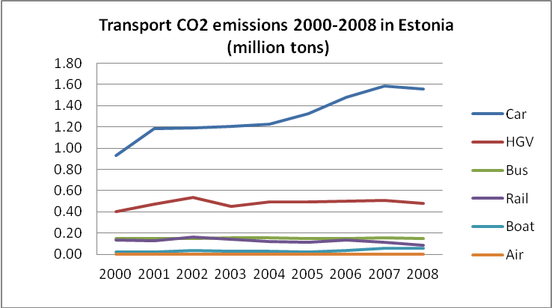  Comparing the Estonian situation to other Member States of the EU, certain distinctions must be taken into account. Although the rate of motorisation has increased rapidly, transport energy demand per capita in Estonia is still relatively low compared to the EU average. Also, GHG emission levels per capita are lower than the EU average. However, several indicators indicate unsustainable trends in relation to the EU average: for example, the Estonian economy is more transport- and energy-intensive; the amount of particle emissions is relatively high; and the CO₂ level of new registered cars is among the highest in Europe (in 2009 the average CO₂ level for new cars in Estonia was 170 g/km).  Estonia’s transport and mobility trends have not been sustainable primarily due to the increase in private car use and road freight, urban sprawl and the decreasing proportion of public transport and walking in daily mobility. Road transport has increased at the same pace as economic growth, which positions Estonia as one of the most transport- and energy-intensive economies in the EU. For example, Estonia uses twice as much transport fuel per unit of GDP than average EU Member States.  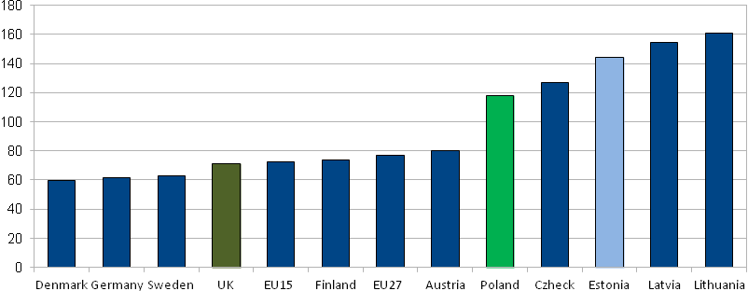  Transport GHG intensity, 2009 (tons per million GDP EUR). Source: Eurostat  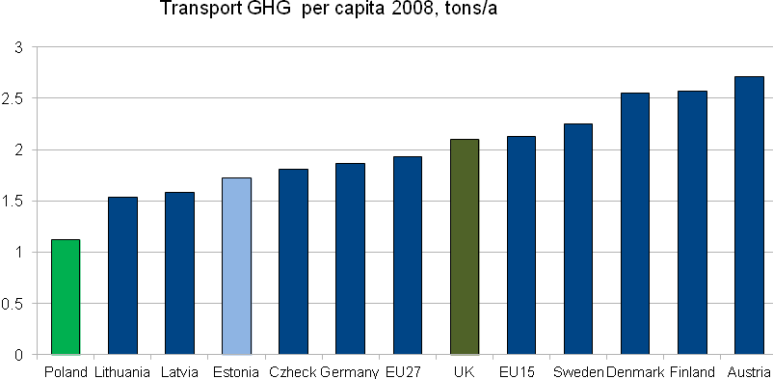  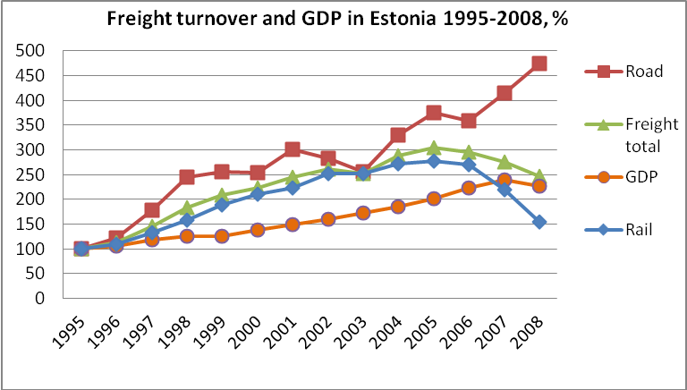  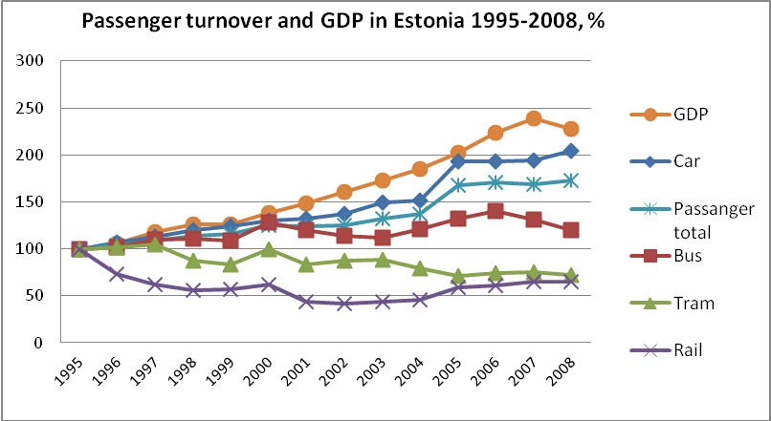  Regardless of the rapid motorisation in Estonia, mobility patterns are still more diverse than the European average: public transport use in daily commuting is higher than the EU average (the share of walking and public transport in Estonian cities is around two-thirds of total trips). We therefore cannot say that Estonians are hopelessly dependant on private cars. For this reason it would be easier to develop public transport and alternative modes of transport and to avoid possible growth in car use rather than expecting a reduction in private car use in future.  Positive trends can be observed in traffic safety: the number of fatal accidents in Estonia has fallen, raising Estonia from the bottom three in the European Union to the EU average. In future, there should be a greater focus on traffic safety in urban areas and improving pedestrian and bicycle safety.  A quarter of Estonia’s final energy demand comes from the transport sector (of which 94% are cars and trucks). Fastest growth in fuel consumption and GHG emissions was from 2004-2007, and the EU’s 11% GHG emission ‘growth limit’ until 2020 has already been exceeded. The potential for energy savings in transport is not widely recognised or debated. Measures for better planning and the influencing of consumers’ choices towards more fuel-efficient cars and sustainable modes of transport are generally absent.  The external costs of transport in Estonia are at least 447 million euros, an annual burden on society as a whole. 80% of these costs are related to traffic accidents, air and noise pollution and impact on the climate. The negative effects of transport on the environment and quality of life are critical in urban areas, making up as much as two-thirds of the external costs of transportation.  Although both national and local government strategies claim to give priority to public transport, cycling and pedestrian traffic and promise to support alternative modes of transport, financing priorities often do not match these goals.  The report showed that prices related to car use have increased more slowly than public transport ticket prices. Average prices for purchasing cars decreased by 30% from 2004-2009.  The fuel excise duty has not proven to be a sufficient measure to achieve a modal shift and reduce the environmental impact of transport. Although the duty has been raised nine times in the last 15 years in Estonia, it has not guided consumers towards more efficient cars or tackled increasing energy demand in transport (gasoline excise tax almost doubled from 2000-2010, but in real terms fuel prices have remained at the 2000 level).  New cars registered in Estonia consume app. 20% more fuel than the average for new cars in the EU. More than half (51%) of these new cars fall in the E-G energy classes, showing no improvement in fuel efficiency compared to the cars sold in Estonia 15 years ago. The EU’s 2010 report on the monitoring of CO₂ from new cars showed that 65% of new cars in the EU already fall in the A-C energy classes i.e. they are relatively fuel-efficient. Although the choice of fuel-efficient cars has become more diverse in recent years, it is not possible to search for cars according to CO₂ or fuel economy indicators in Estonia’s online car sales portals. The largest urban areas in Estonia (Harju and Tartu Counties) are the leading regions for the least fuel-efficient cars. In Finland, the average new car emits 155 g/km of CO₂; in Estonia, the average is 170 g/km. Examples from Finland, Sweden, Denmark and France have shown that the most effective ways of influencing consumer choices are vehicle taxes and incentives based on fuel efficiency.  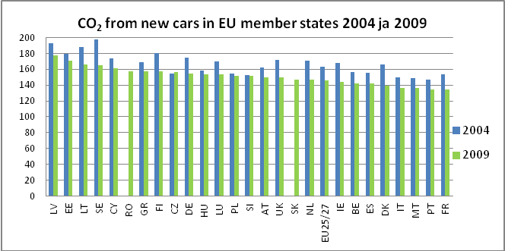  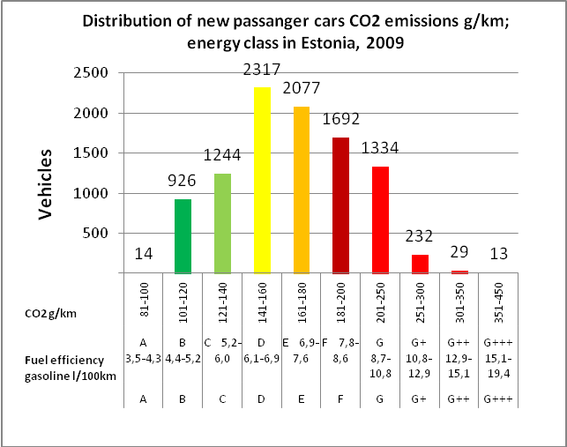  Not even a widespread transition to electric cars in Estonia would result in a rapid decrease in GHGs. While most of Estonia’s electricity continues to be produced from oil shale, electric cars using such energy source will produce significantly more GHG than the vehicles used in Estonia at present. However, electric vehicles would justify their use in urban areas and as public transport because they produce less noise and air pollution.  Summary of transport scenarios  The report analysed three possible scenarios which focused mainly on changes in peoples’ mobility, road transport demands and transport greenhouse gases (GHG) until 2020. The continuation of current trends is the BASE scenario, which was compared to the TECHNO scenario (rapid improvement in vehicle fuel efficiency) and the EFFECT scenario (modal shift scenario). The calculated ‘cap’ for GHGs in 2020 was set at a maximum of 11% growth compared to 2005 levels based on the European Parliament’s decision to limit non-ETS sector GHG levels in the EU.  The BASE-scenario draws on assumptions that road transport in Estonia will continue to increase in a similar way as in the last 10 years, being directly linked to the rate of economic growth. A number of current road construction plans are based on such outlooks and encourage such trends in the country. If such trends continue, the same problems will remain: an increase in transport energy demands and GHG emissions; an increase in PM emissions; and further modal shift from rail to road and private car use.  The BASE scenario GHG trends exceed the set limit of 11% by 0.484 million tonnes. In order to reduce this, two policy pathways/scenarios were devised.  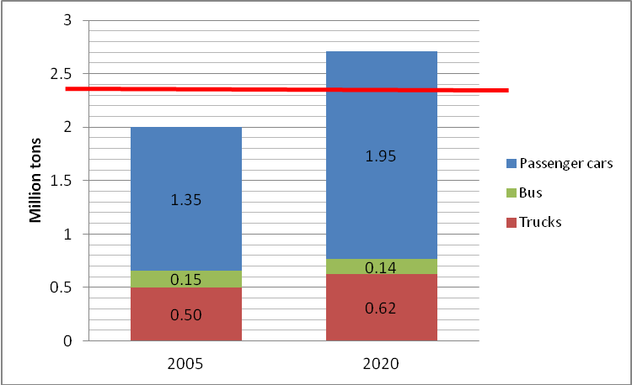  BASE (BAU) scenario, road transport GHG, million-tons. Red line marks non-ETS sector GHG target for 2020 in Estonia: -- max 11% growth  The TECHNO scenario analysed how the efficiency of vehicles should increase in order to limit growth of GHG emissions. This requires the rapid replacement of existing cars with more fuel-efficient ones, the introduction of eco-driving and increasing the proportion of renewable energy in the transport sector to 10%. Compared to the BASE scenario, transport energy efficiency would improve, GHG emissions would decrease (by 18%) and PM emissions would be reduced. This goal also requires the strong implementation of CO₂-based vehicle taxes, incentives and other fiscal measures, which directly affect consumers’ choice. Scenario measures can also be regulatory, such as limiting car parking options for cars with large fuel consumption.  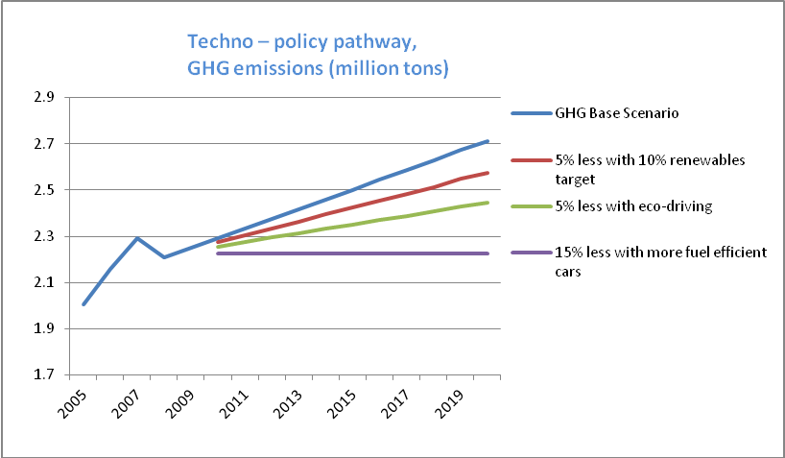  The EFFECT scenario focused on influencing people’s modal choices and level of car use, which would result in a slower increase in energy demand and improve the performance of other sustainable transport indicators. In this scenario the 11% GHG emissions ‘cap’ would require ca 2 million vehicle kilometres (20% of total mileage) to be tackled or shifted to sustainable modes of transport. Compared to the BASE scenario, the following indicators would improve: energy-efficiency (by ca 18%); decreased PM and GHG emissions (also by ca 18%); and the proportion of public transport, cycling and rail use would increase. Traffic safety would also improve more than in the BASE and TECHNO scenarios, as more investments would be made to enhance pedestrian and cyclist safety. The transport price index would improve too under the EFFECT scenario – modes of sustainable transport would become more competitive and transport prices would more accurately reflect environmental and health-related impact.  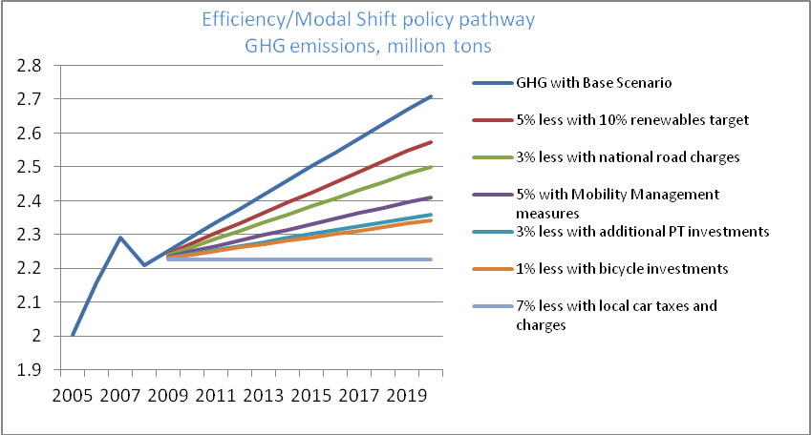  Implementing the TECHNO or EFFECT scenarios separately would not be feasible, as the first scenario requires the implementation of strong regulatory measures (high levels of car tax) and the second scenario requires significant changes to urban and transport system planning. Estonia’s transport system will only become more sustainable if the TECHNO and EFFECT scenarios are both implemented.
8 Lessons learnt from the best practice | The BASE scenario and 13 sustainable transport indicators show that if current trends continue, Estonian transport and mobility will not achieve goals for more sustainable transport. The current transport policy in Estonia does not support the achievement of EU-level commitments in improving transport energy efficiency and limiting greenhouse gas emissions by 2020. At the same time, Estonia has great potential to increase transport energy efficiency and to develop a more sustainable transport system. The analyses resulted in the following policy recommendations:  Greater consistency between strategic transport goals and financing priorities  The next programming period for EU funds (2014-2020) should give clear priority to public transport and integrated transport schemes. Currently earmarking 75% of fuel excise duty revenue for national road construction relegates public transport and integrated urban mobility solutions to a minor position.  When planning land use in urban areas and defining locations for new housing development areas (residential and office buildings), locations with existing and good public transport networks should be preferred (i.e. areas near rail and public transport stops). This would help to improve the efficiency of existing public transport use and to avoid automobile dependency.  Sustainable transport targets should be taken into account when new transport development strategies are drafted (both national and local strategies). The implementation of such targets – energy efficiency, increase in use of public transport and cycling and improvements in air quality – should be monitored. Strategic choices should be analysed when resolving transport problems and determining financing priorities. The full impact of such decisions on sustainable transport targets should be measured.  A four-stage evaluation process should be considered when resolving transport issues:  - Is it possible to resolve the transport problem by influencing demand for private car use and increasing the proportion of more efficient modes of transport?  - Is it possible to resolve the transport problem through better use of existing infrastructure and vehicles?  - Is it possible to resolve the transport problem via minor improvements in existing infrastructure?  - If the answers to the previous three questions are ‘no’, should construction of new infrastructure be considered as an alternative solution?  In this type of decision-making process, traffic and transport problems are handled as a whole, not as single aspects of road construction.  Public transport, cycling and walking should be given clear priority along with maintenance of existing infrastructure and sea and rail freight  Public transport and cycling should have secured funding to support the advantages of sustainable modes of transport and to decrease transport externalities. At the national level, priorities could be set through increased financing for EU projects for public transport and cycling and introducing vehicle taxation based on CO₂ emissions (there is currently no vehicle taxation in Estonia). In larger urban areas financing could be improved by implementing more efficient parking management and with congestion charges in Tallinn.  Large companies, employers, public institutions and shopping centres should develop and implement mobility management plans which favour sustainable transport choices among their employees and customers and save on parking and company car expenses.  The development of rail connections should focus on the reconstruction of existing rail infrastructure and increasing the frequency of trains between larger Estonian towns and cities (Tallinn, Tartu, Pärnu and Narva) and to larger metropolitan areas like St. Petersburg, Riga and Moscow. Buying new trains and renovating tracks is not enough to increase the competitive advantage of rail transport. Improvements in rail transport quality should be implemented along with other measures, such as planning new developments close to railway stations, internalising road transport externalities (mileage-based road charges for road freight and congestion charges in Tallinn) and improving intermodality (public transport interchange stops and ‘Park & Ride’ systems).  Innovative solutions should be implemented which make transport changes smoother and allow better connectivity between different modes of transport modes (car sharing, bike sharing, bus-on-demand etc.).  A national cycling and walking strategy should be drafted which clarifies development constraints, goals, stakeholders and parties.  A common ticket system should be developed for Estonia’s public transport systems.  In order to increase the energy efficiency of the transport sector, transport-related fiscal system should be changed and consumer choices should be influenced  The introduction of energy labelling for cars which is similar to domestic electrical appliances could be used to influence consumer choices towards more fuel-efficient vehicles. Energy labelling should include online car sales portals, which would allow customers to easily search for cars according to fuel efficiency and energy class.  Public campaigns should focus more on increasing consumer awareness of the impact of transport on the environment and people’s health and quality of life.  Measures based on car fuel efficiency and CO₂ emissions which reduce the demand for fossil fuels should be analysed and developed. More efficient vehicles would boost Estonia’s economy and energy security and reduce the population’s sensitivity to volatile oil prices. To achieve this, the following measures should be implemented simultaneously:  - public procurement conditions should clearly prioritise more fuel-efficient vehicles (national and local authorities could organise joint procurements);  - the introduction of a CO₂-based registration tax or annual car tax should be considered;  - regulatory measures should be introduced so as to encourage the scrapping of fuel-consuming vehicles and the purchasing of more efficient vehicles through national programmes; and  - the use of inefficient vehicles in cities should be limited by differentiating parking fees and congestion charges.
9 Contact information | Contact person: Mari Jüssi, mari@seit.ee
10 Other possible interesting information | This case study delivered the first detailed CO₂ analyses of Estonian transport sector.  Three policy recommendations were adopted by the national government (in the governments action plan for 2011-2014)  Outreach  A Policy Brief in English was published in April: http://www.seit.ee/failid/822.pdf  Input to Estonian Sustainable Development Committees transport report:  http://www.valitsus.ee/et/riigikantselei/saastev-areng/saastva-arengu-komisjon/saastva-transpordi-raport (launched in January 2011)  The results of the carbon audit and sustainable transport report have been presented on different occasions:  - Biofuels conference in Tartu, March 23-24 2011  - Agenda: http://www.tartu.ee/?lang_id=1&menu_id=6&page_id=24084  - Presentation: http://www.tartu.ee/data/SAKTRA.pdf (Helen Poltimäe and Mari Jüssi)  - TraCit Krakow Workshop, http://www.ksk.pk.edu.pl/pl/tracit Presentation (Mari Jüssi) http://www.ksk.pk.edu.pl/system/physicals/43/original/TRACIT_Presentation_Mari_Jüssi.pdf?1305544393  - 27.10.10 Public lecture on sustainable transport by Mari Jüssi in Pärnu http://www.kuhuminna.ee/hariv/473877/event/  - 20.11.10 Pirita,Tallinn transport conference http://www.piritaselts.ee/index.php?option=com_content&view=article&id=449:tulemas-on-liiklusteemaline-konverents-20novembril&catid=6:uued-uudised&Itemid=7  - 30.11.10 Telliskivi (Tallinn) transport forum http://www.facebook.com/media/set/fbx/?set=a.10150108066491273.300998.140613656272 http://www.telliskiviselts.info
11. Best practice transferred | Results of the carbon audit were shared with TraCit partners, valuable exchange of experience from similar studies of CUT were shared during Krakow workshop in May.  Estonian transport carbon audit methodology and analyses was used in Power SEEDA pilot studies on Tallinn transport and eco driving.

References

Adhvaryu (2010). “Enhancing urban planning using simplified models: SIMPLAN for Ahmedabad, India.” Bhargav Adhvaryu. Progress in Planning (2010), doi:10.1016/j.progress.2009.11.001.
CFTE (2005), Building Communities Through Public Transportation: A Guide for Successful Transit Initiatives, Center for Transportation Excellence, for the Public Transportation Partnership for Tomorrow (www.cfte.org/Building_Communities.pdf) accessed 15.5.2011
Cooper and Smyth (2001). “Contemporary lifestyles and the implications for sustainable development policy: Lessons from the UK’s Most Car Dependent City, Belfast. Cities, Vol. 18, No. 2, pp. 103-113, 2001.
Cooper et al (2001). “Energy Trade-offs and Market Responses in Transport and Residential Land-use Patterns: Promoting Sustainable Development Policy.” J. Cooper, T. Ryley and A. Smyth. Urban Studies, Vol. 38, No. 9, 1573-1588, 2001.
Defra (2007). Guidelines to Defra's GHG conversion factors for company reporting: Annexes updated June 2007. Department for Environment, Food and Rural Affairs. Accessed at http://archive.defra.gov.uk/environment/business/reporting/pdf/conversion-factors.pdf on 13/9/2011.
Department for Communities and Local Government (2001). Planning Policy Guidance 13: Transport. Department for Communities and Local Government. March 2001. Accessed at http://www.communities.gov.uk/documents/planningandbuilding/pdf/155634.pdf on 13/9/2011.
Department for Transport (2008). The Essential Guide to Travel Planning. March 2008. Department for Transport. Accessed at http://www2.dft.gov.uk/pgr/sustainable/travelplans/work/essentialguide.pdf on 13/9/2011.
Department for Transport (2011). Road Traffic Reduction Act 1997: draft guidance to local traffic authorities. Accessed at http://www2.dft.gov.uk/pgr/roads/tpm/congestionresearch/roadtrafficreductionact1997d4027.html on 13/9/2011.
Department of Energy and Climate Change, (2009).CO2 emissions from road transport in Poartsmouth. Accessed at http://www.dft.gov.uk/pgr/statistics.
Government Legislation UK (2011a) Environment Act 1995. Accessed at http://www.legislation.gov.uk/ukpga/1995/25/contents on 13/9/2011.
Government Legislation UK (2011b) Transport Act 2000. Accessed at http://www.legislation.gov.uk/ukpga/2000/38/contents on 13/9/2011.
Joseph, P (2010) Tretsiakova-McNally, Svetlana Sustainable Non-Metallic Building Materials. Sustainability 2010, 2, 400-427.
Jüssi, M., Poltimäe, H., Sarv, K., Orru, H. Säästva transpordi raport 2010. Säästva Arengu Komisjon, Tallinn, 2010 [Sustainable Transport Report 2010. Commission on Sustainable Development, Tallinn, 2010]
Office for National Statistics (2010).Census data 2001. Accessed at http://neighbourhood.statistics.gov.uk/dissemination/LeadTableView.
Portsmouth City Council (2008).The second local transport plan for Portsmouth, 2006/07 to 2010/11: 2008 progress report. Accessed at http://www.portsmouth.gov.uk/media/Portsmouth_LTP_Progress_Report_Dec_2008.pdf
Portsmouth City Council (2010). Draft air quality action plan. Accessed at http://www.portsmouth.gov.uk/media/cab20100628r2appB.pdf
Scottish carbon footprint: H Gillies, S Cragg, J Davidson, K Lumsden (2006): Land-use and transport integration in Scotland (LATIS): a national carbon footprint. European Transport Conference, 2009, available at www.etcproceedings.org;
STEPS project: Fiorello, D., Huismans, G., López, E., Marques, C., Steenberghen, T., Wegener, M., Zografos, G. (2006): Transport Strategies under the Scarcity of Energy Supply. STEPs Final Report, edited by A. Monzon and A. Nuijten. Den Haag: Buck Consultants International. Available at www.steps-eu.com/reports.htm
Sustainable Alberta Association (2011). The Calgary Commuter Challenge. Accessed at http://www.calgarycommute.ca/commuter_challenge.html on 13/9/2011.
The News (2011). Crammed city has most concentrated population in UK. Published Thursday 13 September 2011. Accessed at http://www.portsmouth.co.uk/news/local/east-hampshire/crammed_city_has_most_concentrated_population_in_uk_1_2358476 on 13/9/2011.
The Wider Impacts Sub-Objective TAG Unit 3.5.14 (DRAFT FOR CONSULTATION, September 2009, Department for Transport). http://www.dft.gov.uk/webtag/documents/expert/unit3.5.14c.php
TfSH, 2011. Transport for South Hampshire Evidence Base, Model Development Report. Report 2, Report for Transport for South Hampshire, August 2011.
TSGB, 2010. Transport Statistics Great Britain, Department for Transport. Accessed Aug 2011 from http://www2.dft.gov.uk/pgr/statistics/datatablespublications/tsgb/#complete
Wall, G.T and M McDonald (2006). Improving bus service quality and information in Winchester. Transport Policy, Volume 14, Number 2, March 2007, pp 165-179.
Wall, G.T, Felstead, T, Richards, A and M McDonald (2008). Cleaner vehicle buses in Winchester. Transport Policy, 15(1), 55-68.
Wider Impacts and Regeneration. TAG Unit 2.8. DRAFT. FOR CONSULTATION. September 2009. Department for Transport. Transport Analysis Guidance (TAG). http://www.dft.gov.uk/webtag/documents/project-manager/pdf/unit2.8c.pdf
WSP Sweden 2007 Effekter av Mobility Management åtgärder – en analys baserad på internationell litteratur.

Appendix 1: BGCC: Portsmouth transport baseline data

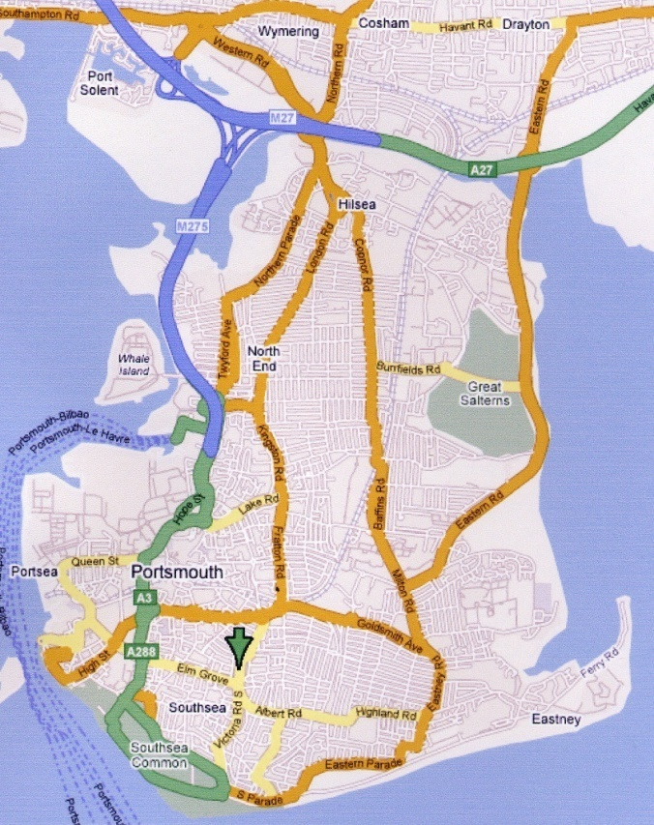
Figure 25: Map of Portsmouth

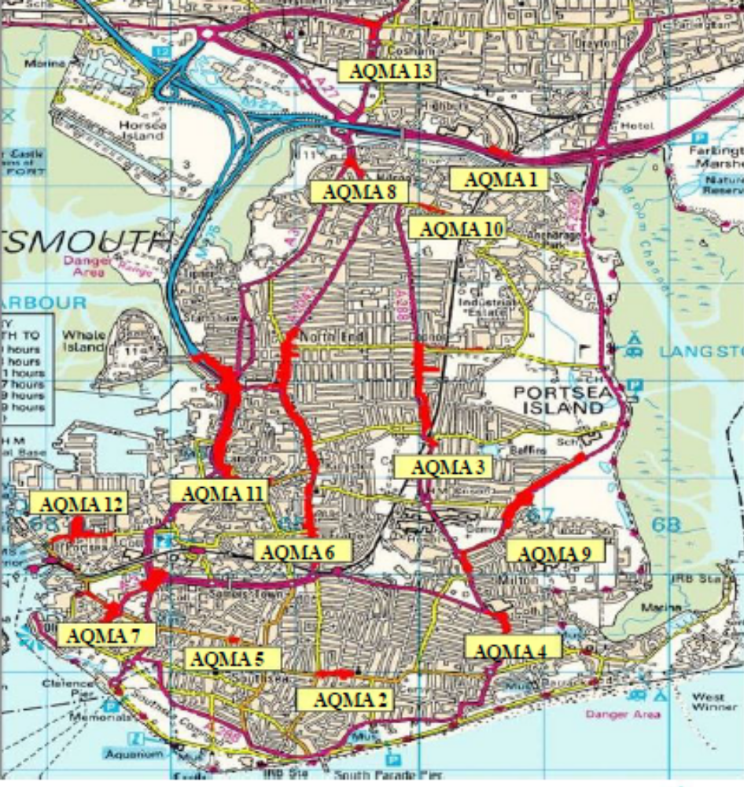
Figure 26: AQMA’s in Portsmouth 2005 (PCC, 2010)
AQMA 4
3
AQMA 9
3
AQMA 3
3
AQMA 10
3
AQMA 8
3
AQMA 13
3
AQMA 1
3
AQMA 12
3
AQMA 11
3
AQMA 6
3
AQMA 7
AQMA 2
3
AQMA 5
3

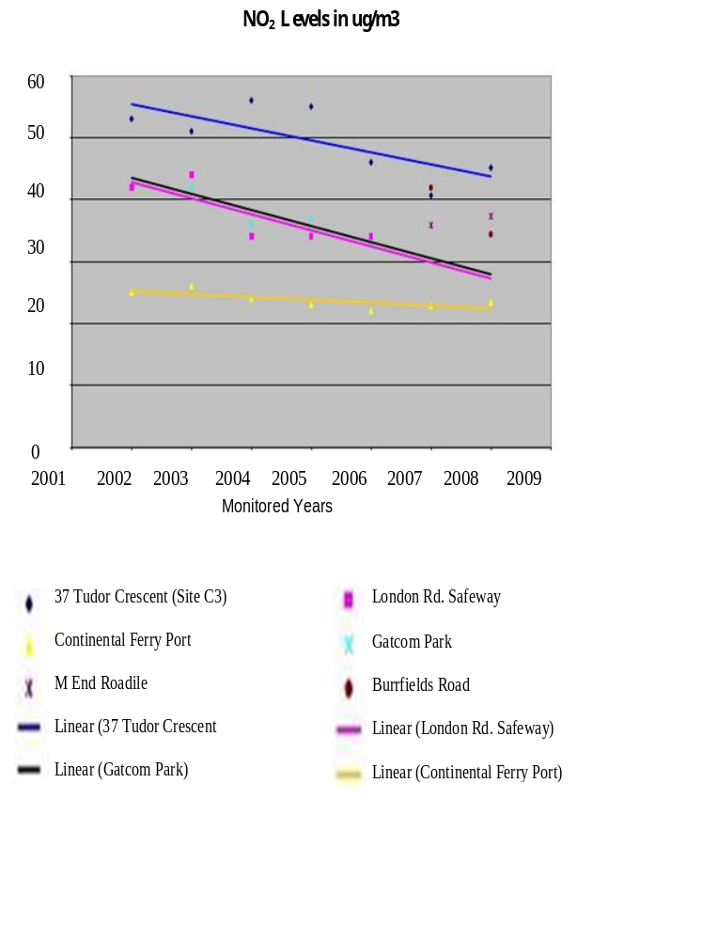

Figure 27: NO_{x} level in Portsmouth (PCC, 2010)

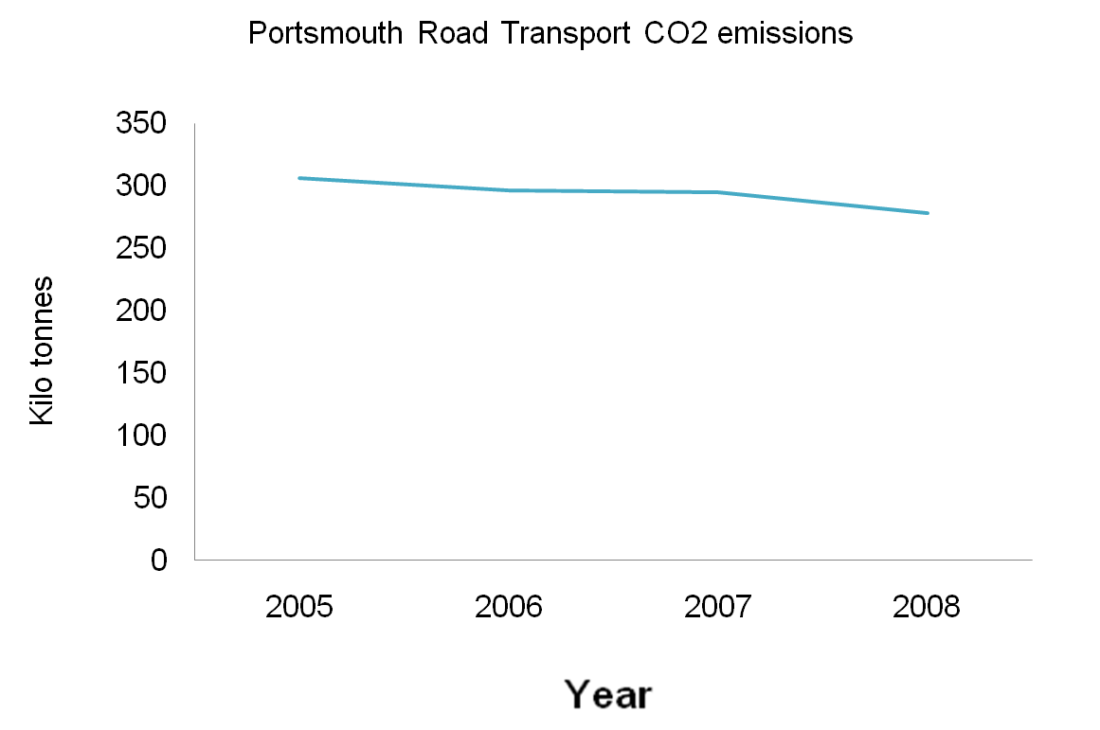
.
Figure 28: Portsmouth Road Transport CO₂ Emissions (DECC, 2009)

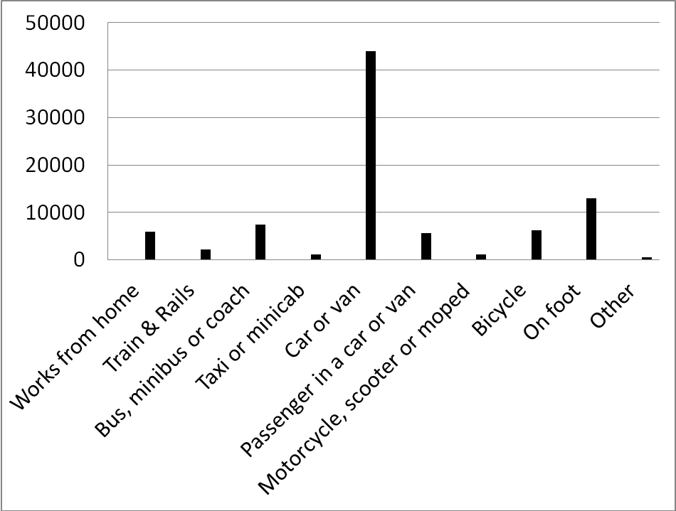
Figure 29: Portsmouth resident’s method of travel to work in miles from the 2001 census (ONS, 2010).

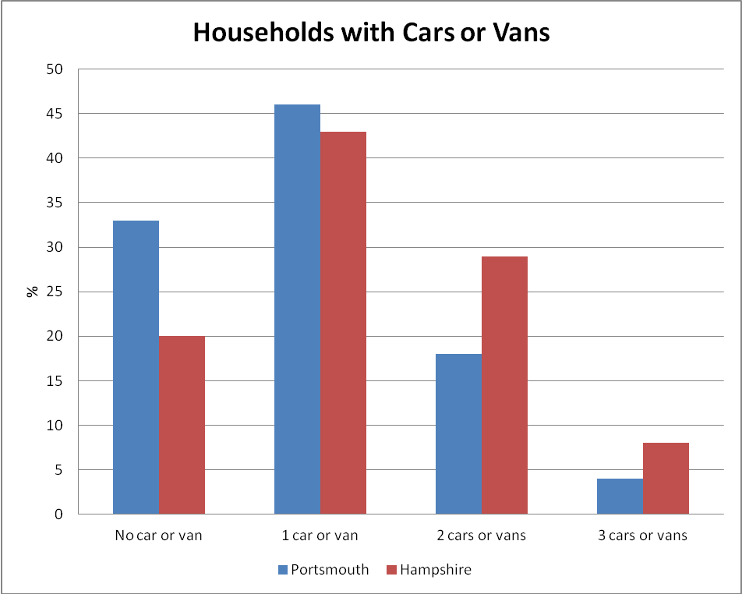
Figure 30: The percentage of households with cars or vans in Portsmouth and Hampshire from the 2001 Census (ONS, 2010)

Figure 31: BGCC questionnaire
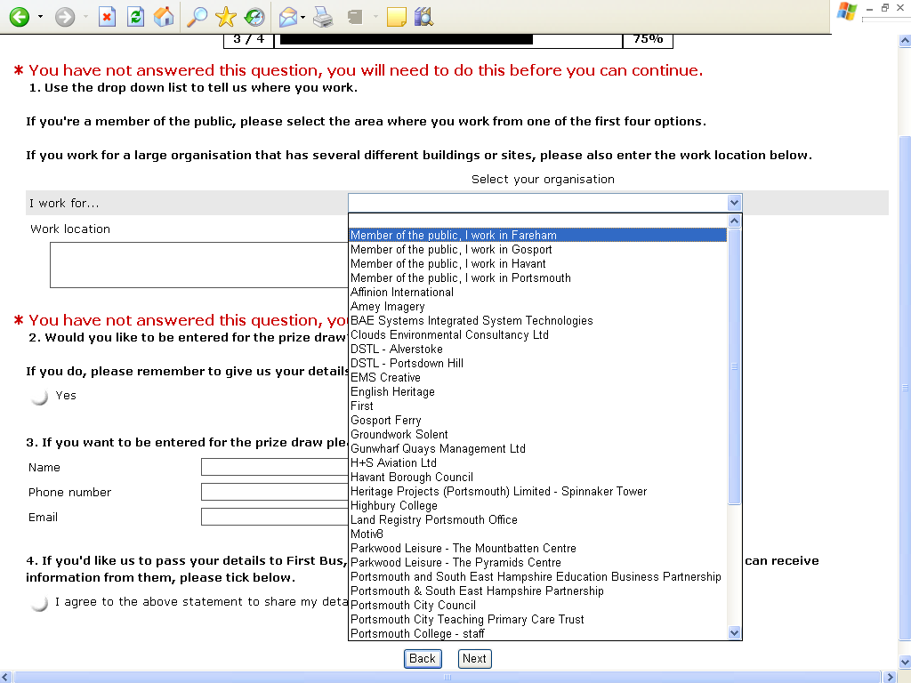
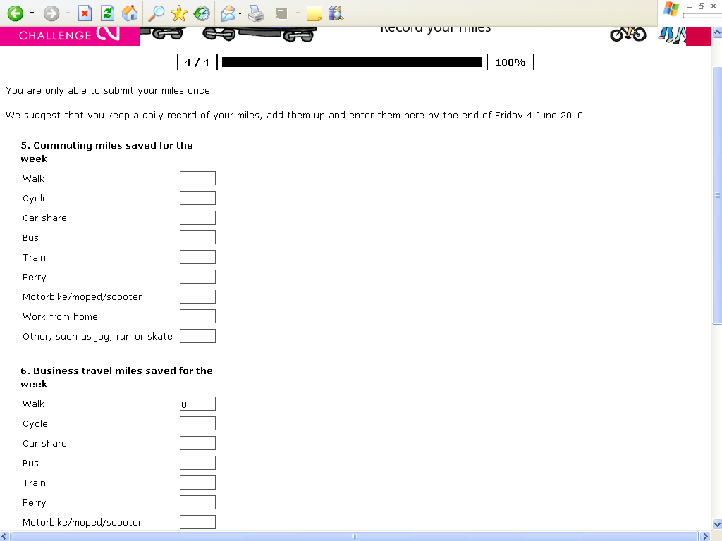

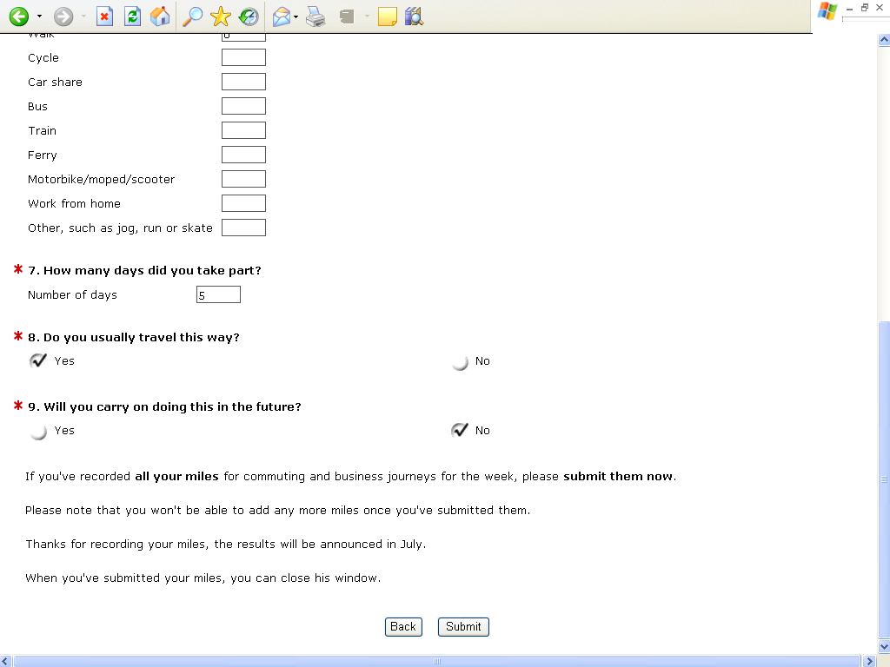

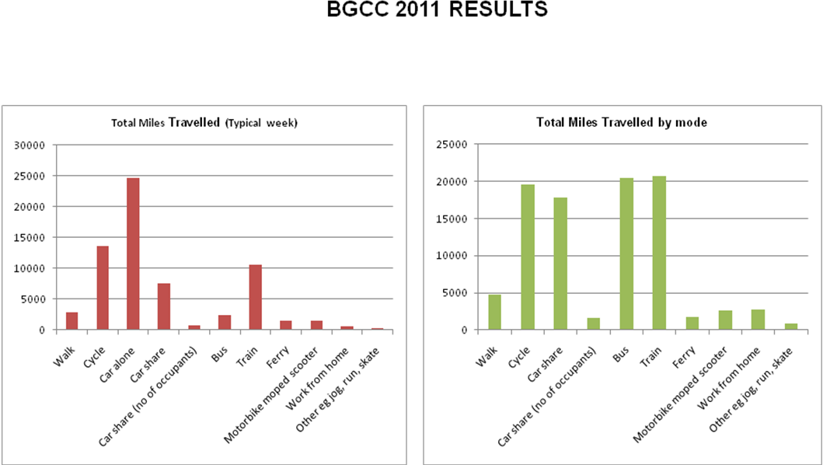

Transport indicator | Baseline (2004/2005) | Actual (2007/2008 )
Traffic flow (7–10)am weekday | 18389 | 17084
Work place travel plan | 5 | 16
Public Transport Accessibility to Major Centres | 98% | 88%
Bus patronage (2003/2004) | 11,201,000 | 11,738,000
Cycling trips (2003/2004) | 100 | 99.7
School travel plans | 45% | 77%
Bus satisfaction | 44% (2003/04) | 56% (2006/07)
Cycle parking | 250 (2005) | 378 (2008)
Table 22: Portsmouth City Council LTP2 transport data (PCC, 2008)

Appendix 2: Questionnaire used during the tram event, Krakow

Krakow University of Technology is a partner in the international project TraCit promoting solutions to reduce CO2 emissions in transport. This survey is anonymous and its results will be used in TraCit project.
Gender: | Education:
Woman | primary
Man | secondary
 | higher
Age: | Status:
<18 | pupil
18-35 | student
36-60 | pensioner
>60 | unemployed  worker
Did you hear earlier about the ongoing marketing campaign in a free tram?
Yes
No
2. Do you drive a car?
Yes, I drive a car every day
Yes, I drive a car occasionally
No
If the answer to that question was "Yes", please go to the question. No.3, if the answer was "No", please go to question. No. 5
3. If you heard earlier about the ongoing action, whether this information has contributed to the resignation of the car today and choose the tram as a transport mode?
Yes (please provide the estimated travel distance or location of the origin and destination of journey, which was to be done by car)………………………………………………………….
No
4. If you did not hear earlier about the ongoing action, did you choose a tram despite of fact you have the opportunity to travel by car today?
Yes (please provide the estimated travel distance or location of the origin and destination of journey, which was to be done by car)………………………………………………………….
No
5. What are in your opinion, the three most important ways to reduce transport emissions CO2 in the cities?
Introduction a ban on lorries driving through the city center
Restrictions in car access to the city center
Introduction of access charge
Extension of charged parking zone
Improvement in quality of public transport services
Organization of events for public transport promotion
Bike network development
Extension of pedestrian zone
Other…………………………………………………………………..
6. Which of the following ways to reduce transport emissions CO2 is used by you every day?
I often travel by bus or tram
I often travel by foot
I often travel by bike
I often travel by car with several passengers
I use more energy efficient vehicles
I choose close located destinations
Neither of above-mentioned
Other …………………………………………………………………………….

Appendix 3: Questionnaire used during ‘Bike Happening’, Krakow

Sex:
Male
Female
Age: | Status:
18 – 35 | Employee
36 – 60 | Student
> 60 | Pensioner

What mode of transport did you use yesterday, during travelling to the University?
Car, as a driver
Car, as a passenger
Bus, tram
Long distance bus
Train
Motorcycle
Bike
Walking

Please, give us the approximate distance of journey made by bike today or origin of journey (street or district name).
………………………………………………………………………………………………………..

Did you have an information about the happening earlier?
Yes
No

4 . If you have an information about the happening earlier, what was the source of the information?
Poster
E- mail information
Website information
Information from colleague
Other (What?)……………

5. Do you know what is the message of this happening ?
Yes, I do (what?) ………………………………………………………………………………………
No, I do not know
6. If you have heard about the happening earlier, whether this information has influenced the resignation from transport mode usually used and choice of bike today?
Yes
No
7. If you haven’t hear about the happening earlier, did you have an occasion to travel by car today and you chose bike instead?
Yes
No

8. Taking into consideration the bike travelling, which of following sentence is characteristic for you?
I travel by bike almost every day
I travel by bike often
I travel by bike occasionaly (e.g. such as today)

9. If you travel by bike almost every day or often, what factors encourage you to do it? (possibility to choose more than one answer).
Lack of car
Risk of car theft or car damage
Lack of car parking places
Low cost of bike journey
Time of journey saving
Independence from traffic jams
Bike paths network
Possibility to transport the bike in public transport vehicles
Low quality of public transport (e. g. low frequency in bus running)
Care about the environment and climate change e.g. care about reduction of CO2 emissions
Care about the health
Other (what?).................................................................

10. If you travel by bike occasionally, what are the reasons? (possibility to choose more than one answer).
Attachment to car travelling
Lack of bike
Lack of possibility to storage the bike in house
To long distances between origin and destination points
Lack of access to bike paths
Large car traffic flows
Lack of possibility to leave the bike on parking in destination point (e.g. in the area of work place)
Lack of possibility to take a shower in destination point
Good public transport service
Fear of accident
Fear of bike theft
Other (what?)...................................................................................................

11. If you travel by bike occasionally, what factors could encourage you to change the transport mode you usually use and travel by bike? (possibility to choose more than one answer).
Possibility to rent a bike
Access to good bike paths network
High number of secured bike racks in destination point
Lower car traffic flows on the streets with bikes
Possibility to take a shower in destination point
Other (what?)...................................................................................................

Appendix 4: Questionnaire used among transport and land use experts in Krakow

Sex: | Status:
Male | Student
Female | Employee
 | Unemployed
Age: | Pensioner
<18
19 – 25 | Place of living:
26 – 40 | Big city (> 100 000 inhabitants)
41 – 65 | Medium size city (20 000 – 100 000 inhabitants)
> 65 | Small town (< 20 000 inhabitants)
 | Village

What mode of transport do you use most often during travelling to the work, science, leisure or shopping places? (Please put “X” in right cells).
 | Bus, tram | Long distance bus | Train | Car, as a driver | Car, as a passenger | Motorcycle | Bike | Walking
Work
Science
Shopping or other services
Leisure

2. Taking into consideration the bike travelling, which of following sentence is characteristic for you?
I travel by bike almost every day
I travel by bike often
I travel by bike occasionally
I do not travel by bike at all

3. Taking into consideration last week, please give information about all your bike journeys related with work, science, leisure or shopping places (Please put “X” in right cells). Please give also information about distance (km) and time (min) of these journeys.
 | Monday | Tuesday | Wednesday | Thursday | Friday | Saturday | Sunday | distance (km) | time (min)
Work
Science
Shopping or other services
Leisure

4. How seasons and weather conditions influence your bike journeys?(possibility to choose more than one answer).
I travel by bike regardless of season
I travel by bike only in spring – summer – fall period
I travel by bike regardless of weather conditions
I do not travel by bike during rainy days
5. If you travel by bike almost every day or often, what factors encourage you to do it? (Please put “X” in right cells - possibility to choose more than one answer).
 | Journey related with home, work, science, shopping places or other service | Journey related with leisure places
Lack of car
Risk of car theft or car damage
Lack of car parking places
Low cost of bike journey
Time of journey saving
Independence from traffic jams
Bike paths network
Possibility to transport the bike in public transport vehicles
Low quality of public transport (e. g. low frequency in bus running)
Care about the environment and climate change e.g. care about reduction of CO2 emissions
Care about the health
Other (what?).................................................................

6. Ifyou travel by bike occasionally or do not travel by bike at all, what are the reasons? (Please put “X” in right cells - possibility to choose more than one answer).
 | Journey related with home, work, science, shopping places or other service | Journey related with leisure places
Attachment to car travelling
Lack of bike
Lack of possibility to storage the bike in house
To long distances between origin and destination points
Lack of access to bike paths
Large car traffic flows
Lack of possibility to leave the bike on parking in destination point (e.g. in the area of work place)
Lack of possibility to take a shower in destination point
Good public transport service
Fear of accident
Fear of bike theft
Other (what?)......................................................................

7. If you travel by bike occasionally or do not travel by bike at all, what factors could encourage you to change the transport mode you usually use and travel by bike? (Please put “X” in right cells – (possibility to choose more than one answer).
 | Journey related with home, work, science, shopping places or other service | Journey related with leisure places
Possibility to rent a bike
Possibility to move the bike in public transport vehicles
Access to good bike paths network
High number of secured bike racks in destination point
Lower car traffic flows on the streets with bikes
Possibility to take a shower in destination point
Other (what?)......................................................................

8. How do you assess mentioned below factors related with bike infrastructure and bike travelling taking into consideration your place of living? Please put right number from 1 to 5, where 1 – means very bad/badly, and 5 – means very good/well.
Surface conditions of bike paths | 1 2 3 4 5
Signing of bike paths | 1 2 3 4 5
Continuity of bike paths system | 1 2 3 4 5
Access to bike parking places in most important destinations | 1 2 3 4 5
Level of security on bike parking places | 1 2 3 4 5

Appendix 5: Questionnaire used to develop Viimsi public transport model.

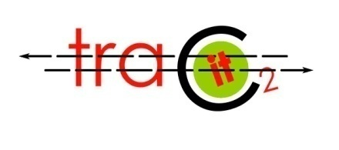

Küsitlus
1. Palun näidake oma igapäevaste liikumiste sihtpunkt!
Kui sihtpunkt asub Tallinna linnas, siis kasutage valikut, Viimsi puhul sisestage tänava nimi.
Viimsi vald
Tallinn
Muu
2. Näidake oma peamine liikumisviis:
Ühistransport
Sõiduauto, väikebuss, pakiauto
Mootorratas
Jalgratas või mopeed
Jalgsi
3. Milline on Teie hinnang ühistranspordi (ÜT) kvaliteedile:
 | Pigem hea | Rahuldav | Pigem halb | Ei oska hinnata
Vallasisene ühistransport
Ühendus Tallinna linnaga

4. Kas oleksite loobuma autokasutusest ÜT kasuks juhul, kui:
kui ÜT oleks..
veidi kiirem, kui auto
oluliselt kiirem, kui auto
sama kiire, kui auto
ei ole nõus
kui ÜT oleks..
veidi odavam, kui tänane ÜT
oluliselt odavam, kui tänane ÜT
ei ole nõus
kui ÜT oleks..
veidi mugavam, kui tänane ÜT
oluliselt mugavam, kui tänane ÜT
ei ole nõus

5. Kas kaalute transpordivahendi valikul ühistranspordi kasutamist
sellel eesmärgil, et vähendada CO2 päästu
kindlasti!
mõnevõrra
ei arvesta sellega

6. Mis on Teie arvates peamine liiklus- või transpordiprobleem Viimsi elanike jaoks?
Ummikud
Ühistranspordi kvaliteet
Kergliiklusteede vähesus
Muu

6. Palun näidake oma vanus ja sugu:
Vanus 
Sugu

TraCit

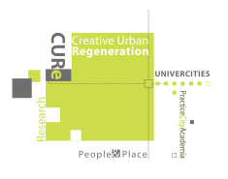




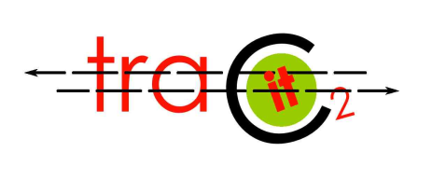

Stern Review on the Economics of Climate Change’ (2006) http://webarchive.nationalarchives.gov.uk/+/http:/www.hm-treasury.gov.uk/sternreview_index.htm Figures detailing energy use and emissions from domestic buildings specifically are found in ‘Climate Change: The UK programme 2006’
Antov, D and M Nigol (2011) Public transport survey and alternative solutions for reduction of CO2 levels in Viimsi municipality. Presented at the Tracit Viimsi Workshop on 16 June 2011. Accessed at http://www.tracit.org.uk/

